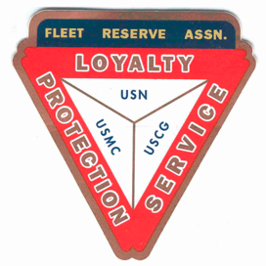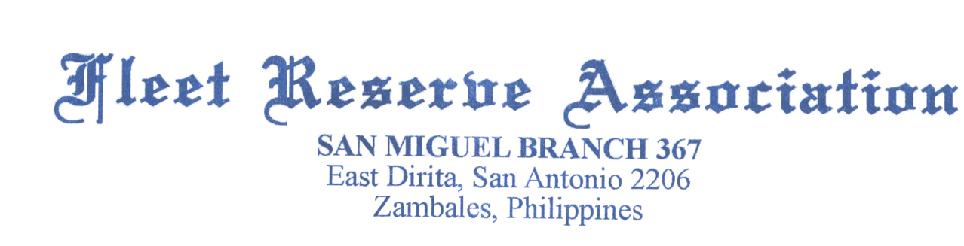

Board of Directors meeting 10 AM, August 25, 2021

Present: Shipmates Pres Lee Vatter, Vice Pres Bill Bay, Sec Pat Winston, Treas David Johnson, John Moore, John Corbin, Carl Schuelke, & John Stanton from the “Garage Grill”.

Present Branch 367 Membership is 126.

Items discussed:

- Thank you Jack Wilbanks for volunteering attendance at the FRA Northwest Region convention held in Spokane Valley, representing Branch 367.
- James Conti became a Branch 367 Member on 20 August 2021.
- On August 12th Shipmate Barry Larsen performed Two Bell Ceremony at Clark Veterans Cemetery for Benjamin Saylor (non member of FRA) .
- On 10 August 2021, President Lee Vatter and Member Donald Robbins performed a Two Bell Ceremony for Branch 367 Shipmate Joe Hinson CPO (Ret) Devine Mercy Memorial Park
- Roger Arimboanga has been our night Security for about 15 years. His eleven year old son “Prince” recently passed away from Covid-19. Lee Vatter motioned to donate p10k to the Arimboanga family. John Corbin 2nd the motion, Approved unanimously.
- 200 total Thanksgiving Turkey Raffle tickets are now available for sale (p500) behind the counter. Please show your support for this important fund raiser.
- The Garage outside bar is closed during GCQ. A liquor ban is in effect, however, the restaurant is open for business.
- Members are highly encouraged to attend both the BOD and GMM meetings
- The next GMM is 01 September. The next BOD 29 Sep meetings start at 10 AM.
The group discussion ended at 10:26 AM.

Submitted: Approved:

//S// //S//
Patrick Winston William “Lee” Vatter
Secretary President
Branch 367 Branch 367

