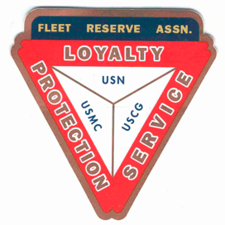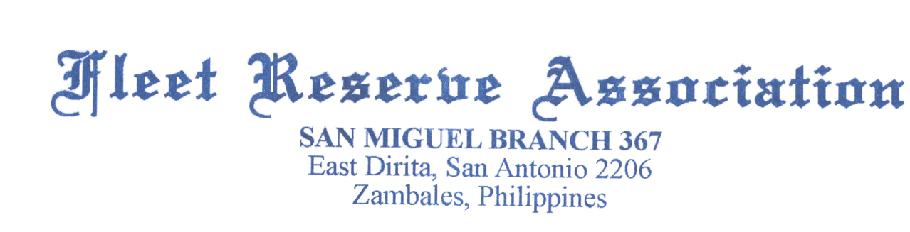

Board of Directors meeting 11:40AM, July 28, 2021

Present: Shipmates Pres Lee Vatter, Vice Pres Bill Bay, Sec Pat Winston, Treas David Johnson, John Moore, David Niemela, Donald Robbins & John Stanton from the “Garage Grill”.

Present Branch 367 Membership is 126.

Items discussed:

- FRA Branch 367 Shipmate Roger W.Limle SCPO (Ret) passed away 13 Nov 2020.
- Shipmate Barry Larsen performed Two Bell Ceremony at Clark Veterans Cemetery for Benjamin Saylor (non member of FRA) .
- President Lee Vatter and Member Donald Robbins performed a Two Bell Ceremony for SD2 Celedonio Fontecha (non Member of FRA) at Angel Grace Memorial Gardens, San Felipe.
- Canon Printers for elementary schools will not be received from the distributor, however, the deposit will be returned to Br 367. Discussion regarding contribution proceeds will be held at the next GMM.
- FRA storeroom has controlled roof leaks, but repairs may have to wait until the rain season is over.
- Secretary Winston submitted check to LAFRA National for three Unit 367 members.
- Members are highly encouraged to attend both the BOD and GMM meetings
- The next GMM is 04 August. The next BOD 25 August. Both meetings start at 10 AM.
The group discussion ended at 1146 AM. Short meeting due to heavy rain and attendance requirement at a Two Bell Ceremony.

Submitted: Approved:

//S// //S//
Patrick Winston William “Lee” Vatter
Secretary President
Branch 367 Branch 367

