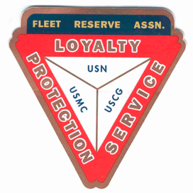

**Board of Directors meeting 10AM, June 30, 2021**

Present: Shipmates Pres Lee Vatter, Vice Pres Bill Bay, Sec Pat Winston, Treas David Johnson, & John Stanton from the “Garage Grill”.

Present Branch 367 Membership is 126.

**Items discussed:**

1. The East Dirita Elementary School overhead rain/shade project has been completed. We hope you enjoyed the drone video that covered the 21,600 sq ft area from overhead. A special thank you to David Johnson for taking charge of this worthwhile project, also the daily Supervisors and contributors.
2. FRA storeroom cleaning is complete. P500 from petty cash.
3. Shuttle scheduling to Manila VA OPC from ROA Barrio Baretto is occurring now. Contact Jack Walker for available seats (p1650).
4. Printers delays continue for elementary schools. 50% deposit was made & the Secretary is following up progress every two weeks.
5. LAFRA memberships have been changed. Specifics are in the July 2021 Triangle Newsletter. Secretary Pat Winston will submit an email to LAFRA National to request grandfather authorization to retain two of our Unit members.
6. July 4th pot luck with VFW POST 11447.10am to sunset. Location is at ALTA Vista. LOCATED **14°51'36.1"N 120°15'36.2"E**
7. President Vatter will authorize Branch 367 Pres, VP, Sec, and Treas access to BPI Peso and Dollar accounts.
8. Treasurer David Johnson stated that all FRA monthly bills are up to date. July rent will be forgiven by the property Owner due to security bar installation. John from the Garage is also up on monthly obligations.
9. Items discussed at the BOD meeting should be voted on so that they can be properly addressed at the GMM. Members are highly encouraged to attend both the BOD and GMM
10. The next GMM` is 07 July. The next BOD 28 July. Both meetings start at 10 AM.

The group discussion ended at 10:28 AM.

Submitted: Approved:

//S// //S//

Patrick Winston William “Lee” Vatter

Secretary President

Branch 367 Branch 367