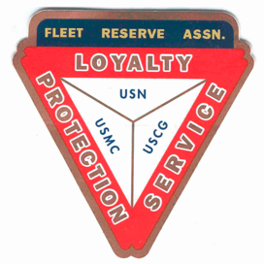

Board of Directors meeting 10AM, May 26, 2021

Present: Shipmates Pres Lee Vatter, Vice Pres Bill Bay, Sec Pat Winston, Treas David Johnson, John Moore, & John Stanton from the “Garage Grill”.

Present Branch 367 Membership is 126.

Items discussed:

- On 23 May, Lee Vatter and Bill Bay conducted a Two Bell Ceremony and presented an American Flag at a funeral service held for Major Richard Randy Lee.
- AGO Optical will offer free eye exams for all at FRA Branch 367 on 3 June.
- FRA Branch 367 Window and Door Security Bars have been installed. Thank you David Johnson for overseeing the project. The FRA Property Owner has agreed to allow non-payment of the July rent to help lower our expense. President Vatter authorized Treasurer Johnson to purchase 2 lock sets (8 total locks) for the new steel doors.
- Pat Winston will ship the 60 custom Branch 367 to attendees at the upcoming FRA National Convention (to be held in Spokane Washington).
- The East Dirita Elementary School overhead rain/shade project will commence in June. Local Members are expected to participate by checking on work progress with the foreman daily.
- COVID Note: "The United States does not require vaccination against COVID-19 as a condition of entry," US Embassy Press Attaché Heather Fabrikant said. https://news.abs-cbn.com/news/05/17/21/covid-19-vaccination-not-condition-to-enter-us-says-embassy-officer
- If you are a Senior (60+) and getting a free Covid Vaccine in the Philippines, be aware that you must show an ID that states you live in that community, be prepared to fill out several documents/questionnaires, and the process could take about 2 hours to complete.
- Treasurer David Johnson stated that all FRA monthly bills are up to date. John from the Garage is also up on monthly obligations.
- Items discussed at the BOD meeting should be voted on so that they can be properly addressed at the GMM. Members are highly encouraged to attend both the BOD and GMM
- The next GMM` is 02 June. The next BOD 30 June. Both meetings start at 10 AM.
The group discussion ended at 10:23 AM.

Submitted: Approved:

//S// //S//
Patrick Winston William “Lee” Vatter
Secretary President
Branch 367 Branch 367

