­­­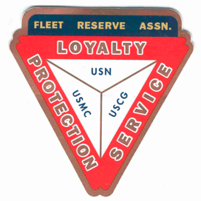­­­­­­­­­

**Board of Directors Meeting 1000 AM, October 26, 2022.** Present: Pres Lee Vatter, Sec Pat Winston, Treas David Johnson, Shipmates Daniel Angeles, Carl Schuelke, Jack Wilbanks, Rick Waite & John Stanton from the “Garage Grill”.

Present Branch 367 Membership is 123.

**Items discussed:**

* Branch 367 will invite a visting FRA Current Regional President and her Spouse to the 02 November GMM.
* October Two Bell Ceremonies presented by FRA Branch 367: Barry Larsen conducted 2 Bell on 05 October for Billy Neil Fitzcharles (RM3) at Clark Memorial Cemetary. Barry Larsen conducted 2 Bell on 18 October for Wallace L Howery (ETRSN) at Clark memorial Cemetary. Lee Vatter, Don Robbins, & David Johnson conducted a 2 Bell for Guillermo Acebedo (CPO USN Ret) at Ruby Memorial Park Cemetary.
* 2 Wreath’s will be purchased (approx p1100 ttl) from the Presidents Fund for 11 November, Veterans Day. They will be presented at ceremonies held at Clark Memorial Cemetary and a location in Barrio Baretto TBD.
* Today (26 Oct) the Annual local facility Propety Tax will be paid. (approxamitely P24,000). The monthly rental payment has also been submitted.
* LAFRA Unit 367 will present their Annual Halloween Party at 4pm on 31 October. Location is the Garage Grill, San Miguel.
* Thanksgiving Dinner Potluckwill be held on 24 November. The start time TBD (approx 1-2pm).
* Parking area gravel price will range p1000 – p1100 per sqm. 18 sqm minimum includes delivery.
* Thanksgiving Day Turkey Raffle tickets are avilable for P500. We are asking members to obtain approximate price quotes for apple and orange cases for Christmas Hospital Gifting.
* The next BOD Meeting is 30 November, & the next GMM is 02 November. Both meetings start at 10 am. The group discussion ended at 1024 am.

Submitted: Approved:

//S// //S//

Patrick Winston William “Lee” Vatter

Secretary President

Branch 367 Branch 367