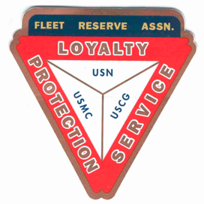

Board of Directors Meeting 1000 AM, December 28, 2022. Present: Pres Lee Vatter (by video), Sec Pat Winston, Treas David Johnson, Shipmates Dan Angeles, Tim Byrnes, Rick Waite, Carl Schuelke, Robert Krauth, John Corbin, Hayden Spalding, Gary Smith, Jack Wilbanks, & John Stanton from the “Garage Grill”.
Present Branch 367 Membership is 123.

Items discussed:
- Christmas Pot-Luck at the FRA was a great success on 21 December 2022 . The turn-out was as amazing as the food. Thank you LAFRA Unit 367 for taking charge of this event.
- Thank you FRA Branch 367 and LAFRA Unit 367 for your participation in gifting the San Marcelino Hospital on Christmas Eve. The Patients and Staff showed their appreciation for our efforts. See the Pictures on BOD Minutes email, Facebook, and frabranch367.com.
- Member Dan Angeles (FRAlic Shirt POC} will present an artist design in January 3023.
- On 21 December 2022, four FRA Br 367 four Officers and three Members agreed unanimously to gift p1K to each of the Garage Grill Employees (p8k total) for their annual Christmas Bonus.
- The next BOD Meeting is 28 January 2023, & the next GMM is 04 January 2023. Both meetings start at 10 am. The group discussion ended at 1013 am.

HAPPY NEW YEAR

Submitted: Approved:

//S// //S//
Patrick Winston William “Lee” Vatter
Secretary President
Branch 367 Branch 367

