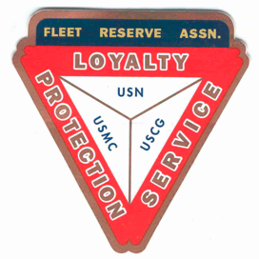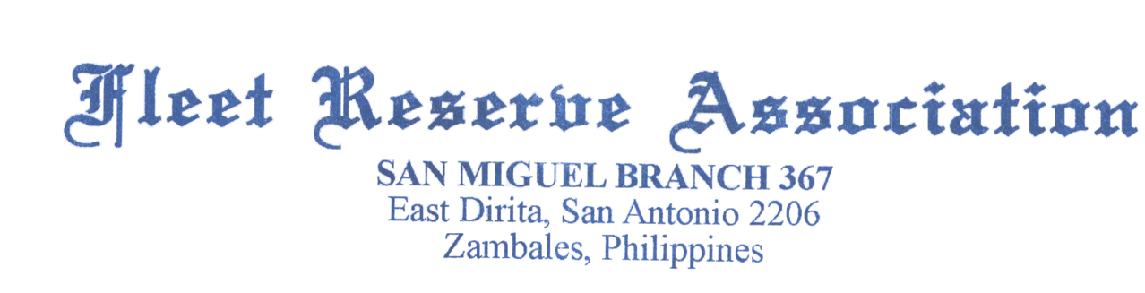

Board of Directors meeting 10 AM, December 29, 2021

Present: Shipmates Pres Lee Vatter, Vice Pre Bill Bay, Sec Pat Winston, Treas David Johnson, Rick Waite, John Moore, David Niemela, Jack Wilbanks & John Stanton from the “Garage Grill”.

Present Branch 367 Membership is 126.
Items discussed: The BOD meeting convened at 10am.

- Secretary Winston mentioned that the FRA finance department does not have current/valid Bank information for Branch 367. Our Treasurer will provide the info & submit to finance@fra.org and Misrak Zeleke misrak@fra.org. Option 2 is to submit a letter for a check to be sent to the Treasurer (signed by the President and mentioned on the GMM minutes).
- VA contact information can be found https://frabranch367.com/ under the CLAIM-COVID tab.
- We are asking local Members to step up for upcoming 2022 Branch Officer elections.
- Planning for April 2022 FRAlics needs to be addressed at each meeting. Topics are : Raffle Tickets (200 at p500 each), Shirts, Golf Tournament, Chili Cook Off.
- FRA San Miguel Property Taxes will be paid January (p13,000).
- Roger to conduct emergency generator operation after key switch is repaired.
- Minor Roof repairs are required at our Storeroom.
- Welcome Shipmate Enrique Silva, our newest Member to Branch 367.
- Barry Larsen conducted Two-Bell Ceremony on 9 December for Richard Allen Faulk DC1 USN at Clark Memorial Cemetery.
- FRA Branch 367 Members Lee Vatter and David Johnson delivered Fruit Cases (Apples/Tangerines) to San Marcelino Hospital on Christmas Eve. Thanks to the Br 367LAFRA Unit for their support too! See the picture below.
- December 23^{rd,,} Several FRA Br 367 played the Bobby Walker Golf Tournament at Pradero Verde Golf Course.
- December 23rd, LAFRA Unit 367 Members put on a successful Christmas Pot-Luck at FRA San Miguel.
- The next BOD Meeting is 29 December. The next GMM is 06 January 2021. Both meetings start at 10 Am.
The BOD group discussion ended at 1017 am.

Submitted: Approved:

//S// //S//
Patrick Winston William “Lee” Vatter
Secretary President
Branch 367 Branch 367
