­­­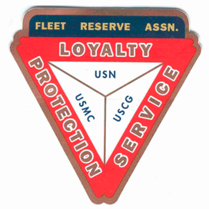

**Board of Directors Meeting 10 AM, June 29, 2022.** Present: Shipmates Pres Lee Vatter, Sec Pat Winston, Treas David Johnson, Shipmates Daniel Angeles, Rick Waite, & John Stanton from the “Garage Grill”.

Present Branch 367 Membership is 125.

**Items discussed:**

* Consider giving blood to support recent hospitaliztion of several local US Mitlitary Retirees.
* Shipmate Rick Waite received a quote for 18m3 north parking lot gravel (3/4 size) p19,260 delivered. John Stanton will help find workers to cut and remove plant overgrowth.
* Poseidon Beach Resort will create a Business Wall Add at their own expence.
* Secretary Winston enquired about the “1 year Moratorium on withdrawing any funds, distributing Life Membership Funds PCT funds to all Branches, and National FRA bank accounts until the Life Membership Program is in compliance.” We ill have to wait until the FRA National Convention addresses this issue in August.
* Repairs still needed: Tent Top repairs (split cost with VFW Post 11447) & minor roof leaks have been reported. Barry Larsen will look into cost of replacing Awning Material (on smaller tent).
* Secretary Winston mailed 40 Year Life Membership Certificate and Pin to Branch 367 member Kevin Kelley. He will also update Pins issuance for Local Membersat the July GMM.
* Treasurer Johnson has paid the FRA rent, and received a $656 check from Pat Winston to cover payment from Branch 367 Donors thru July 6, 2022. The Treasurer will look into receiving Member funds “electronically” into our Pilippine Bank accounts.
* The next BOD Meeting is 27 July & the next GMM is 06 July. Both meetings start at 10 am. The BOD group discussion ended at 1032 am.

Submitted: Approved:

//S// //S//

Patrick Winston William “Lee” Vatter

Secretary President

Branch 367 Branch 367