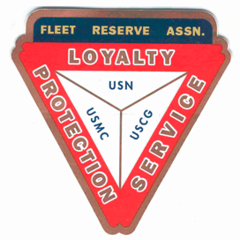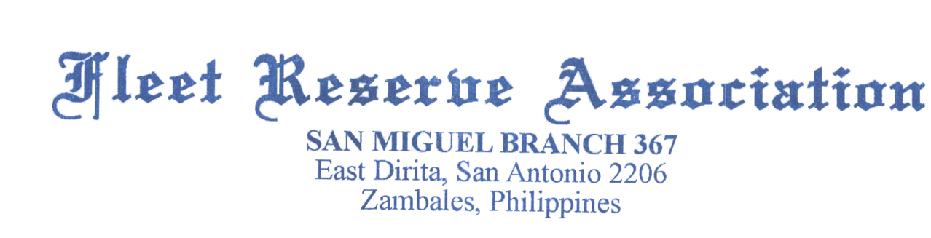

Board of Directors meeting 10 AM, April 27, 2022. Present: Shipmates Pres Lee Vatter, Vice Pres Bill Bay, Sec Pat Winston (video), Treas David Johnson, Shipmates Daniel Angeles, Rick Waite, & John Stanton from the “Garage Grill”.

Present Branch 367 Membership is 125.
Items discussed: The BOD meeting convened at 10am.

- FRA Br 367 Treasurer reported that the 2022 FRAlics was a great success. Thanks for all the support and contributions from Members, Family, and Friends.
- REPAIRS/REPLACEMENTS to be discussed at the 04 May GMM: Outside Bar Ceiling Flags, Roof leak, kitchen REF repair, four outside bar chairs, two Tent Top repairs (split cost with VFW Post 11447) & move speakers closer to outside bar.
- Memorial Day-Celebrate-Honor-Remember: A Wreath will be purchased for Clark Memorial Cemetary for approximatly p750 each to each of the 4 Service Organizations (FRA, VFW,PT11,AL4).
- Secretary Winston will submit PCT Dues Payment Check of $43.75 to RNW FRA. He is presently in the USA, thus making it easier and faster to submit payment.
- President Vatter and Vice Pres Bay performed a Two Bell Ceremony for deceased US Navy and US Army Veteran Edilberto "Boyet" Solano on 20 April, at Subic Cemetery IWAS.
- President Vatter and Mike Mummey (VFW Post 11447) performed a Two Bell Ceremony for ANSAC Day at the Palm Tree Resort on 25 April 2022.
- President Vatter and Treasurer David Johnson performed a Two Bell Ceremony for U.S. Navy Veteran Primo F. Gines at San Marcelino Cemetery on 26 April at the San Marcelino Public Cemetary.
- US Embassy Manila: The Philippine presidential and local elections are scheduled to be held on May 9, 2022. As the election nears, we remind U.S. citizens that foreign nationals are prohibited by Philippine law from engaging in partisan political activities in the country.
- FRA Branch 367 & LAFRA Unit will conduct Officer Installation at the 4 May GMM.
- FRA Branch 367 Selectees: Pres Lee Vatter, VP Bill Bay, Sec Pat Winston, Treas David Johnson.
  - LAFRA Unit 367 Selectees: Pres Fely Delay, VP Carmin “Mejo” Hendricks, Sec Cathy Campisi, Treas Malou Randolph. Officer Uniform will be Covers (all), Men (Barong, shorts), Unit (FRA Shirts, shorts).
- PayPal is unable to receive monetary Donations while Secretary Winston is out of country.
- The next BOD Meeting is 25 May & the next GMM is 04 May. Both meetings start at 10 am. The BOD group discussion ended at 1035 am.

Submitted: Approved:

//S// //S//
Patrick Winston William “Lee” Vatter
Secretary President
Branch 367 Branch 367

