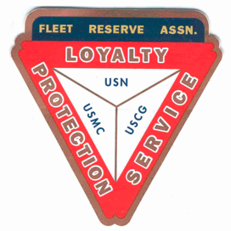

Minutes: Board of Directors meeting 10AM, December 23, 2020.

Present: Shipmates Lee Vatter, Tom Wickes, Pat Winston, David Johnson, Bill Bay, Dan Wilson, Carl Schuelke, Bill Castle, & John Stanton from the “Garage”.

Items that were discussed:

1. FRA Regional and National both wished Branch 367 a Merry Christmas and a Happy New Year.
2. The 500 Christmas Gift Bags are on track for complete delivery by Christmas Eve. Thanks to all (especially the LAFRA Members and friends. All 500 gift bags and 500 face shields were assembled in only 1 hr 45 minutes.
3. “For the Kids” Holiday money collection box was turned into the Treasurer (approx. 5,000p was raised).
4. Branch 367 should consider planning for April FRAlics and start by contacting the local Officials to discuss patronage allowed.
5. Rodger (Night Security) was overlooked when Christmas Bonuses were Voted on. President Lee paid his bonus from the Presidents fund. President Lee will be reimbursed from the Treasurer.
6. At the next GMM (Jan 8th), Secretary Pat will turn in all data to the Treasurer regarding, PayPal contributions, Gift Package purchases, office expenses, and the Go-Daddy FRA Website annual expense.
7. Treasurer David stated that all FRA monthly bills are up to date. John from the Garage is also up on monthly obligations.
8. Next GMM (8 January), We will vote on moving the GMM meeting from the 1st Friday to the 1st Wednesday of the month.
9. Turkey Raffle will be held today at 4pm.
10. Bill Bay stated he will seek Wall Add funding for 2021. VP Tom volunteered to pay for Dynamite Dicks Wall add. Secretary Pat will send a list of all 2019 & 2020 Member Contributor names to President Lee for wall identification.
11. Next BOD 27 January at 10AM. Next GMM is 08 January at 11AM.

Group discussion ended approximately 1028 AM.

Submitted: Approved:

//S// //S//

Patrick Winston William “Lee” Vatter

Secretary President

Branch 367 Branch 367