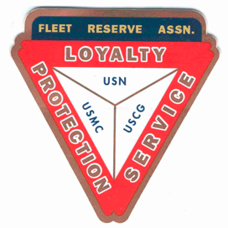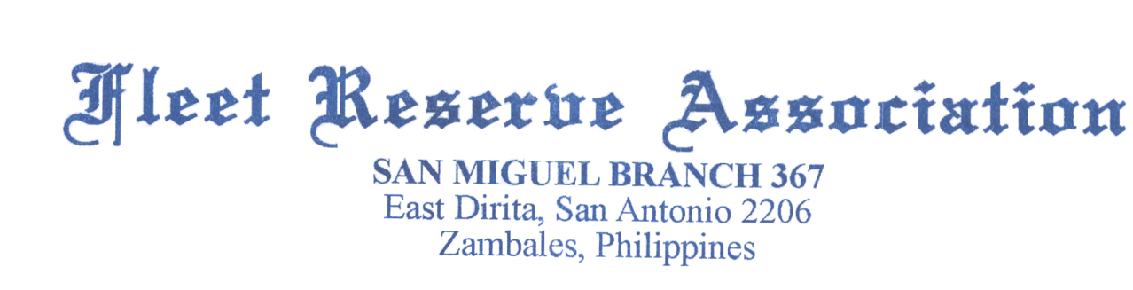

**Board of Directors meeting 10 AM, January 26, 2022**

Present: Shipmates Pres Lee Vatter, Vice Pre Bill Bay, Sec Pat Winston, Treas David Johnson, John Corbin, Hayden Spalding, Jack Wilbanks, Carl Schuelke, Barry Larsen & John Stanton from the “Garage Grill”.

Present Branch 367 Membership is 127.

**Items discussed:** The BOD meeting convened at 10am.

1. FRAlic Raffle Tickets for 2022 FRAlics are on Sale. All local members are expected to sell a minimum of 10 tickets. VFW Post 2485 (Angeles) will take 50 tickets to sell. Winners: 1st Prize is p30,000, 2nd Prize is p20,000. The drawing will be held 10 April, 2022.
2. Planning for April 2022 FRAlics needs to be addressed at each meeting. Topics to include, Shirts, Golf Tournament, & Chili Cook Off.
3. FRA National survey regarding FRA Branch recruiting was completed by Presdent Vatter and returned.
4. The 2022 Northwest Region Convention will be August 19-20, 2022, in the Spokane/Spokane Valley area.
5. The 2022 FRA/LAFRA National Convention will be held October 16-22, 2022, at the Hyatt Regency Birmingham.
6. FRA National sent an overdue Membership stipen check to the Treasurer $2,590. This fund will be used to pay rent for the next 6 months rent. Property Taxes were paid for 2021.
7. Thank you Barry Larsen conducting a Two Bell Ceremony for MRC Cortez at the Clark Memorial Cemetery on 16 Jan 2022.
8. We are asking local Members to step up for upcoming 2022 Branch Officer elections.
9. Roger tested the emergency generator operation after a new key switch was replaced.
10. Roof repair was partially complete in storage room, however, additional minor work is still needed above the stage area due to inadequate roof sheet overlap.
11. The next BOD Meeting is 23 February. The next GMM is 02 February. Both meetings start at 10 am.

The BOD group discussion ended at 1024 am.

Submitted: Approved:

//S// //S//

Patrick Winston William “Lee” Vatter

Secretary President

Branch 367 Branch 367