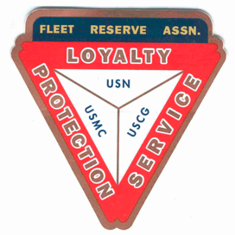

Minutes: Board of Directors meeting 1005AM, January 27, 2021.

Present: Shipmates Lee Vatter, Tom Wickes, Pat Winston, David Johnson, John Moore, Bill Bay, Carl Schuelke, , & John Stanton from the “Garage”.

Items that were discussed:

- President Lee Vatter has 200 FRAlics Raffle Tickets for sale (500p each). Don’t wait to make your purchase. John Moore paid p250 for pocket for Raffle Tickets.
- FRA Branch 367 Member Roger William Limle passed away 13 November, 2020. Barry Larsen will conduct a Two Bell Ceremony at Clark Cemetery. Lee Vatter stated that deceased names on our wall needs to be updated.
- April FRAlics Dates for Chili Cook Off and Beauty Contest have not been confirmed. Local Municipal approval is required.
- VP Tom Wickes stated that if you have a VA debt. Do not give up attempting to lower or eliminate you bill via an appeal. See Tom if you have questions.
- President Vatter and Secretary Winston will be sending out Solicitation Letters to all Members and Local Friends to raise funds for April FRAlics.
- Secretary Winston is looking up the PCT member Check amount due us this January.
- We need to continue updating up Branch 367 Bylaws. Volunteer if you want to help.
- At the next GMM, Pat Winston will motion to raise funds for eleven San Antonio Elementary School Printer.
- Secretary Winston purchased from pocket the Banner on the back to illustrate what Branch 367 accomplished during 2020. Thanks for everyone’s support.
- Treasurer David stated that all FRA monthly bills are up to date. John from the Garage is also up on monthly obligations.
- Next GMM is 03 February at 10AM. Next BOD 24 February at 10AM.

Group discussion ended approximately 1028 AM.
Submitted: Approved:

//S// //S//
Patrick Winston William “Lee” Vatter
Secretary President
Branch 367 Branch 367

