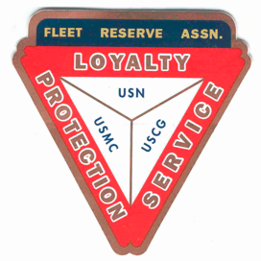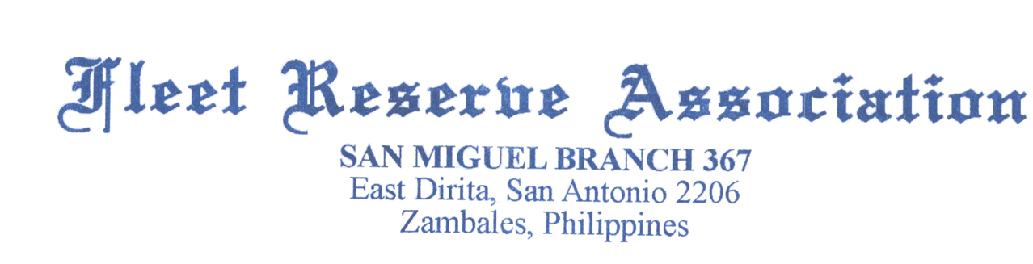

Board of Directors meeting 10 AM, March 29, 2022. Present: Shipmates Pres Lee Vatter, Vice Pres Bill Bay, Sec Pat Winston (video), Treas David Johnson, Rick Waite, & John Stanton from the “Garage Grill”.

Present Branch 367 Membership is 124.
Items discussed: The BOD meeting convened at 10am.

- Two Bell Ceremony for deceased Veteran Solano at 10am on 20 April, to be held at Subic Cemetery IWAS. Particiption & attendance is encouraged.
- The FRA Commemorative Coin Bill (HR 6663); FRA National urges Shipmates to use the FRA Action Center to weigh in on this issue. ( https://www.votervoice.net/FRA/campaigns/91704/respond)
- Meet the US Navy’s next MCPON: https://www.navytimes.com/news/your-navy/2022/03/10/meet-the-navys-next-mcpon/
- Suicide Prevention Study: please provide input if you receive this.
- US Embassy Manila: The 2022 Philippine presidential and local elections are scheduled to be held on May 9, 2022. As the election nears, we remind U.S. citizens that foreign nationals are prohibited by Philippine law from engaging in partisan political activities in the country.
- US Embassy Manila: Virtual Town Hall for U.S. Citizens in the Philippines 06 April 2022: Documenting Your Child as a U.S. Citizen. Hosted by the Embassy’s American Citizen Services (ACS) Unit. See below for FORM for Birth Abroad.
- LAFRA Triangle Newsletter (April 2022): Section 1405(a). Nominations for Unit Officers shall be opened at a meeting in March, April, or May, as specified by the Bylaws of each Unit. They remain open until a meeting in the month following opening of nominations, then closed, and officers elected for a period of one year, except that Secretaries and Treasurers may be elected for a period of two years.
- FRAlic Pre-Event Meeting is 6 April. Most of the FRAlic Raffle Tickets for 2022 FRAlics have been sold. The drawing will be held 10 April, 2022.
- FRAlic Golf Tournament POC’s are Hayden Spalding and Scott Paul. 2020 Shirts are for sale for 600php, older shirts are 500php.
- Pinatubo Craft Beer will be for sale at our FRAlics. For take home only, by the case.
- Gary Campisi; help with welder for FRAlic tent repair.
- Thank you Bobby Woodell for $100 contribution for FRAlic’s fundraiser (PayPal)
- We are asking local Members to step up for upcoming 2022 Branch Officer elections.
- Treasurer received $208.34 check for monthly membership stipend from FRA National.
- The next BOD Meeting is 30 April The next GMM is 06 April. Both meetings start at 10 am. The BOD group discussion ended at 1019 am.

Submitted: Approved:

//S// //S//
Patrick Winston William “Lee” Vatter
Secretary President
Branch 367 Branch 367

US Consular Report for Birth Abroad: https://forms.office.com/Pages/ResponsePage.aspx?id=dFDPZv5a0UimkaErISH0S_Yl5wUu9eFMgyaP8VRieBVURDhWU09WOE8wOE1TQ1lJNUtGR0dXRTk5Ri4u

