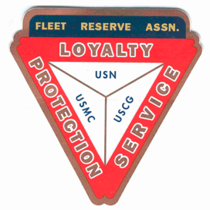

Board of Directors Meeting 10 AM, May 25, 2022. Present: Shipmates Pres Lee Vatter, Vice Pres Bill Bay, Sec Pat Winston (video), Treas David Johnson, Shipmates Hayden Spalding (video), John Corbin, Daniel Angeles, Rick Waite, & John Stanton from the “Garage Grill”.

Present Branch 367 Membership is 125.

Items discussed:
- Consider giving blood to support recent hospitalized Branch Members: John Moore at Baypoint, Tom Burnett at St Jude. Please keep them in your thoughts and prayers.
- John JR Walsh: recently deceased. Homicide investigation is in progress.
- Shipmate Rick Waite has volunteered to look into the cost of expanding gravel in the parking lot on the north side of the property in a way that would limit rapid plant overgrowth.
- Repairs still needed: Tent Top repairs (split cost with VFW Post 11447) & move speakers closer to outside bar. Bill Bay completed repair roof leak.
- Memorial Day-Celebrate-Honor-Remember: Wreaths (p525 each) have been purchased for Clark Memorial Cemetary by each of the 4 Service Organizations (FRA, VFW,PT11,AL4). Clark Memorial FRA Reps Barry Larsen, Dan Wilson, Dave Niemela. Arizona Memorial (wreath p500): FRA Reps Lee Vatter, David johnson.
- Treasurer Johnson has paid the FRA rent and Daniel Angeles has received his ceremonial Barong.
- The next BOD Meeting is 29 June & the next GMM is 01 June. Both meetings start at 10 am. The BOD group discussion ended at 1035 am.

Submitted: Approved:

//S// //S//
Patrick Winston William “Lee” Vatter
Secretary President
Branch 367 Branch 367

