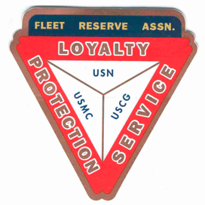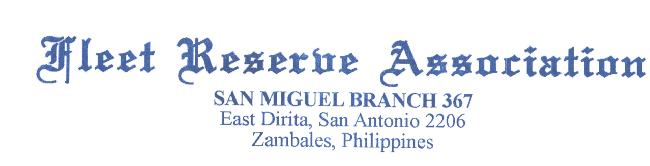

Minutes: Board of Directors meeting 10AM, November 25, 2020. No votes were conducted.

Present: Shipmates Lee Vatter, Tom Wickes, Pat Winston, David Johnson, Bill Bay, Carl Schuelke, & John Stanton from the “Garage”.

Items that were discussed:

1. November 11. Lee Vatter & Pat Winston attended Veterans Day Ceremony at Baloy Beach, Lagoon Beach Resort with the RSL. Barry Larson attended Veterans Day Ceremony at Clark Cemetery. Two Wreaths were presented in behalf of FRA Br 367.
2. Branch 367 Constitution and Bylaws were placed on a memory Stick and issued to Officers, Dan Wilson and Hayden Spalding for amending.
3. Pat Winston has requested “Payments Received Report” one time audit & rebate check distribution from FRA National two times a year.
4. The 500 Christmas Gift Bags are on track for assembly and distribution. We will set a date to assemble all 500 bags at the next GMM.
5. President Lee Vatter has made the annual property Tax payment.
6. Turkey Raffle: Only 34 tickets remaining for 1st & 2nd  prize “Smoked Boneless Turkeys, 3rd prize is now a Frozen 12lb Butter Ball uncooked Turkey. Raffle drawing date is 23 December.
7. There is no Thanksgiving or Christmas Party scheduled for 2020.
8. Get your TriCare updated. It is not Automatic. 1-877-451-8659 Option #1, or toll free at +6563392676.
9. Barry Larson purchased 8 FRA Garrison Covers.
10. Treasurers report was read by David Johnson. Rent is up to date.
11. Next BOD 23 December at 10AM. Next GMM is 04 December at 11AM.

Group discussion ended approximately 1024 AM.

Submitted: Approved:

//S// //S//

Patrick Winston William “Lee” Vatter

Secretary President

Branch 367 Branch 367