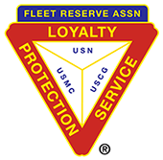

FRA BRANCH 367 San Miguel, San Antonio, Zambales

**MINUTES: General Membership** Meeting May 5th, 2021 was called to order by President Vatter at 10:00 am. In attendance were 8 members and John Stanton from the “Garage”. PRESENT: Lee Vatter, Tom Wickes, Pat Winston, David Johnson, Bill Bay, John Moore, Dan Wilson, Gary Campisi.

**CONDUCTED OPENING CEREMONIES:**

Gary Campisi motioned to approve the April GMM Minutes, Bill Bay 2nd the motion. The GMM was approved unanimously. The April 28 BOD Minutes were read during “New Business” to ensure all topics were covered.

**MEMBERSHIP:** Current membership total remains at 127.

**COMMUNICATIONS:**

* “Saved Lives Act”. Covid Vaccines for VA Spouses and Caregivers. Sign up and standby for a call.
* **Options for Notary Services** during the Ongoing COVID-19 Pandemic: Specific for the Philippines https://ph.usembassy.gov/message-for-u-s-citizens-options-for-notary-services-during-the-ongoing-covid-19-pandemic/
* **ANZAC Remembrance Day** was held at the Palm Tree Resort, 25 April. A big thank you to all Branch 367 Members that participated and attended the ceremony.
* US Passports can now be paid for online using numerous pay services. See US Embassy. <https://ph.usembassy.gov/u-s-citizen-services/passports/renew-an-adult-passport/>

**STANDING COMMITTEE REPORTS:**

* **Secretary**: The Secretary has submitted the Election of Officers Report for Branch 367 and the LAFRA Branch Unit. He will also work to receive PCT funds transfer into our dollar account.
* **Treasurer**: The Treasurer Report was read by David Johnson. Gary Campisi motioned to accept the Treasurers report, Pat Winston 2nd the motion. Approved unanimously. Rent is paid to date.
* **Wall adds:**  Wall Adds are presently on hold until 2022.
* **Building Maintenance**: Back lot grass cutting is on hold.
* The **FRAlic** Golf Tournament is on hold.
* **Canteen:** John Stanton from the “Garage Grill” stated that the social distancing policy are still in effect. All minor repairs have been completed.

**UNFINISHED AND DEFERRED BUSINESS:**

* Pat Winston motioned to produce 60 total face masks to issue to the FRA Region North West Convention attendees as part of a ditty bag. One side of the face mask will display FRA Branch 367 Logo and San Miguel Philippines. The other side will display the American and Filipino Flags. Cost will be 60peso each. Dan Wilson Second the motion, Approval was unanimous.
* Bill Bay motioned to install Security grills to 6 doors and 13 windows at FRA San Miguel for $1770 USD. Tom Wickes 2nd the motion. Approved unanimously. We will ask Dr Ramos (Property Owner) to assist with cost.
* Gary Campisi motioned to repair and replace rain/shade roofing at the East Dirita Elementary School. Material and labor for the U-Shape structure is p120k (approx. $2500). Pat Winston 2nd the motion. Approved unanimously. Local Members will be expected to check in on the job daily (2-3 weeks). Volunteers Members please wear a FRA Hat/Shirt when you check in on the work & take a picture with the Contractor/Foreman.
* Thanks to David Johnson for getting multiple estimates on the FRA grill work and the school roofing projects.

**NEW BUSSINESS**

* Bill Bay volunteered to replace Tom Wickes as Brach 367 Vice President. Lee Vatter, Pat Winston, David Johnson agreed to continue with their current Officer positions. Hayden Spalding motioned to accept, 2nd by Bill Castle, and the VOTE was approved unanimously.
* 2021-2022 Officer installation was held. Dan Wilson was the Installing Officer.

|  |  |
| --- | --- |
| **FRA Branch 367**  President Lee Vatter  Vice President Bill Bay  Secretary Pat Winston  Treasurer David Johnson | **LAFRA Branch 367 Unit**  President Ofelia Moore  Vice president Carmelita Hendricks  Secretary Alona Wickes  Financial Secretary Desiree Sandoe  Treasurer Violita Randolph |

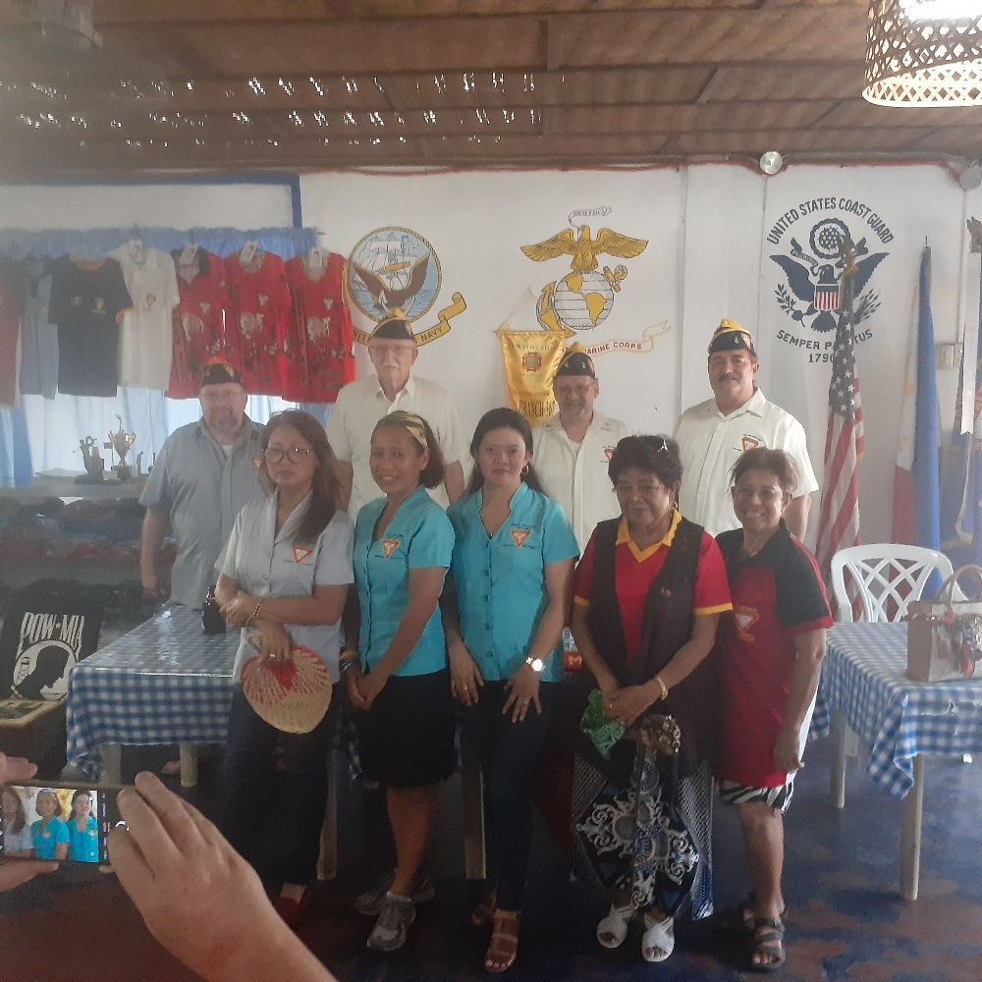

**GOOD OF THE ORDER**

* Branch 367 Members are encouraged to support other Service Organizations. VFW 11447 meets 2nd Wednesday of the Month. MOC meets 1st Thursday of the month.
* Members do at least one good deed each year to represent our group in San Miguel.
* Thank you Robert Krauth for the fan purchase in the patio.
* Thank you Chris from the Car Wash Restaurant for $100 donation to FRA Br 367. If you go there and have lunch, look up and you will see a very large American Flag displayed overhead.
* Next FRA 367 BOD meeting will be 26 May at 10:00am.
* Next FRA 367 GMM will be 2 June at 10:00am.

**CONDUCTED CLOSING CEREMONIES:**

Meeting adjourned at 1112am.

Submitted by: Approved by: //S// //S//

Patrick Winston William “Lee” Vatter

Secretary President

FRA Branch 367 FRA Branch 367