

FRA BRANCH 367 San Miguel, San Antonio, Zambales

**GENERAL MEMBERSHIP MEETING** on June 2nd, 2021 was called to order by President Vatter at 10:00 am. In attendance were 10 members and John Stanton from the “Garage”. PRESENT: Lee Vatter, Bill Bay, Pat Winston, Tom Wickes, David Johnson, Bay, John Moore, Dan Wilson, Gary Campisi, Carl Schulke, Patrick Howerton.

**CONDUCTED OPENING CEREMONIES:**

**MINUTES:**The Minutes from the May GMM and BOD had been posted and distributed.No changes were made. Motion to accept the GMM was made by David Johnson and Bill Bay seconded the Motion. The BOD Minutes was read by the Secretary. Motion to accept the May BOD minutes was made by Patrick Howerton, Tom Wickes seconded the Motion. The GMM and BOD minutes were approved unanimously.

**MEMBERSHIP:** Current membership total remains at 126.

**COMMUNICATIONS:**

* Secretary read briefly from the FRA Newsbytes Newsletter this is posted on our bulletin board. The topic was Veterans Toxic Exposure Bill with Hypertension from Agent Orange.
* US Embassy Note: Keep your Passports up to date for travel. Emergency Passports take 2 weeks.
* DFAS want everyone to receive documentation electronically vice mail.

# **Philippine Red Cross eases burden on hospitals under siege as COVID-19 cases hit 1 million** https://www.cnnphilippines.com/news/2021/5/17/Philippine-Red-Cross-Moderna-COVID-19-vaccine.html

* **Information no-cost Moderna Covid-19 Vaccine** https://www.cnnphilippines.com/news/2021/5/17/Philippine-Red-Cross-Moderna-COVID-19-vaccine.html
* **Philippine Red Cross - Moderna Vaccination Pre-Registration. NO COST** https://vaccines.redcross.org.ph/

**STANDING COMMITTEE REPORTS:**

* **Secretary**: The Secretary will be receiving the 11 Canon Printers in June for distribution to the San Antonio Elementary Schools. PayPal contribution funds of will be paid to the Treasurer before the 20 June GMM.
* **Treasurer**: The Treasurer Report was read by David Johnson. Dan Wilson motioned to accept the Treasurers report, Gary Campisi 2nd the motion. Approved unanimously. Rent is paid to date. Our Landlord authorized non-payment of the July Rent to help pay for the security bars on window and doors.
* **Wall adds:**  Wall Adds are presently on hold until 2022. Our POC is Bill Bay.
* **Building Maintenance**: Back lot grass cutting is on hold.
* The **FRAlic** Golf Tournament is on hold.
* **Canteen:** John Stanton from the “Garage Grill” stated that the outside seating area is open as of today, however, social distancing policy id still in effect. There is a small section of broken tile behind the bar that allows water leakage into the cabinet. Pat Winston will provide adequate granite tile and adhesive for the repair.

**UNFINISHED AND DEFERRED BUSINESS:**

* Repair and replacement of the rain/shade roofing at the East Dirita Elementary School will start June. Thank you Bill Castle and Tom Wickes for the great photos/video for drone footage of the repair area. Funds have been raised for material and labor. Branch 367 Members will monitor the work once per daily. Volunteer Member Requirements: please wear a FRA Hat/Shirt when you check in with the Foreman. Send a picture of you with the Foreman to David Johnson to prove you showed up for the assigned task. Project will take 2 or 3 weeks. 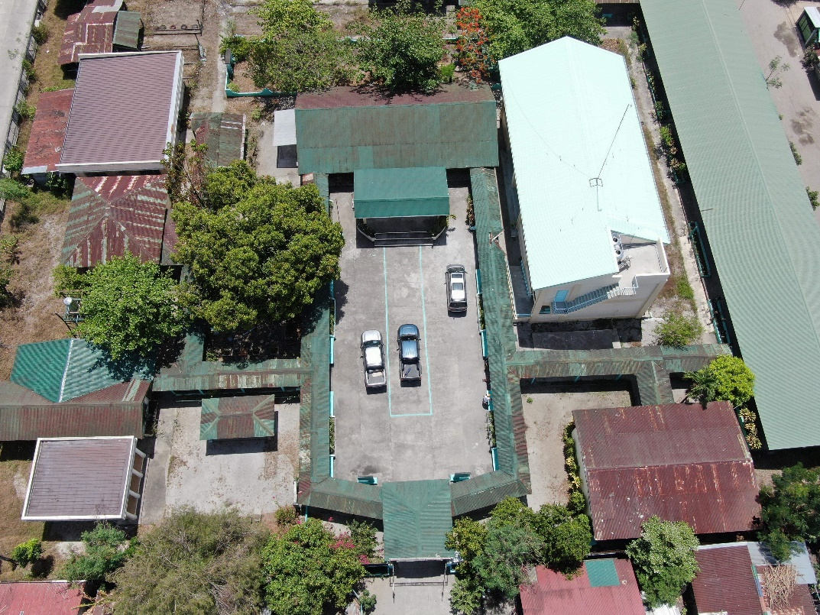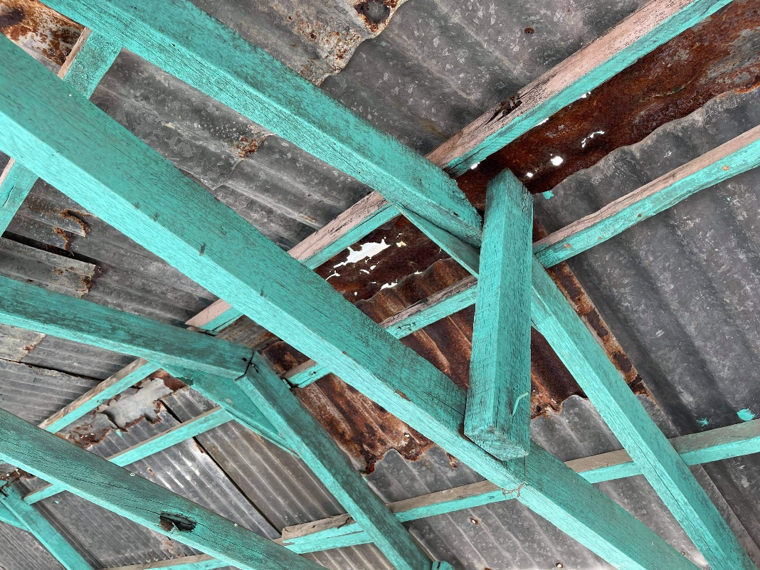

**NEW BUSSINESS**

* LAFRA President mentioned that there will be a Holiday Raffle to be held around the end of October. There was a mention of a Halloween Party, Zumba, and Ballroom Dancing. More details to come.

**GOOD OF THE ORDER**

* President Lee Vatter and Vice President Bill Bay conducted a Two Bell Ceremony for the passing of Shipmate EOC Rodney M. Yost at today’s BOD meeting.
* Thank you Shipmate Barry Larsen for presenting a wreath Memorial Day at Clark Veterans Cemetery.
* Branch 367 Members are encouraged to support other Service Organizations. VFW 11447 meets 2nd Wednesday of the Month. MOC meets 1st Thursday of the month.
* Members are urged to do at least one good deed each year to represent our group in San Miguel.
* Next FRA 367 BOD meeting will be 30 June at 10:00am.
* Next FRA 367 GMM will be 7 July at 10:00am.

**CONDUCTED CLOSING CEREMONIES:**

Meeting adjourned at 1052am.

Submitted by: Approved by: //S// //S//

Patrick Winston William “Lee” Vatter

Secretary President

FRA Branch 367 FRA Branch 367