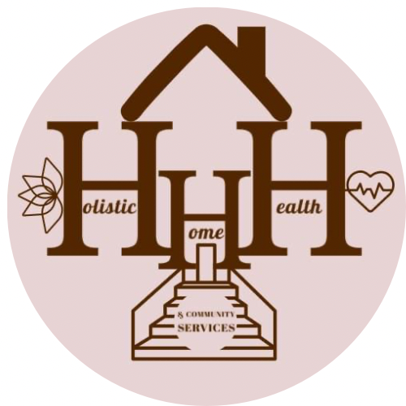
Holistic Home Health & Community Services, is an In-Home Care Agency, has been actively helping in the community for only a few months now, however our company is vastly growing. We provide unique and individualized care to elderly and disabled persons. We assist with ADL’s such as bathing, grooming, eating, transferring, etc. We also provide trusted Companionship that you can rely on as well as confide in. We offer Light Housekeeping such as vacuuming, taking out trash, laundry, and washing dishes. Meal Preparation, Medication Reminders and Errands are also included in our services. Our mission is to provide safety, security and superior care needed to accommodate your loved one all from within the comfort of their own home. We have a dedicated team of Aides ready to assist with all of your needs. We want to be able to keep your loved one at home and involved in their care as much as possible for as long as possible. It can be tough caring for a loved one, we are very aware that it can sometimes become a full-time job. Holistic Home Health & Community Services is here to help alleviate some of the stress and worry that may come along with that. Please visit our website at HHHCommunityServices.com or contact Briona Wilson at 402-707-1053 with any questions on how we can help you or your loved one. We’re here to bring a Hol’ lot of Care.

Services
•Personal Services (ADL’s/ & IADL’s)
ADL’s; •Bathing, Grooming, Dressing,Safe, supported mobility and transfers, Eating daily meals and snack Managing toileting needs or incontinence
IADL’s;

