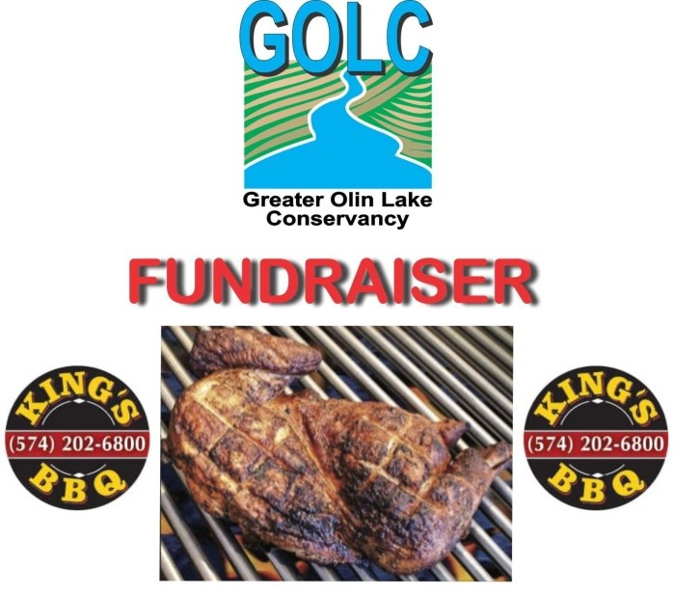
Fill out this order form and mail with your payment to:
GOLC CHICKEN FUNDRAISER
1110 E 455 S
LaGrange, In 46761
Orders must be received no later than Monday June 13th, 2026
DO NOT HESITATE! PLACE YOUR ORDER TODAY. EAT WELL AND KEEP OUR LAKES CLEAN!
We are taking orders for pickup on June 20th, 2026 after the Oliver & Martin Lake Association meeting.
Full Name__________________________________________
Address___________________________________________
City_____________________State_________Zip__________
Phone#_____________________________________
Email ______________________________________
Credit card#_________________________________________
Credit card expiration date:_______/________
Credit Card Security code#___________
Quantity Chicken Halves Ordered =_______x $9.50ea = Total payment enclosed
$_______________________

