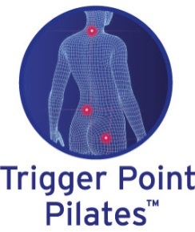

Please complete the following carefully (and write clearly). All the details below are confidential.

Full name……………………………………………………………………… DOB……/………/………

Address……………………………………………………………………………………………………..

Postcode…………………………………………Contact telephone……………………………………

Email……………………………………………...Occupation……………………………………………

Children………………………………………….. Relationship Status………………………………....

GP…………………………………………………GP telephone……………………………………..….

How active is your lifestyle? How often do you train? What is your current exercise / sport activity?

Do you have a recurring old injury? Or suffer from chronic pain?

Are you taking any medication? ………………… smoker?...................Supplements?...................

What diet are you on? healthy or random?

Can you relax? Do you make time to relax? How well do you sleep?

What are your current stress levels? High / Moderate / Low

Do you suffer from headaches / migraines?

Are there any other conditions currently being treated by your GP?
What is your past injury?/accident history?

Have you recently suffered from or do you suffer from any of the following? If yes please give details

Have you had recent surgery/injury? If yes please give details

Do you suffer from a chronic painful condition? If yes please give details

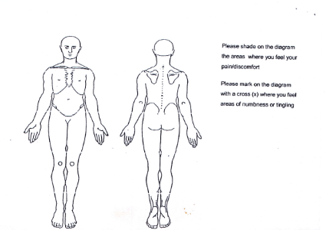

Do you suffer from dizziness / fainting?

Have you recently had a kidney / bladder infection?

Have you recently had an infectious disease?

Do you suffer from any skin allergies or contagious skin rashes?
Please circle any conditions below that are relevant

Tiredness / ME

Skin Conditions eczema / psoriasis / acne / athletes foot / sunburn

Stress / tension / anxiety / depression / epilepsy

Breathing conditions / asthma / hayfever / chronic cough / sinus problems

Circulatory HBP/ LBP / heart condition / fluid retention / varicose veins / cold extremeties

Have you currently suffered from weight loss / gain / indigestion / constipation / abdominal pain

Muscular conditions arthritis / rheumatism / gout / stiff joints / osteparosis / cramps / sprains / strains

Glandular conditions throid high/low / diabetes / adrenal / hormonal

Immune system conditions – are you prone to infections / colds / sore throats / chest

Females

How many pregnancies have you had?.............. How many children have you had?....................

Did you have difficulty with delivery?...................If yes what?.........................................................

Have you had a ceasarian section?.................

Since having children, have you had chronic pain in the back / hips / pelvis / shoulders / neck?

Do you consider yourself Perimenopausal?.……..Menopausal?.........Post Menopausal?.............

Are you still having regular periods? Yes / No

I have read the above and confirm that I do not suffer from any other conditions that may prevent me from attending a TPP class. I will keep my instructor informed of any changes in my health.

Signature………………………………………………..Date…………………………………….……….Instructor Signature ……………………………………………………………………………….………

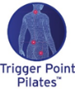Welcome to Trigger Point Pilates™ this class has been created from years of clinical work and Pilates teaching experience by Lydia Campbell, a Fitness Industry expert of over 40 years. She created Trigger Point Pilates for fascia health to cater for chronic painful conditions and scar tissue. The programme has just been released after thirteen years of her own research from clinical work and TPP class teaching. Including her own personal rehab journey and living with osteoarthritis after years of intense exercise and professional dance...
A Trigger Point Pilates™ class combines Pilate’s core moves and applies clinical Myofascial principles to help alleviate chronic pain conditions. The class is designed to release tight muscles and enhance functional daily movement,and restructure the body. This class attracts everyone from the elite fit to the post rehab. Fascia restrictions occur in everyone, whatever their age, activity or level of fitness. Equipment is used to release and re align the body which you can buy from your instructor to exercise at home.
What is Myofascial Myo = Muscle and Fascia means a continuous band of connective tissue wrapping around and throughout the body. Think of the transparent tissue you see when you remove the skin of a chicken. That transparent film is fascia; our bodies are made of fascia. This is what we are working on to release in class. There is a massive science on using Myofascial release for chronic painful conditions and scar tissue through Myofascial work. Fascia is the system of connective tissue that lay just under the surface of our skin. Under a microscope, fascia is highly organized tissue filled with water, and its job is to attach, stabilize, enclose and separate muscles and internal organs.
It is highly sensitive as it is full of nerve cells, sensitive to every hormone in your system. With every repetitive functional movement, the fascia reacts to every bump, bruise, physical and emotional trauma. A build-up of fascia cells creates inflammation, a nagging deep painful area known as Trigger Points in the body. Referral pain can occur in the body from a nerve run from one area to another part of the body where a Trigger Point may be.
In class there are many exercise sections where we work deeply on releasing into the deeper layers of fascia targeting the release of Trigger Points. Healthy fascia needs to be kept hydrated with water and movement. This allows the body tissue to change and heal. The worst thing you can do is sit around in a chair all day, even if you are injured or post-operative or live with a chronic painful condition. .
Think of fascia as a transparent cling film, a cob web covering every muscle, a web of 3dimensional connective tissue. This multi-dimensional matrix surrounds, intertwines, protects, and supports every part of the body. Fascia is wrapped throughout the body on "lines of pull." Think of one piece connecting from the brow to your toes, fingers to chest and neck. Fascia creates our form, shaping and supporting us. The Medical world is finally acknowledging that fascia restrictions cause chronic pain conditions. Yet in a clinical check fascia restrictions cannot be seen on most MRI ‘s or X-rays. Superior MRI scanners and Ultra sound used in research programmes can see fascia, unlike current hospital equipment. The more we discover about fascia the more we understand how important it is to every cell in the body for health...
Injury or trauma outward and inward to the body, for example a fall, a collision, surgery, repetitive physical stress to emotional stress affects the fascia system. The body movement affects fascia health. Trauma causes fascia adhesions to form a chronic pain, a change in joint motion (scar tissue) to change in bodily functions from digestion to elimination, headaches, arthritis including osteoarthritis, to fibromyalgia.
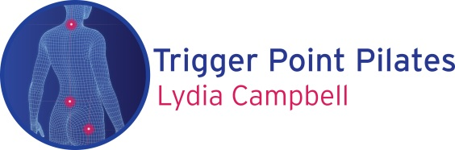

General Trigger Point Pilates class information

TPP release is ideal for everyone however fit and effective for pre and post surgery after your Physio check. Many of the exercises you can do at home to gain constant benefits of fascia release.
Wear comfortable clothing that is not too tight to move in, wear socks or Yoga shoes in class if you have a skin/foot condition. Please bring a small towel to use in class and water to drink.
The fascia release can stimulate the bladder, please do not feel embarrased to go to the loo.

In class or after class you may experience some of the following:-

1 Working on equipment you can feel discomfort / burning / cracking / popping / a tearing feeling. These are only temporary while the fascia is being released. As the fascia releases using your body weight you are slowly working deeper and deeper on certain areas on your body.

2 If you have any sharp, shooting, electric nerve pain, this is a sign that something is wrong. Please inform your instructor.

3 After class you may feel extremely relaxed, body lengthened and your joints released. A sense of feeling taller. You may notice a sudden burst of energy as your body is working more efficiently. Just do as you feel but don’t go crazy as your body is adjusting.

4 You could feel that you just want to rest and sleep, listen to your body as this is a healing time. You may notice mild discomfort from headaches to sweating to the body getting hot. Again this is a reaction to the fascia releasing.

5 You may notice a mood change. As feel good factor hormones have been released in your system but you can be abit sensitive. If this is the case make time for yourself to do deep breathing.

6 You may notice a change in your appetite and start craving foods that your body is lacking nutritionally. Listen to your body, feed it foods that are going to assist with healing and cellular regeneration.

7 You can feel headachy or a deep ache due to the body re-structuring itself and toxins being released via your lymphatic / nervous system. This will pass just keep well hydrated.

How often should you do a class?

It is a good idea to do two to three Trigger Point Pilates classes a week. And you can exercise daily at home with the right equipment. You can buy equipment directly from your instructor for home use.

The class will actually prepare your body and warm you up to do more strenous exercise such as dance, jogging and the gym.

