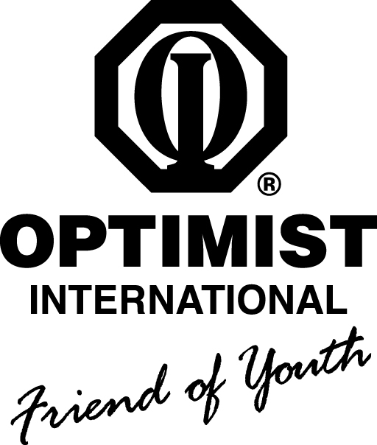
_{Harper Creek Optimist Club}

Grant Application 2018-2019

Information & Guidelines:

Grants from the Harper Creek Optimist Club are for individuals and organizations within the community and financially help serve the needs of the applicants with an emphasis on youth. Grants will be voted upon monthly by the Club Board of Directors and if approved the monetary value may or may not be the complete amount of the request. The typical approved amount is generally more for a group versus an individual. An individual or organization may submit more than one application and please allow up to a month for correspondence from our club. If approved, it is recommended that recipients attend a Harper Creek Optimist Club meeting to accept their monetary funds and explicate their mission. Upon conclusion of the project, our club would also appreciate a brief presentation from the recipient summarizing the experience. After completion of this form: please submit to a Harper Creek Optimist Club member, fax to 269-979-1562, or email to camod@comcast.net.

Date of Application:

Requesting Individual or Organization:

Contact Person:

Phone#: Email: Fax#:

Address of contact:

Amount of Request:

Total Project Budget:

Briefly summarize the purpose of your request:

Please note the objective of this program/project:

Who will benefit from your program/project?

Describe the funding options and plans for attainment with respect to your mission:

Has the Harper Creek Optimist Club funded your organization in the past?

If so, how recently?

