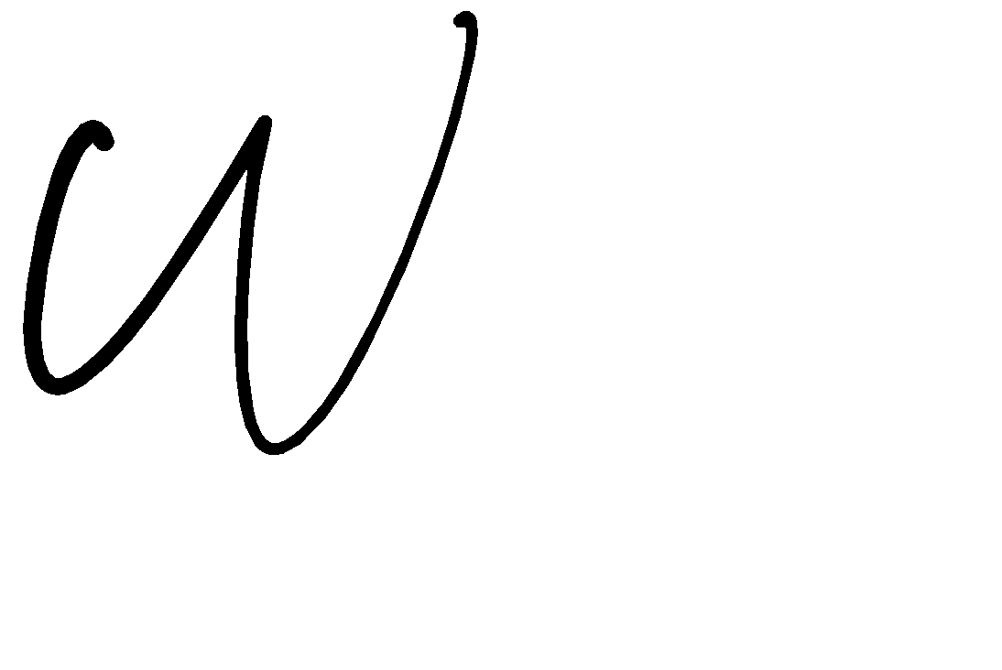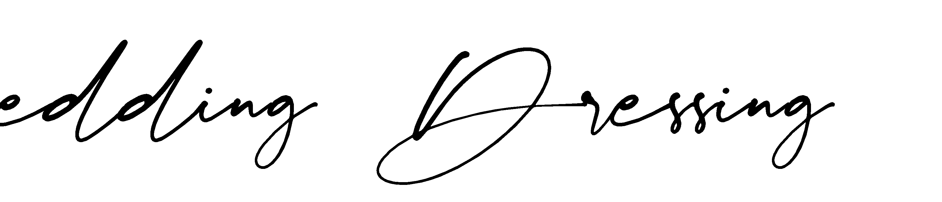

# BOOKING FORM & PAYMENT INFORMATION

Thank you for choosing Marry Me Cyprus Ltd to provide your Wedding Day with Dressing, Hire & the Finishing Touches for your Special Day! To ensure that we understand your specific requirements and order, we ask that you kindly complete the below booking form information and for anything bespoke or more specific, to complete the ‘Additional Information’ section at the end.

Once you have completed the Booking Form, we ask that you are able to return this to us at: [orders@marrymecyprus.co.uk](mailto:orders@marrymecyprus.co.uk)

There will be 2 Options we ask you to choose from to select your service:

1. Reserve your Date for €100.00 Reservation Fee

An invoice will be sent to you for a non-refundable reservation fee to secure Marry Me Cyprus for your Day. You will then be able to place your order anytime from this date. The reservation deposit will be deducted from your final invoice. We advise you that any of our large items like Dancefloors, Lights and Arches – you request on your order form as soon as you know what you would like. When your remaining order is placed an additional deposit may be required (up to maximum of 20% of your order, less already paid deposit, as per option 2)

1. Already Know What You Would Like? Confirm Your Order with us for your Day

If you know what you would like for your day, then simply place your order with us and you will be required to pay a 20% non-refundable reservation fee to confirm service. Final numbers for guests can be submitted to us before final payment is due and the guest’s numbers and packages will be adjusted accordingly.

An invoice will be generated for you when booking option 1 or 2. All reservation fees made are subject to your agreement to our Terms & Conditions of Service and are non-refundable.

I WOULD LIKE TO BOOK: OPTION 1 **** PLEASE TICK BOX

##  Reserve my date for €100.00 – I will add onto the order when I know what I would like.

I WOULD LIKE TO BOOK: OPTION 2 **** PLEASE TICK BOX

 I know what I would like and can order now.

TERMS & CONDITIONS OF SERVICE

You are kindly required to read through the terms and conditions of business detailed on this booking form. placing an order and making payments appertaining to an order is acknowledged as acceptance of the terms and conditions as detailed. please note all items are hire only. any breakages, theft or non-returned items will be your responsibility to cover costs to repair or replace.

We Look Forward to Dressing Your Day, With Love from

KATIE & THE TEAM AT MARRY ME CYPRUS

# xxxxxxxx

CLIENT INFORMATION

|  |  |
| --- | --- |
| Name of Bride & Groom |  |
| UK Address |  |
| Telephone Number (When in UK) |  |
| Telephone Number (When in Cyprus) |  |
| Email Address |  |

WEDDING DAY INFORMATION

|  |  |
| --- | --- |
| Date of Wedding |  |
| Wedding Ceremony Venue |  |
| Within Resort Ceremony Area |  |
| Time of Wedding |  |
|  | |
| Wedding Reception Location |  |
| Time of Reception |  |
| No of Attendees to Wedding |  |
| Colour & Design Theme |  |
| Wedding Booked with a Tour Operator | YES / NO DETAILS: TEL NO: |
| Wedding Booked with a Planner | YES / NO DETAILS: TEL NO: |
| Confirmed Authorisation of Venue Acceptance | YES / NO |

OPTION 1 – RESERVE THE DATE

|  |  |  |  |  |
| --- | --- | --- | --- | --- |
| RESERVE THE DATE | | | | |
| ORDER NUMBER | | DESCRIPTION | WEDDING DATE | PRICE |
| ▪ | RESERVE THE DATE | RESERVE YOUR WEDDING DAY WITH MARRY ME  CYPRUS – NON REFUNDABLE DRESSING & DÉCOR RESERVATION FEE |  | €100.00 |

OPTION 2 – ORDER REQUIREMENTS

|  |  |  |  |  |  |
| --- | --- | --- | --- | --- | --- |
| ORDER REQUIREMENTS | | | | | |
| ORDER  NUMBER | PAGE  NO | DESCRIPTION | NO  REQUIREMENT | COLOUR | PRICE |
| ▪ | PLACE MY ORDER | PLACE MY ORDER.  NON REFUNDABLE DRESSING & DÉCOR RESERVATION FEE DUE ON ORDER | | | |
| CVD-DP-01  EXAMPLE | | Diamond Dressing Package 20 Guests  Centrepieces: CP07 EXAMPLE | 1  EXAMPLE | Coral &  Ivory | €160.00  EXAMPLE |
|  |  |  |  |  |  |
|  |  |  |  |  |  |
|  |  |  |  |  |  |
|  |  |  |  |  |  |
|  |  |  |  |  |  |
|  |  |  |  |  |  |
|  |  |  |  |  |  |
|  |  |  |  |  |  |
|  |  |  |  |  |  |
|  |  |  |  |  |  |
|  |  |  |  |  |  |
|  |  |  |  |  |  |
|  |  |  |  |  |  |
|  |  |  |  |  |  |
|  |  |  |  |  |  |
|  |  |  |  |  |  |
|  |  |  |  |  |  |
|  |  |  |  |  |  |
|  |  |  |  |  |  |
|  |  |  |  |  |  |
|  |  |  |  |  |  |
| OFFICE USE ONLY | | SUBTOTAL | | |  |
| 20 % DEPOSIT | | |  |
| BALANCE DUE | | |  |
| INVOICE NUMBER | | |  |
| ADDITIONAL INFORMATION FROM CLIENTS | | | | | |
|  | | | | | |

TERMS & CONDITIONS

1. Booking – We want to make your day very special, but we can only work with the information that you supply. The Marry Me Cyprus Ltd booking form needs to be fully completed and returned to us or your wedding co-ordinator. Failure to provide all relevant information may lead to errors and/or omissions or maybe a cancellation. We, Marry Me Cyprus Ltd (MMC), will not be held responsible for any errors and/or omissions or cancellations caused by the lack of required suitable information to fulfil your order. Any changes to your venue, booked date and/or time for your ceremony/reception must be confirmed with us so that we can still fulfil your order, failing to check with us may result in your order not being carried out due to other commitments. Date/time alterations that result in a booking cancellation will be subject to the rules of section 13; Cancellations.
2. Agreement –
   1. You (the customer) agree to pay the full price listed on your invoice for the hire, from us Marry Me Cyprus Ltd, for the listed items requested by you on your booking form.
   2. You agree to take care of the items hired to you and will make sure that no damage, staining or hindrance is caused to the products hired. If returned in a poor state, you will be responsible for full replacement or cleaning costs. Should any hired items be taken from the venue, you will be liable to pay for these in full to Marry Me Cyprus Ltd. Legal action will be enforced for theft or vandalism of our goods. You will be held responsible for the damage/theft caused by your guests, even if their actions are completely unknown to you.
   3. You agree to return to us the hire products in the same condition they were hired to you.
   4. In the event of damage/theft to our goods you agree that they will be paid for in cash in full when our representative brings the damage/theft to your attention. Failure to immediately pay for the damaged/stolen goods in cash will result in legal action. Failure to immediately pay for the damaged items will result in the immediate removal of all the booked services/goods, regardless of the time and no refund will be given.
   5. In the event of rowdy/disrespectful behaviour towards our staff members or our goods, our services and goods will be withdrawn; goods removed immediately without notice and no refund will be given.
   6. By booking our services/products you agree that Marry Me Cyprus Ltd Terms & Conditions (T&C’s) are the governing T&C’s which override all other T&C’s, this applies no matter what clauses are listed in your T&C’s.
3. Nominated Person - You need to allocate a suitable person to receive any items you have purchased and delivered to your venue on the expected delivery date. Their name and contact details must be provided at least one week in advance of the delivery date or on the booking form if known at the time of booking. Goods will be dispatched in good order and delivered to the charge of your nominated person, to be signed for by them upon receipt.
4. Hotel Acceptance – Prior to ordering, you or your wedding co-ordinator must check with the hotel/venue to ensure that they will accept our goods/services on their premises. No responsibility will be accepted for the refusal of said goods/services by the hotel/venue host. No refunds will be issued for the failure to ensure that this is prior arranged. For candy items please contact your hotel and inform them of the delivery so that a suitably cool air-conditioned room can be used to store your items (refrigeration is not advised as this can cause condensation). However, no responsibility will be accepted for delivery issues caused by the hotel/venue. It is very important to note: some hotels will not accept food items.
5. Delivery - All bought goods will be delivered by us. Your order will be delivered in plenty of time to be ready for your wedding day (according to the information provided by you to us) for you and your guests to enjoy. If we are not notified of a nominated person, we will attempt to deliver the items to the requested venue on the booking form, once delivered we accept no responsibility for their whereabouts or condition of the goods thereafter.
6. Responsibility - As soon as your order is delivered to the care of your nominated person, our liability ceases; it is then the responsibility of your nominated person to keep these in good order for you.
7. Storage - All supplied candy items must not be stored or displayed in direct sunlight and should be placed in a cool/air-conditioned and shaded area.
8. Starlight Backdrop & Letter Lights – You must ensure that your hotel can provide a suitable 240v electricity source within 3 metres of your set-up position for the curtain and/or Love/ Mr & Mrs Lights. In some instances, there might not be enough room to place the curtain and/or letter lights behind the top table, in this instance they will be placed near the party area wherever there is enough space to safely accommodate the curtain and/or letter lights. If there is no/insufficient power available, the curtain/letter lights will still be displayed without lights; no refunds will be given. In the event of adverse weather conditions (windy and/or wet) and at our sole discretion, the starlight backdrop and/or letter li ghts will not be available, and a refund will be given, less 30% abortive costs. We will always ensure that all lights are working once they have been set-up and we leave the venue. However, should a technical fault occur, and the lights do not work after we have left the venue, we cannot be held responsible and no refund will be given. If there is a technical fault discovered when setting up the curtain/letter lights you will be offered a full refund, in lieu of the curtain/letter lights being set out.
9. Fairy & Festoon Lights – Our fairy lights are battery powered so no need for any 240v supply. The fairy lights will be either wrapped around vertical posts or wrapped/draped around/along handrails, banisters or nearby fences, at a height of no more than 3 meters. No expectation should be assumed that they will be placed in/on a ceiling or ceiling type structure or in trees/shrubs.
10. Payments – For all orders a deposit of 20% is to be made to reserve your booking with Marry Me Cyprus Ltd and the balance should be paid by bank transfer no less than 8 weeks prior to your venue date. Failure to pay the balance 8 weeks prior to the venue date may result in your reservation being cancelled without notification and the deposit will be non- refundable. If for any reason you are unsure on what you would like to hire or dress your day, we are able to reserve the date for a non-refundable deposit of £100.00.
11. Last minute bookings - If you book with us less than 30 days prior to your venue date, full payment will be required before any confirmation will be made.
12. Cancellations - In the event of cancellation from the time of ordering until 8 weeks before the supply date your 20% deposit will be non-refundable due to abortive costs to cover goods and materials for the booking. Should you cancel within the 8-week period prior to the supply date you will not be eligible for any refund.
13. Refunds - In the event of a permissible refund being issued this will be provided to you within 14 days upon receipt of your banking details being provided to us and confirmation of the refund due.
14. Photographs - Marry Me Cyprus Ltd reserves the right to take photographs of your venue decorations and products supplied by us, for promotional use and use of photos associated to our hire and dressing services.
15. Sparklers – You must check with your hotel/venue that they will allow the use of sparklers. We will not be held responsible for the hotel confiscating these from your party. Please also ensure that safety is considered always and that children are supervised. We cannot be held responsible for any damage or injury caused from the use of the sparklers.
16. Hanging Decorations – Prior to ordering you must check that the hotel/venue allow hanging decorations and that the maximum hanging height should be no more than 3 meters for health and safety purposes. We cannot be held responsible for not being able to fulfil your order and no refund will be given.
17. Wedding Post Box – Not all our post boxes are lockable, therefore a nominated person from your wedding party should be given responsibility to empty the post box of any contents at the end of the evening. We cannot be held responsible for anything that may go missing from the post box.
18. Colours – We will endeavour to provide the colour listed on your booking form, if for whatever reason the colour does not match your colour scheme, but it is correct with what was ordered on the booking form, no refund will be given.
19. Candy Cart & Ferris Wheel Hire –
    1. The Cart/Ferris wheel will be delivered and set up 120 minutes prior to your requested booking time. The commencement of your hire time will commence from the set-up completion. Should you wish to hire the Cart/Ferris wheel for a longer period; a charge per hour will be applied thereafter.
    2. The Cart/Ferris wheel will not be set-up during the ceremony, dinner or party; therefore, this must be taken into consideration when planning how long you wish to book the cart for and extra charges will apply per hour.
    3. You must check with your hotel/venue that there is easy access to the location of where the cart is to be placed; staircases and lifts must be taken into consideration for logistical and health and safety purposes.
    4. Should access not be given to us by the venue/hotel or the set-up location is not accessible, we cannot be held responsible for not being able to fulfil your order and no refund will be given.
    5. Any breakages which occur must be paid for immediately to a member of our staff. PLEASE do not allow your guests to use the Cart/Ferris wheel as a leaning post or a place to deposit their drinks glasses.
    6. Please note that some sweets may contain or have traces of nuts or nut oils, they may also have been in contact with sweets that contain nuts. Marry Me Cyprus Ltd cannot be held responsible for any issues resulting from any food allergies.
    7. Customers should also be aware that parts used to make the Candy Trees, plastic bags and sweet wrappers can cause choking especially to young children. We therefore recommend that all children are supervised always as Marry Me Cyprus Ltd cannot be held responsible for any safety issues which may occur from the consumption of our confectionary or the use of our equipment at your event.
    8. Sweet choices will be supplied wherever possible, if your choice(s) is not available, an alternative sweet choice will be supplied without prior notice.
20. Changes to Terms & Conditions and Pricing – Marry Me Cyprus Ltd reserves the right to change or amend these terms & conditions at any time and without prior notice. Pricing may change throughout the year due to currency fluctuation and Marry Me Cyprus Ltd reserves the right to charge new pricing to customers who have not yet paid a deposit.
21. Extent of persons involved - These terms and conditions apply to all parties involved in the use/hire of our goods and services, directly or indirectly. This includes customers that book us through their wedding planners or other agents. You, the customer (the name on the booking form) are responsible for upholding the safe undamaged return of our goods. Special attention should be made to section 2d regarding payment for damaged/stolen goods.
22. Force Majeure – We cannot be held responsible for any action beyond our control that may in any way affect your order. No refunds will be given in such circumstances, this includes weather conditions where stock is not able to be placed out for hire.

**PRINT NAME KATIE BROOKE**

# CONTACT US

TELEPHONE: UK: 07557 676250 UK



CYPRUS: (00 357) 26 323209 SHOWROOM & ORDERS - CYPRUS

(00 357) 99 911078

WEBSITE: [www.marrymecyprus.co.uk](http://www.marrymecyprus.co.uk/)



EMAIL: [orders@marrymecyprus.co.uk](mailto:orders@marrymecyprus.co.uk)

FACEBOOK: www.facebook/com/marrymecyprusltd

**REGISTERED OFFICE ADDRESS:**

Cyprus Registered Number: HE374002 Marry Me Cyprus Ltd

Warehouse Address:              Ilektras 1, Tremithousa 8072, Paphos, CYPRUS

Office Address: 4 Agiou Stephanou, Lempa 8560, Paphos, CYPRUS

VAT Registration Number: 96091

TIC (Tax Identity Code): 10374002A

