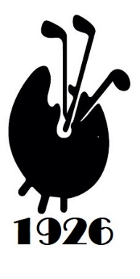
Scotland tour and FAGS v SAD 1st October 2025
The 5-day tour I outlined recently will not go ahead, however, the match against Scottish Art Dealers (SAD) at Dunbar will take place as planned on Wednesday 1st October. I am now looking to build a team of 8 or more to defend the RoBerti Trophy.
I set out below a shortened 2-night trip to Dunbar and Gullane in East Lothian and hope that a few more will join the 5 already signed up for the match.
Tuesday 30 September
- Travel to Dunbar, East Lothian, meet at 18.00, stay and dine in Pine Marten lodge
- www.pinemartenpubdunbar.co.uk

Wednesday 1st October
- Free morning
- 12.30 at Dunbar GC for match v SAD at john Dixon’s very fine club on the shoreline.
- Dinner in local restaurant, stay overnight in Pine Marten

Thursday 2nd October
- 9.30 tees at Gullane 2, 18 holes on marvellous links course
- All depart following light lunch

Cost: single occupancy £590 pp, £470 sharing includes…
- 2 nights B&B at the Pine Marten
- 2 rounds of golf at Dunbar and Gullane
- 2 dinners and 2 light lunches
Does not include travel to Scotland
All are welcome, feel free to ask for more information

