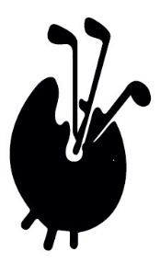
And the winners are … end of term report, December 2021
Our season started later than planned when Covid curtailed all golfing activity well into the spring with the result that matches planned for Hankley Common and Ashridge were cancelled. However, despite the fact that we could only start in May we managed to play matches at The Berkshire, Moor Park, Swinley Forest, Worplesdon, West Hill, Woking and squeeze in a week-long Scottish tour.
Andrew Jobson did a fine job as Captain and made sure that our wines were of the highest quality including an offering of Sauternes at his home club lunch. Andrew says “It’s been a real privilege for me to be FAGS Captain. I’ve thoroughly enjoyed it and I send my best to Philip for his year as Captain next year. Thanks also for all the support Simon and Eric have provided me as Captain but also the Society across the year. Thank you.”
Sponsors: We also thank our various sponsors who provided prizes for Nearest the Pin and Longest Drive competitions: Gavin Graham, Kim Tassell, Ken Bull, Ben Haynes, Sam Loxton and Andrew Jobson.
Donors: Additionally a number of members donated their match fees when they had been obliged to pull out and effectively bought the drinks for us all. We thank Giles and Lawrence Bright, David Brindley, Hugh Edmeades, Ed Monagle, Mike Dove and Kerry Hill for treating us all in this way. Cheers!
Scotland: Thanks are also due to Philip de Bay for his hospitality at The New Club in St Andrews (founded 1902) and also to John Dixon for arranging a memorable dinner at The New Club in Edinburgh (founded 1787). John also arranged our never-to-be-forgotten match v Scottish Antiques Dealers at Dunbar in a biblical downpour in spite of the fact that I distinctly remember ordering sunshine for the day! John also got us a game at The Renaissance, home of the Scottish Open, at “mates’ rates” via his pal, John Hall. We thank them both for their wonderful contribution to our year and hope to see them at matches in England or Scotland next year. Top tip - if you ever get to The Renaissance, make sure you stop for a pie at the halfway hut.
Roll of Honour
- The Berkshire, Cecil Millar Cup: Sam Loxton
- The Berkshire, Bailey & Stoner Cups: Lawrence and Giles Bright
- Moor Park, President’s Plate: Harry Apter
- Worplesdon, Butler Salver: Robert Frew
- Swinley Forest, Omel Bowl: Mary Spanner
- Swinley Forest, Frank Patten Salver (par 3s): Mary Spanner
- Swinley Forest, Lewis & Parker Cups: Eric Bryan and Robert Frew
- West Hill, Harris Cup: Philip de Bay
- Eden Course St Andrews, Harris & Whittaker Salvers: Gavin and David Graham
- Woking, Omel Salver: Giles Bright.
Full Season trophies
Cliff Williams led the way into the final match of the season with 113 points (40, 38 and 35 had not been enough to win any of the individual trophies) and held off all challengers to win the Frank Partridge Trophy and is crowned Golfer of the Year 2021.
It should be noted that Sam’s 108 points would have been enough to win in most years.
Robert Frew retained The Seniors Cup (99 points) with Eric as runner up (93) and also took the Rabbits Cup with Gavin runner up (91). Robert is looking for a sponsor for his silver polish.
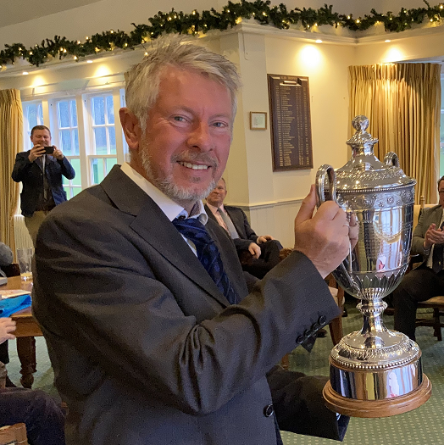

2022 Philip de Bay will have the Captain’s honour in 2022, we wish him well. Philip has helped me enormously in shaping our calendar next year which looks very different and promises to be great fun.
- Ashridge 13 April 2022 (18)
- Princes 4-5 May (2x18)
- The Berkshire 12 May (36)
- Coombe Hill 13 June (18) BBQ lunch
- Swinley Forest 30 June (36)
- Tandridge 25 August (18)
- Wimbledon Common 20 Sept (18)
- Tour early October TBC
- Worplesdon 24 Oct (18)
- Woking 6 December (18)

We wish Ken Bull and Joe Cattermole well in their private health struggles and hope to swing a club with them next year.
And finally, thank you to Eric for your invaluable assistance and guidance. We both wish you all a Merry Christmas and Happy New Year and look forward to seeing you all in the spring.
Simon & Eric

