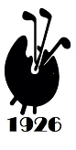
Worplesdon - and the winner is…
Plus Woking bookings, YTD scores,
subscriptions, 2026 calendar,
and an apology

Worplesdon
On a day best devoted to hunkering down indoors while the storm blows through we chose to venture down to Worplesdon. My group (Sam, Henry and Ian Cadzow) came close to walking off at the second when the green was totally unplayable but the rain calmed down, the waters receded, the dove returned with the olive branch and we cracked on and had a brilliant day.
Receptive greens meant a birdie-fest as Ben, Cliff, Eric, Henry, James, Joe, John Phillips and Sam all added to their tally. None could compare with Ben’s guest, PGA Pro Luke Bangerter, who scored 4 birdies and an eagle. Puzzlingly, he only made 37 points to win the guests comp by 7 points.
Captain Hughes was the overall winner with 38 points from James Bennett (34). Ben Haynes was closest to the pin at 10 and Geoffrey Poxon won at 13. Andrew Jobson generously provided the prizes and must have felt great satisfaction that his course played so well in spite of the conditions. John Phillips and Steve Pusey bought the post-match drinks, we thank them all for their generosity.
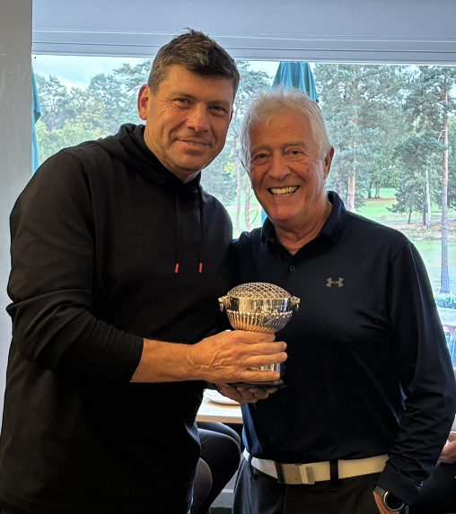
Woking bookings
Our final event of the year will take place at Woking on Friday 12 December where we will play for the Omell Salver followed by our Christmas carvery lunch and end of season prize-giving.
Great value @ £155, pay by BACS or at the link below.
www.fineartgolf.org/store/ols/products/woking

Year to date scores
With one event to go this is the leaderboard for the four season-long competitions.

Birdie Bird – an apology
As we can see there is a 3-way tie for the Birdie Bird but I must apologise for my failure to record the Birdies scored at North Hants. The contenders are welcome to submit evidence from handicap submissions for North Hants to add to the totals.

2026 Centenary year subscriptions
I will share the full schedule for 2026 later this week, we have a fantastic programme and I hope that you will be able to support as many events as possible throughout the year. Special events mean that I am obliged to increase the annual subscription fee to £100 as a one-off.
I have to pay some punchy deposits in the next few weeks and as an incentive for everyone to renew their subscriptions early I am offering a 15% discounted price of £85 until the end of November. Please renew online in the normal way
www.fineartgolf.org/store/ols/products/sub

See you all at Woking
Simon

