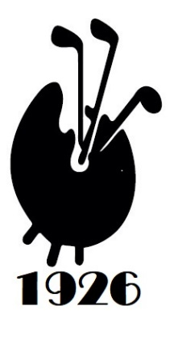
The Berkshire, and the winner is…
Plus Swinley Forest

The Berkshire
A three-way tie on 33 points meant that Eric’s countback computer worked overtime at The Berkshire yesterday as David Hughes, John Phillips and Nick Mirzyantz slugged it out for the title. The captain was quickest out of the blocks with 22 points on the front 9 but just eleven home took him out of the running. John’s 17/16 mix had him in contention but Nick took the title to add a new name to the honours board by going out in 16 and back in 17, congratulations! The first player with two Zs in his name in our 99 years of records! Waldemar Januszczak must be furious at the missed opportunity.
John Phillip’s disappointment was short-lived as he and Kerry took the pairs competition in the afternoon with 38 points from Mike Dove and Robert Frew (36), another new name on the trophy.
We thank Tony Thomas for the pre-lunch drinks and Eric for buying the prizes won by Andrew Jobson and guest Carl Harry.
David Brindley brought two great guests who added to the day. Chris Unsworth, playing off Plus 1 scored 3 birdies and an eagle to win the guests’ comp with 37 and Chubby Chandler came along and added to the fun, we hope to see them both again.
We also thank Captain David for buying the wines and for standing back and letting someone else get a taste of glory, a noble sacrifice.
A great day on a great course with a newly remodelled clubhouse. We hope to go back next year on the equivalent date and play Red in the morning.

Swinley Forest Thursday 10th July 2025
Our next outing will be Swinley Forest on Thursday 10 July; the match is now sold out. If you are one of the lucky holders of the golden tickets the day will look like this…
- Bacon rolls, tea or coffee from 7.15
- 8am, 18 holes Stableford playing for the Omel Bowl & The Frank Patten Salver (Par 3 competition)
- 4 course carvery lunch - jackets and ties, please.
- 14.00, 18 holes Greensomes playing for the Lewis and Parker Cups
- Afternoon tea will be served following play
- David Mills has generously offered to buy the pre-lunch drinks
- Mike Roberts’ company PennyMatters is sponsoring two Nearest the Pin competitions at 8 and 17, we thank them both for their generosity.
- www.swinleyfgc.co.uk

See you there

Simon

