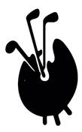

Good evening to all

We had a glorious day at Coombe Hill in Kingston upon Thames today. This new venue was a Captain’s Pick which did not disappoint in giving us a fine course in great condition and a fine BBQ lunch on top. Lightning fast upturned saucer greens sorted the wheat from the chaff – it turned out we had a lot of chaff!

Ian Cadzow won The President’s Plate with 32 points from Kerry Hill

Giles Bright won Nearest the Pin and his guest Bill Warburton won Longest Drive

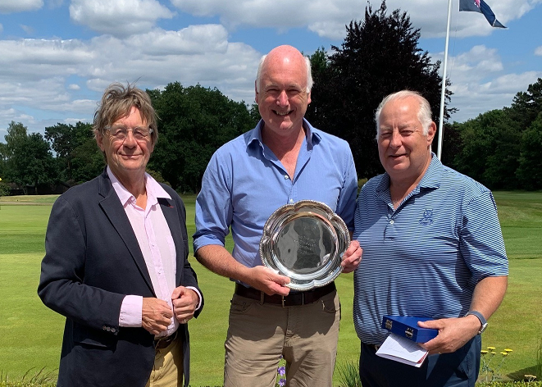

Our next meeting is Swinley Forest at the end of month, Thursday 30th June to be precise.  Singles in the morning, the full Swinley lunch and Greensomes in the afternoon.

Mary Spanner will be defending The Omel Bowl and The Frank Patten Salver that she won last year. We’ll need *every tool in the box* to *wrench* these trophies away from La Spanner (see what I did there?)

If you are thinking of playing and haven’t yet booked, please let me know asap. Book online <https://fineartgolf.org/shop/ols/products/swinley>

**Finally, I’m having trouble with lots of emails going to spam. Please reply if you get this**

See you there

Simon

Simon Berti

Fine Art Golfing Society

Mundy Bois House

Mundy Bois Road

Egerton

Kent, TN27 9EU

[www.fineartgolf.org](http://www.fineartgolf.org)

01233 840328

07775 731441