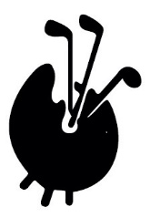 FAGS October 2022 tour. Sunday 2 – Friday 7 October
Sunday 2nd October
- 18.00 Meet Sunday evening for drinks & dinner at Bliss Hotel, Southport
- Drinks sponsored by Andrew Jobson, thank you Andrew!
- Simon, Eric, Andrew J, Andrew L, Robert, Ken, Paul & Ben, Gavin, David & Jane Graham
- https://blisshotels.co.uk/
Monday 3rd
- 18 holes at Formby, tees 9.36 (25 min drive) www.formbygolfclub.co.uk
- Simon, Eric, Andrew J, Andrew L, Robert, Ken, Paul & Ben, Gavin, David & Jane Graham
- Dinner not included in costs today
- Philip & Liz de Bay check into Marine Hotel North Berwick
Tuesday 4th
- 06.30 Check out of Bliss Hotel early to drive to Lytham – 1 hour’s drive
- Tees 8.00 www.royallytham.org
- 18 holes at Royal Lytham St Anne’s.
Andrew J Andrew L, Ken, David & Jane return home after golf

- Tuesday pm drive to Marine Hotel North Berwick
- Simon, Eric, Robert, Gavin, (plus Paul and Ben join for dinner only)
https://marineandlawn.com/marinenorthberwick/
- Dinner Tuesday evening at Marine Hotel 19.30
- Pre-dinner drinks sponsored by Eric, thank you!
Wednesday 5th
- Match v Scottish Art Dealers at Dunbar GC playing for The RoBerti Trophy
- Tees from 10.36 https://dunbargolfclub.com/
- Simon, Eric, Robert, Gavin, Philip & Liz, Paul & Ben to play
- Dinner booked for 6 at The Puffin, High St, North Berwick (not included in cost of the week)
- https://thepuffin.co.uk
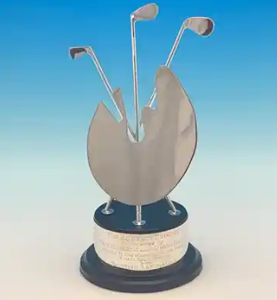

Thursday 6th
- 18 holes at Gullane 2, Tees from 8.56. www.gullanegolfclub.co.uk/course_no.2
- Simon, Eric, Robert, Gavin, Philip & Liz, Paul & Ben

- 17.45 taxi to Thursday evening dinner at The New Club Edinburgh
- Simon, Eric, Robert, Gavin, Philip & Liz in taxi - meet Paul & Ben and re-joined by David & Jane Graham, John Dixon
- www.newclub.co.uk

Friday 7th:
Golf at The Renaissance, home of Scottish Open. https://trcaa.com/
- Tees from 10.0 playing in pairs for The Harris & Whittaker Salvers
- Pairs & groupings… Yellow tees,
- Full handicap adjusted for the slope rating
- Winners will be the best combined points score for the pair.

- Jonathan Hall & John Dixon playing alongside Philip de Bay & Robert Frew
- Gavin and David Graham (trophy holders) playing Liz de Bay and Jane Graham
- Simon Berti & Eric Bryan playing Paul Roberts & Ben Leslie
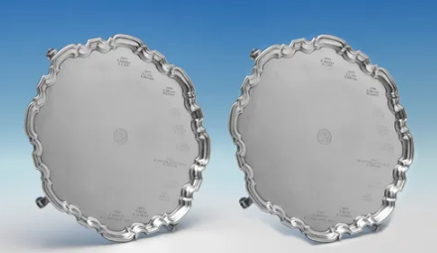
Friday afternoon we go our separate ways. Paul and Simon staying in Marine Hotel North Berwick overnight joined by wives

