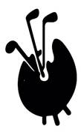

**FAGS October Tour 2023,**

**Sunday 1st October – Friday 6th**

The main body of the tour will see us return to The Marine Hotel in North Berwick for 4 nights. We will play matches on a range of very fine East Lothian Courses; Renaissance, Dunbar, Gullane 2, Kilspindie.

The match at Dunbar will be the annual challenge against Scottish Art Dealers playing to retain the Roberti Trophy. One evening we will travel into Edinburgh for dinner at The New Club on Princes St.

As always I have to thank John Dixon for his help in organising the match at Dunbar and dinner at The New Club.

**Yorkshire stop off**

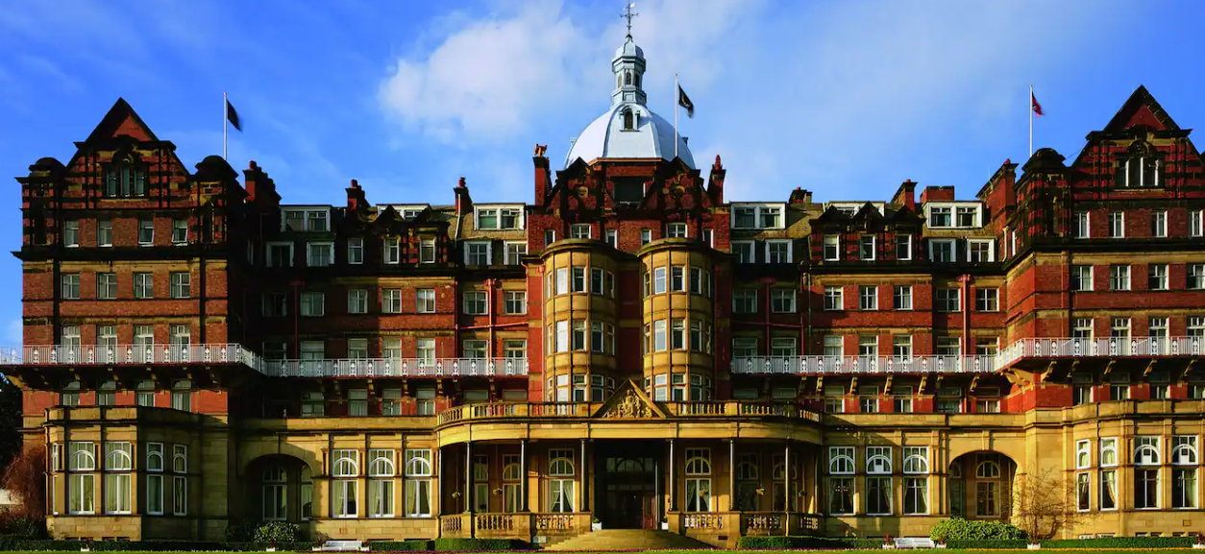

I have arranged a stop off in Yorkshire for those driving to Scotland. Meet on the afternoon of Sunday 1st October at The DoubleTree by Hilton Harrogate Majestic Hotel & Spa.

[www.hilton.com/en/hotels/lbahadi-doubletree-harrogate-majestic-hotel-and-spa](http://www.hilton.com/en/hotels/lbahadi-doubletree-harrogate-majestic-hotel-and-spa)

Monday morning we will play 18 holes at Pannal Golf Club, one of Yorkshire’s finest courses before heading up to Scotland in the afternoon.

**Full Itinerary**

**Yorkshire, Sunday 1 – Monday 2 October**

Meet at 18.00 at Harrogate Majestic Hotel for dinner. Overnight stay in the hotel followed by golf at Pannal (tees from 9.38) [www.pannalgc.co.uk](http://www.pannalgc.co.uk)

Drive to Marine hotel, North Berwick after a light lunch – approx. 3 hrs 3.30 drive

**Scotland, Monday 2 – Friday 6 October**

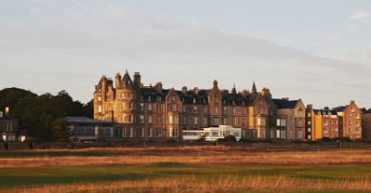

**Monday 2 October**, check in to sea view rooms andmeet at 19.30 for group dinner at Marine Hotel, North Berwick [www.marineandlawn.com/marinenorthberwick](http://www.marineandlawn.com/marinenorthberwick)

**Tuesday 3 October,** relaxed morning followed by golf at Kilspindie, 35th oldest golf course in the world; tees from 12.32 [www.kilspindiegolfclub.co.uk](http://www.kilspindiegolfclub.co.uk/)

**Wednesday 4th October,** challenge match against Scottish Art Dealers at Dunbar GC, tees from 12.52. [www.dunbargolfclub.com](http://www.dunbargolfclub.com)

**Thursday 5th October,** golf at Gullane 2, tees from 9.36, spectacular views [www.gullanegolfclub.co.uk](http://www.gullanegolfclub.co.uk/)

**Thursday 5th** 18.00 taxi into Edinburgh for dinner at The New Club (est 1787). Pack jacket and tie. [www.newclub.co.uk](http://www.newclub.co.uk)

**Friday 6th October;** 10.0 tees at The Glen Golf Club, North Berwick [www.glengolfclub.co.uk](http://www.glengolfclub.co.uk/)

**Friday afternoon all depart.**