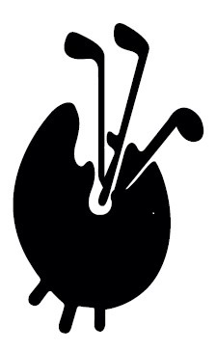
Itinerary Scotland tour Sunday October 3rd – Friday October 8th 2021.

Sunday 3rd October
Simon, Kim and Robert meet at The Buxton Palace Hotel at 18.00 for pre-dinner drinks.
B&B at Buxton Palace Hotel:
www.britanniahotels.com/hotels/palace-hotel-buxton
David Brindley has generously invited us to dinner at Bacchus despite not being able to join us

Monday 4th October
Check out of Buxton Palace Hotel
Meet Lawrence at 8.0 at The Cavendish Golf Club for 8.30 tees (5 minute drive from hotel)
www.cavendishgolfclub.com/
Golf plus sandwiches and soup: Simon, Kim, Robert & Lawrence

Afternoon, drive to Marine Hotel, North Berwick (Simon, Robert, Kim, Lawrence, David)
Andrew, Eric & Diane, Philip & Liz, Gavin & Giles plus Gavin’s brother David & wife, Jane to meet us there having travelled separately.

19.0 pre-dinner drinks followed by dinner booked in The Library, we will be joined by Paul Roberts and Ben Leslie.
www.marineandlawn.com/marinenorthberwick/ note, the hotel is newly refurbished.
Seaview rooms are booked. Marine Hotel residents will be…
Simon, Andrew, Robert, Kim, Lawrence, Giles, Gavin, Eric & Diane, Philip & Liz, David & Jane Graham, (10 rooms, 13 people)

Tuesday 5th October
Dunbar Golf Club for match against Scottish Art Dealers (30 mins). Meet at 8.45 for tees at 9.30; https://dunbargolfclub.com/
Format for golf will be 4 ball better ball, taking the shots from the lowest Handicap
12 players per team
Light lunch at Dunbar after the match
The RoBerti Trophy:
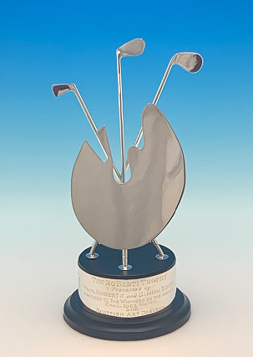

Travel to Edinburgh by minibus at 17.30. Dinner for 14 at The New Club, 86 Princes St, Edinburgh EH2 2BB www.newclub.co.uk
We will be expected to wear jacket and tie for dinner.
Return on the bus at 22.30

Wednesday 6th October
Check out of The Marine Hotel at 10.0 and meet at 10.30 at The Renaissance Golf Club, Gullane, home of The Scottish Open. Tees 11.30. Each group be required to hire a caddy – expect jumpsuits like The Masters. https://trcaa.com/
Golfers (16): Simon, Andrew, Robert, Kim, Lawrence, Giles, Gavin & David Graham, Eric, Philip & Liz, Paul Roberts, Ben Leslie, John & Padraic Dixon & John Hall who has invited us to play as his guests for the day.
Please make a point of using the clubhouse as lockers have been set aside for each of us
Light lunch at the club after the match
After playing The Renaissance Lawrence, Giles and Gavin will travel home while Simon, Kim, Andrew, Robert, Eric & Diane plus Paul and Ben will drive north to St Andrews where we will stay at Hotel du Vin.
www.hotelduvin.com/locations/st-andrews/
8 rooms – 6 for single occupancy; Simon, Paul, Ben, Kim, Andrew, Robert
2 rooms double occupancy (E&D + P&L)
Philip de Bay has generously offered to host the pre-dinner drinks at the New Golf Club each evening. Thank you Philip!
Dinner will be at 19.45 in a private Bothy at Forgans www.forgans.co.uk/st-andrews/bothies/
Thursday 7th October
Golf at The Jubilee Course www.standrews.com/Play/Courses/Jubilee-Course
Meet 9.45 for tees at 10.24 www.standrews.com/relax/st-andrews-links-clubhouse

10 Golfers: Simon, Paul, Ben, Kim, Robert, Andrew, Eric & Diane, Philip & Liz
Light lunch following the golf
Dinner will be in the club house of The New Club St Andrews overlooking the links courses. The Captain and his wife will be our guests. Jacket & tie, please, gents.
www.newgolfclubstandrews.co.uk/

Friday 8th October
Check out of Hotel du Vin and meet at Eden Golf Course 8.45 for 9.28 tees
www.standrews.com/relax/eden-clubhouse
www.standrews.com/play/courses/eden-course
12 Golfers: Simon, Paul, Ben, Kim, Robert, Andrew, Eric & Diane, Philip & Liz, Gavin & David Graham
Following a light lunch we will go our separate ways.

