**FAGS Tour report, October 2022**

A group of golfers enjoyed a wonderful tour that took in visits to a range of championship courses in Lancashire and East Lothian last week.

We met in Southport for dinner last Sunday 2nd October in advance of our first game of the week at Formby. Eric played a great game and won the day. The course is delightful and highly recommended, extremely welcoming. Gavin, ever the iconoclast, enjoyed playing in last years’ tour cap.

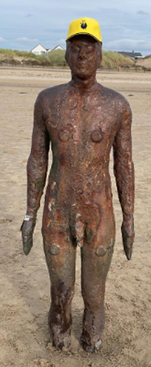

Following our game most of us went to the beach at Blundellsands where Anthony Gormley briefly joined the tour.

Early start on Tuesday to get to Royal Lytham St Annes for an altogether different kind of experience at the course where Seve twice won The Open.

174 bunkers gave most of us the opportunity to work on our sand game, the one on the 18th fairway provided this shot, below. Jane Graham, playing off 8, plotted her way around the course and won the competition with 38 points. Hats off to Jane for taming this brute of a course!

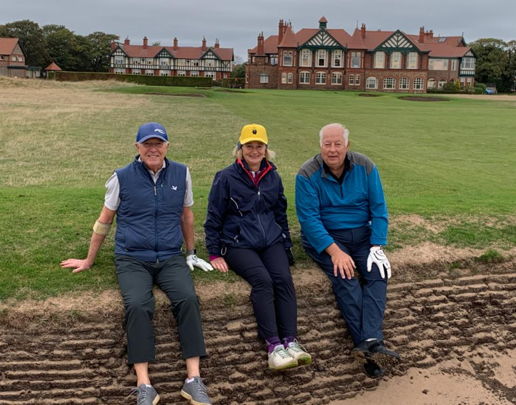

After Lytham a few went home and the rest went on to Scotland for the crunch match with Scottish Art Dealers (SAD) at Dunbar.

Gavin had learnt a lesson at Lytham as a wayward tee shot gave him the chance to demonstrate his bunker play from the beach – a fine up and down. It’s hard to describe the thrill of finding your ball on the beach when you expected it to be submerged in a rock pool and then you manage to blast out of the seaweed back into the match.

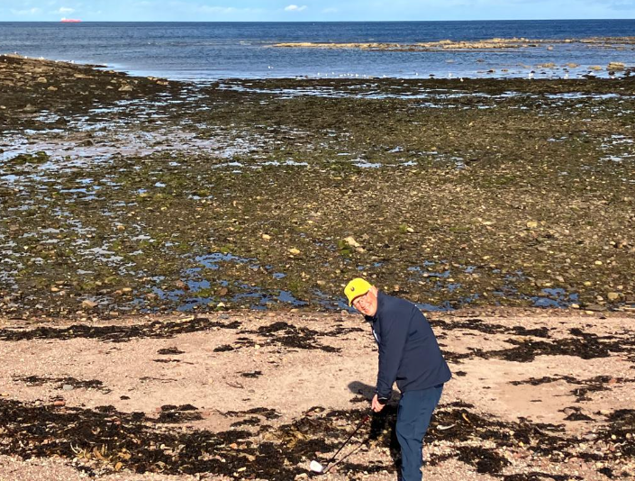

We had spent the previous fortnight studying worsening weather forecasts and wondering how bad it could be, those who had been at Dunbar last year could testify to a Biblical experience, but not in a good way! In the event, the sun shone and the rain only came when we were safely back in the clubhouse.

In a wonderful match played in a great spirit and high winds you will be pleased to learn that FAGS won the RoBerti Trophy by 2 ½ to ½. Dunbar is a wonderful links offering the best value catering anywhere; soup and a sandwich @ £5.95.

On Thursday we played Gullane 2 in hysterically windy conditions. A Texas Scramble format gave us all a chance of keeping a ball in play and we came in with scores of just 5 and 6 over par having had the most fun ever on an indescribably beautiful course that we all want to play again, a perfect day.

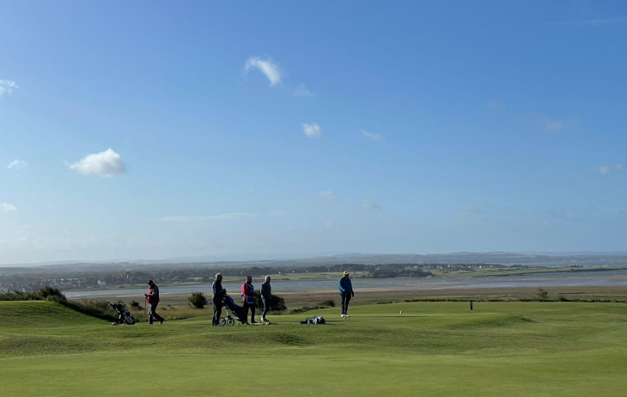

John Dixon hosted us for a marvellous dinner in the New Club in Edinburgh on Thursday night before we assembled at Renaissance, home of The Scottish Open on Friday morning for a pairs competition.

By now we had played 16 hours of golf without a drop of rain, would our luck hold? It didn’t look good as a storm blew through while we were having coffee before golf but in the event the skies cleared and we stormed round the course. Gavin and I won the Harris and Whittaker Salvers with 39 points on countback from Robert and Liz. What a week!

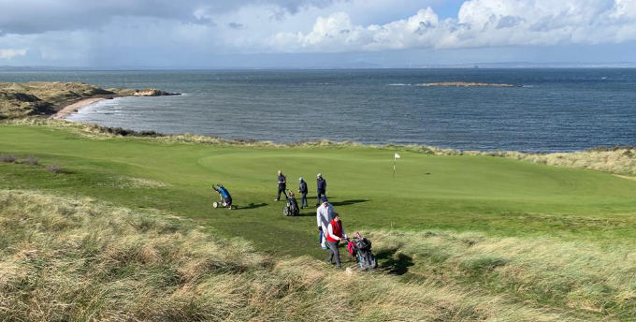

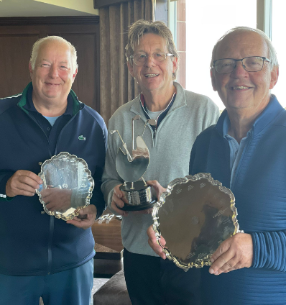

Thanks are due to a number of people who helped to make the tour a success. **John Dixon** organised the match at Dunbar and the dinner at The New Club in Edinburgh and again proved to be a great friend of FAGS, we look forward to welcoming him to one of our matches next year as our guest.

**John Hall** extended another invitation to play at Renaissance, a fine course with the finest facilities for golfers anywhere. Play it if you ever get the chance if only to enjoy the pies at the hallway house! We also hope to welcome John as our guest in 2023.

**Andrew Jobson** generously bought the pre-dinner drinks on Sunday; **Eric** did the same on Tuesday in North Berwick and **Robert** treated us all to lunch after the match at Gullane. Thank you all for your hospitality.

And finally to **Captain de Bay** who led the team to victory, hats off to PdB.

Block out 2-6 October 2023 for our next visit to Scotland. We may go to St Andrews but we had so much fun that we all fancy going back to North Berwick again and playing the same courses, possibly adding the West Links at North Berwick to the mix. Watch this space.