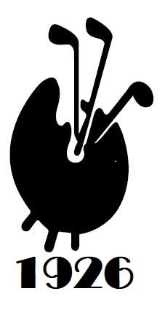
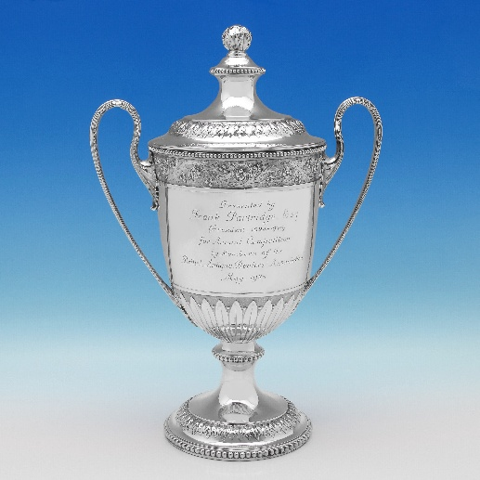

Fine Art Golfing Society history, episode 1
Our society dates from 1926 when Frank Partridge presented the trophy that bears his name to be played for by members of the British Antiques Dealers Association (BADA).

Partridge, born in Hertfordshire, was a remarkable man who became the most respected antique dealer in the land with premises in London and New York…

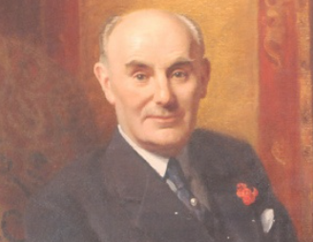
Frank Partridge 1875-1853

After some years in the US and later working for his brother Leonard, Partridge opened his own shop at 4 King Street, St James’s in 1904 and later opened a New York branch on Fifth Avenue in 1912.

He survived the sinking of the Lusitania in 1915 while returning from a buying trip and by 1938, the firm held a Royal Warrant as antique dealers to Queen Mary.

After its King Street premises were destroyed by bombing in April 1943, Partridge reopened the next day in Bruton Street, later moving in 1944 to 144–146 New Bond Street over the road from Sothebys. Frank Partridge was a founding member of the BADA in 1918 and led the business until his death in 1953.

The first winner of The Partridge Trophy was Basil Dighton, a high profile art and antiques dealer based in London who later went into business with Leonard Partridge, Frank’s brother.

Dighton was made infamous through the Dighton vs Shrager antique furniture trial in 1923 where Adolphe Shrager sued antique dealers Dighton & Co. for fraud, alleging over 500 pieces of 18th-century furniture purchased for over £111,000 were fake or grossly overpriced. Shrager lost both the trial and appeal amidst allegations of establishment bias.

Dighton’s notoriety didn’t appear to have affected his swing at our first match.

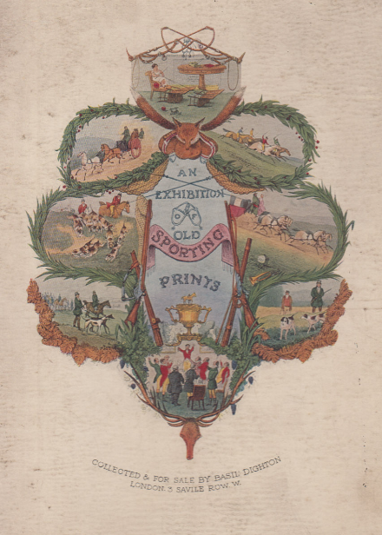

Cover of Basil Dighton’s catalogue

An Exhibition
of
Old Sporting Prints

