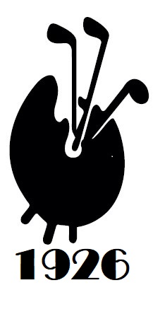
Angus Lloyd, 1935-2025, British Fine Art dealer and golfer.
I regret to inform you all of the passing of Angus Lloyd who played with FAGS regularly until just a few years ago.
Angus features on most of our oldest trophies with his first win in 1977 and his last in 2003 appropriately winning the Apter and Lloyd salver that he had donated in 1985. Angus was golfer of the year in 1978, 1988 and 2003. Angus last played with us at Swinley Forest in 2021.
Angus had a long and successful business career across many fields but in our world, he was the owner and Director of Burlington Galleries for many years.
In the golfing arena he collected so many golf club memberships that it’s hard to imagine how he fitted the business in. This is the list sourced from the internet so it may not be completely accurate …
- Member Royal St. George's Golf Club (captain 1985)
- Berkshire Golf Club (captain 1978)
- Walton Heath Golf Club
- Royal West Norfolk Golf Club
- Swinley Forest Golf Club
- Royal and Ancient Golf Club (St. Andrews)
- Honorable Company of Edinburgh Golfers - Muirfield
- Old Marsh Golf Club (Florida)
- P.G.A. National Golf Club (Fla)
The last few years have been blighted by Alzheimers but his wife, Wanda, is grateful for 60 odd years they spent together. The photo below is from 2021.
Angus passed away in June and the funeral and thanksgiving services were held recently.
