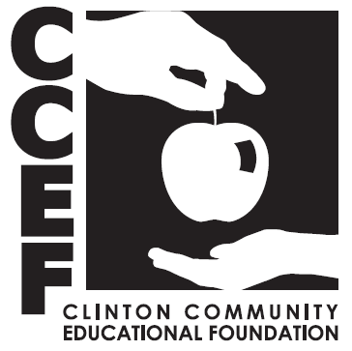

**APPLICATION FOR THE**

**SGT REBECCA “BECKI” FARRIS MEMORIAL SCHOLARSHIP**

**\*Complete this application if you are applying for the scholarship below.**

**Sgt Rebecca “Becki” Farris Memorial Scholarship:** for students planning to enroll full-time at an accredited Junior College or an accredited four-year college or university to pursue an *undergraduate degree* in a Law Enforcement Field.

Award Amount: $1,000

This scholarship, named in memory of a former Clinton High School Alumni, recognizes the Importance of Women in Law Enforcement Careers. Applications should demonstrate both academic achievements and community service; applicants should explain the relevance of their career pursuit in one of the following Law Enforcement Fields: Police, Sheriff, Trooper, Forensics or Corrections. This scholarship requires applicants to submit, in addition to the application, a short essay on how they hope to impact the community around them in this field. The successful applicant will have a 3.0 or higher GPA, experience with community service in the Clinton Community and a well written short essay. Before receiving this scholarship, applicants are required to show intent and/or proof of registration as a full-time student in a program described in the fields above. (Should the winner not be able to provide verification prior to the fall semester following their application process, their award will be presented to runners-up.)

**Application Deadline: Tuesday March 31, 2026.**

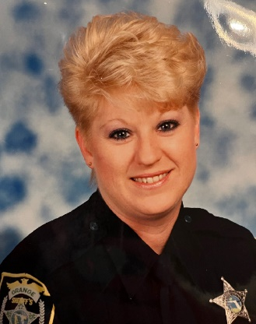

**Sgt Rebecca “Becki” Farris**

Sgt. Rebecca “Becki” Farris (maiden name Taylor), was a Clinton High School Alumni - Class of 1978. Growing up in Clinton, Becki pursued a family and career with her life journey taking her to Orlando, FL in 1990. Shortly after, Becki attended the Law Enforcement Academy at Seminole Community College and was sworn in as an Orange County Deputy Sheriff in 1993. Throughout her 13-year career, Becki achieved the ranks of Corporal and then Sergeant with a squad of 14 deputies within the Court Security Division of the Orange County Sheriff’s Office in Orlando, FL. Helping her community was a calling that led her into Law Enforcement, a primarily male dominated profession. Her challenges and successes helped pave the way for other women to gain traction in their law enforcement careers.

With both compassion and determination, Becki created a legacy of service living on past her death. In 2017, Becki was diagnosed with a heart and lung condition that caused her to be oxygen dependent until her passing on December 1, 2022. Her determination was still prevalent throughout her health battle, ending with her passing at age 62.

Her family has chosen to honor all the amazing character traits and accomplishments of Becki with this scholarship. The goal is to continue her legacy with empowering young women in the fields of Law Enforcement. This scholarship is annual and is awarded $1,000 to one successful applicant.

**SGT REBECCA “BECKI” FARRIS MEMORIAL SCHOLARSHIP**

A Clinton High School graduate may apply for the Sgt. Rebecca “Becki” Farris Memorial Scholarship. Scholarship candidates are evaluated by completing an application, submitting an essay, and sitting for a personal interview, if invited, with the scholarship committee. A complete application includes:

* **General information Document-** See attached form.
* **Applicant Essay-** See attached form.
* **Personal Resume-** Please list your community and church activities, school extra-curricular, interests and hobbies, employment history and any honors/awards you have received while in high school
* **High School Transcript(s)-** Complete, except for last semester
* **College Transcript(s)-** for any college courses completed while in high school
* **Three letters of recommendation -** Request and submit three (3) letters of recommendation, only one of which may be provided by a current or recent teacher or school employee, and **two provided by contacts outside of the school district. Do not use relatives or CCEF board members**.
* **Be sure to include all of the above or the application will be denied.**

Are you a current or past student of Clinton High School?

(YES) (NO)

Are you currently studying a career in law enforcement or mentoring with a local agency?

(YES) (NO)

Is your career path going into law enforcement, forensics, or corrections?

(YES) (NO) If yes, which? _____________________________________

Do you have a family member in a law enforcement occupation?

(YES) (NO) If yes, explain: _____________________________________

**Scholarship Eligibility Criteria:**

* The successful applicant will have a 3.0 or higher GPA, experience with community service in the Clinton Community and a well written short essay
* Applicant must be a young woman looking to start or continue education into a Law Enforcement career
* Applicant must plan to be enrolled as a full-time student during the academic year that begins the fall following application process, within the fields listed above
* Applicant must have a current 3.0 GPA or higher

Completed applications are to be returned in a sealed envelope to the high school guidance office by the application deadline noted on the application packet cover page. The outside of the envelope must be marked with the student’s name and CCEF- Sgt. Rebecca “Becki” Farris Memorial Scholarship.

After submission of a complete application, selected students will be informed of the date, location and time for a personal interview with the scholarship committee. *Failure to be present for the interview will disqualify the student from the selection proces*s. The student should be prepared to speak with the scholarship committee about his/her application

Those students selected to receive a scholarship will receive further instructions outlining the eligibility requirements for disbursement of the scholarship award.

The number of scholarships awarded may vary each year depending on Foundation Income and student disbursement may vary according to student needs. Scholarship decisions are made by the scholarship committee which is comprised of district faculty members, CCEF board members and/or community members, and finally by the Farris Family. The Farris Family has the final decision on all scholarship awards.

Questions: Contact the CCEF Scholarship Committee by email at [info@ccef15.org](mailto:nansto923@gmail.com).

**SGT REBECCA (BECKI) FARRIS MEMORIAL SCHOLARSHIP**

**General Information Document**

**APPLICANT INFORMATION**

**Name: ________________________________________________________________________**

**Address: ______________________________________________________________________**

**City: _______________________________ State: _______________ ZIP Code: _____________**

**Phone: ____________________________ Email: _____________________________________**

**PARENT/GUARDIAN INFORMATION**

**Name: ________________________________________________________________________**

**Address: ______________________________________________________________________**

**City: __________________________________ State: ______________ ZIP Code: ___________**

**Phone: ______________________________ Email: ___________________________________**

**Name: ________________________________________________________________________**

**Address: ______________________________________________________________________**

**City: ___________________________________ State: ______________ ZIP Code: __________**

**ACADEMIC INFORMATION**

**H. S. Grade Point Average: _____________________ SAT/ACT Composite Score: ___________**

**POST HIGH SCHOOL EDUCATIONAL INFORMATION**

**School/Program attendance plans, include school/institute name and program of study:**

**______________________________________________________________________________**

**APPLICANT CERTIFICATION**

**I certify that I am currently in my last academic year and graduating from Clinton Community High School. All information provided on this application is true and accurate.**

**Signature: ___________________________________________ Date: ____________________**

**SGT REBECCA (BECKI) FARRIS MEMORIAL SCHOLARSHIP**

**Applicant Essay**

In an essay of approximately 500 words, describe the life experiences and/or people that have most influenced your career decision. How do you envision those influences impacting your future? What community service have you provided? How do you plan to impact the future of your community. Explain the relevance of your career pursuit in one of the following Law Enforcement Fields: Police, Sheriff, Trooper, Forensics or Corrections.

Please double space and use a legible font 12 pt. or larger. Sign and date below and attach the essay to the back of this form.

Signature: ______________________________________________ Date: _________________

**LETTER OF RECOMMENDATION**

In your letter of recommendation, the writers should mention how long and under what circumstances they have known you. Please comment on the applicant’s potential. Please instruct the writers to submit the letter in a sealed envelope. Include the two letters of recommendation with the rest of the application packet. Remember, request and submit three (3) letters of recommendation, only one of which may be provided by a current or recent teacher or school employee, and **two provided by contacts outside of the school district** (a family friend, church leader, coach of non-school related activity, previous employer, etc.). **Do not use relatives or CCEF board members.**

Reference Name/Title:___________________________________________________________

Address: ______________________________________________________________________

Signature: ______________________________________________ Date: _________________

**Applications are due Tuesday March 31, 2026.**