**Ruth A. Lowers Memorial Scholarship**

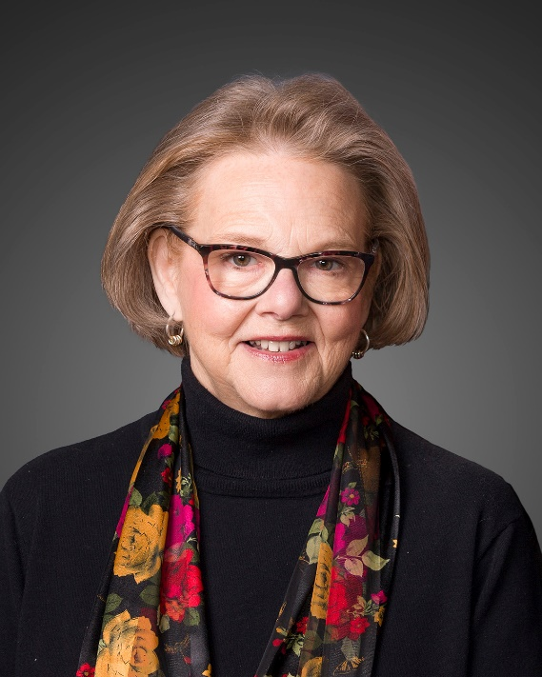

The family of Ruth A. Lowers is pleased to announce a scholarship opportunity

to all graduating seniors of Clinton High School who plan to

pursue higher education by attending a college/university or trade school.

Two scholarships will be awarded annually; one for $1000 and one for $500

Mrs. Lowers resided in Clinton for 50 years. She and her husband raised their three children here; all whom graduated from Clinton High School. Alongside her husband, Ted, they owned and operated businesses in Clinton for 35 years. Mrs. Lowers was a prominent supporter of education and advocated for students at all grade levels. She served on the CUSD15 Board of Education for 16 years. She was president of the Board when the new junior high was built in 2005. She was a founding member of the Clinton Community Educational Foundation (CCEF) in 2006. She served on the DeWitt County Dove, Inc. Board. She was a proud community member with a servant’s heart and always rooted for the underdog. A strong believer in education, serving your community through volunteerism, and lending a hand to all, she instilled those same values in her children, grandchildren, family and friends.

As a family, we are proud to continue her legacy through this generous memorial.

**Scholarship Guidelines and Information**

You may write or type your answers on the application.

Please be sure to include the following when turning in your application:

1. Completed application
2. Most recent high school (and/or college if applicable) transcript
3. Essay Response - 750 words or less
4. Two (2) letters of recommendation; Only **one** letter may be from a teacher/coach/administrator from the school. The **second** letter should be a non-relative, non-school related individual. Both letters should be in a sealed envelope with the signature of the reference written across the seal
5. Please provide ALL the above materials in a sealed manila envelope with your name and scholarship title on the front.
6. ***Applications in full are due in Student Services at CHS no later than***

***April 2, 2025. Late applications will not be accepted.***

Any current student or recent CHS graduate may apply each year they are enrolled full-time in college/university or trade school. You do not have to be a past recipient. Priority will be given to current graduating high school seniors. Students may not “hold” their scholarship for any length of time. Scholarship monies will be distributed in the fall each year to the recipient’s college/university or trade school in which they are enrolled. CCEF will provide information on how to obtain payment when the scholarship is awarded each year at the Gold Star Banquet at Clinton High School.

**Ruth A. Lowers Memorial Scholarship**

**Personal Information:**

Name: ____________________________________________

Address: ___________________________________________

Phone Number: _______________________________________

Parent/Guardian Name(s) _________________________________

Address (if different than above) _____________________________

**Academic Information:**

GPA ___________ Class Rank __________ (attach your most recent transcript)

Will you be a first generation college student? _____________

What college/university or trade school will you be attending? _____________

_______________________________________________

Have you been accepted? __________

What is your intended major? _______________________________

How do you plan to pay for your continued education? __________________

________________________________________________

**Extra-Curricular Activities:**

List any school related extra-curricular activities or groups you participated in with year:

**________________________________________________**

_________________________________________

_________________________________________

_________________________________________

_________________________________________

List any non-related school extra-curricular activities or groups you participated in with year:

___________________________________________________

___________________________________________________

___________________________________________________

___________________________________________________

___________________________________________________

List any volunteer work you’ve done with dates:

___________________________________________________

___________________________________________________

___________________________________________________

___________________________________________________

___________________________________________________

Is there anything else important that you would like us to know about you?

___________________________________________________

___________________________________________________

___________________________________________________

___________________________________________________

___________________________________________________

___________________________________________________

___________________________________________________

___________________________________________________

___________________________________________________

___________________________________________________

**Essay Prompt-** In 750 words or less, on a separate sheet of paper, typed, no larger than 12 fonts, answer the following prompt:

*Once you’ve completed your education post high school, what do you aspire to do to help in the community where you will live? Is there an organization that you would like to be involved with? Why?*