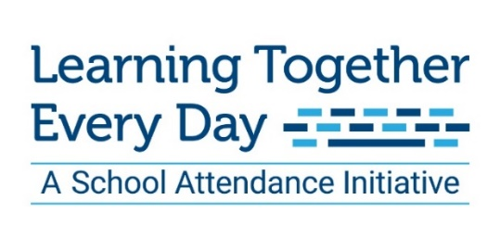

Social Media Posts
September – Attendance Awareness Month 2020

Thank you raising awareness about the importance of student attendance! Please share any of the following social media messages that will resonate with your community and help our students maximize their learning time – whether that is from the classroom or from home.

Facebook
- September is National Student Attendance Month, and we’re celebrating all week month by sharing resources for our region’s students, teachers and administration. Follow along and share our posts with teachers in YOUR network to help us get even more Kansas City kids from pre-K to graduation day! http://bit.ly/34NUbyD #AttendanceWorks #LearningTogetherEveryDay #ForOurKids

- Remote learning was a struggle last spring. But this fall will be successful if we work together as a community to support families and schools - whether learning is in person, virtual or a blend. http://bit.ly/34NUbyD #AttendanceWorks #LearningTogetherEveryDay #ForOurKids

- Learning from home requires that parents/guardians and teachers work together to keep our students on track. Check out the list of 10 tips to support strong student learning from home. Remember, we’re all in this together! http://bit.ly/34NUbyD #LearningEveryDayTogether

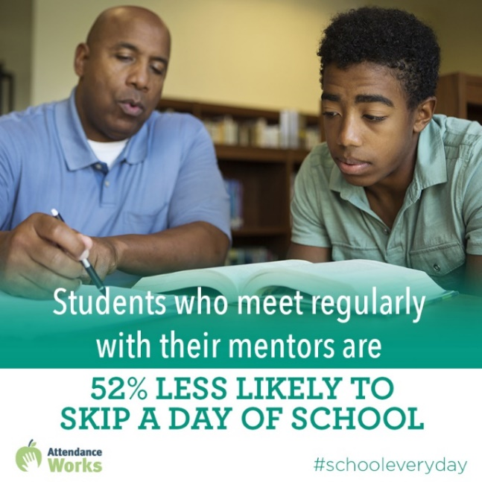
- Volunteer mentors in a quality program can be leveraged as a strategy to improve attendance & academic achievement. Studies have shown that students who meet regularly with their mentors are 52% less likely than their peers to skip a day of school. Contact your local school district today about mentorship opportunities! http://bit.ly/34NUbyD #AttendanceWorks #LearningTogetherEveryDay http://bit.ly/34NUbyD #ForOurKids

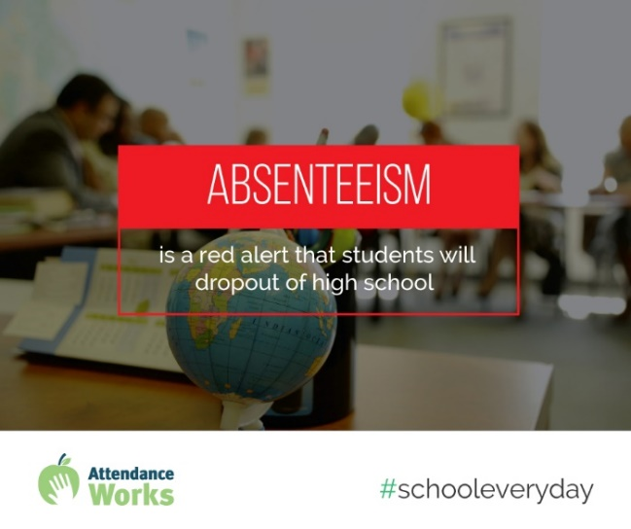
- By 9th grade, regular and high attendance is a better predictor of graduation rates than 8th grade test scores. Let’s work together to make sure our students are present and engaged every day. #AttendanceWorks #LearningTogetherEveryDay #ForOurKids

- Improving attendance is not rocket science, but it does take commitment, collaboration and tailored approaches to the particular strengths and challenges of each school or community. Let’s do it! http://bit.ly/34NUbyD #AttendanceWorks #LearningTogetherEveryDay #ForOurKids

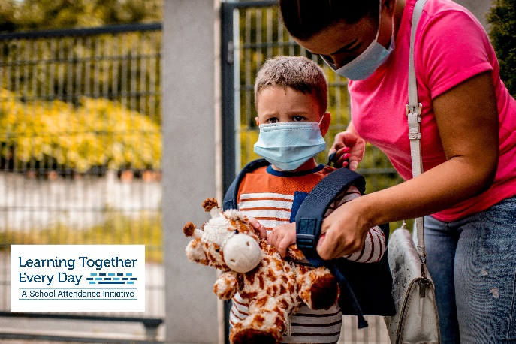
- One in 10 kindergarten & 1st grade students misses nearly a month of school each year. Let’s make sure our youngest learners are learning every day – whether online or in-person. #AttendanceWorks #LearningTogetherEveryDay #ForOurKids

- Supporting strong student attendance and engagement is one of the most effective ways we can reduce educational inequities. September is National Student Attendance month – find out more here! http://bit.ly/34NUbyD #AttendanceWorks #LearningTogetherEveryDay #ForOurKids

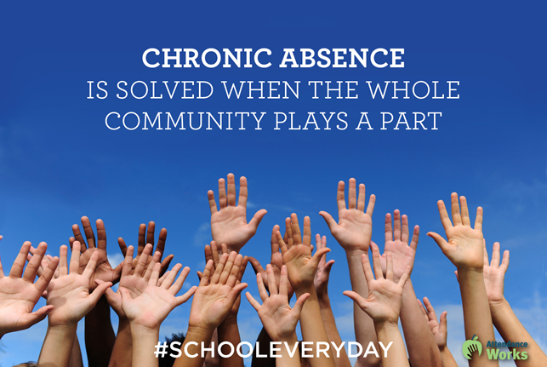
- Strong student attendance requires collaboration and trust between schools, families and community partners. Together, we can help our students learn every day. http://bit.ly/34NUbyD #AttendanceWorks #LearningTogetherEveryDay #ForOurKids

Twitter
- One in 10 kindergarten & 1st grade students misses nearly a month of school each year. Let’s make sure our youngest learners are learning every day – whether online or in-person. #AttendanceWorks #LearningTogetherEveryDay #ForOurKids

- Making sure your child attends school regularly (in-person or online) helps students succeed and the whole school community thrive. http://bit.ly/34NUbyD #AttendanceWorks #LearningTogetherEveryDay #ForOurKids

- Reducing chronic absence takes commitment, collaboration & tailored approaches, particularly during these uncertain times. Will you help? http://bit.ly/34NUbyD #AttendanceWorks #LearningTogetherEveryDay #ForOurKids

- Students who have a mentor growing up are more likely to graduate & enroll in college. Contact your local school district today about mentorship opportunities! http://bit.ly/34NUbyD #AttendanceWorks #LearningTogetherEveryDay #ForOurKids

- Missing 10% of school days, just 2 days each month, can put children at risk of academic failure. http://bit.ly/34NUbyD #AttendanceWorks #LearningTogetherEveryDay #ForOurKidsLearningEveryDayTogether

- Students lose 14 million school days to asthma each year. Controlling asthma = better attendance. http://bit.ly/34NUbyD #AttendanceWorks #LearningTogetherEveryDay #ForOurKids

