Social Media Posts

Thank you for raising awareness about the importance of enrollment, engagement and student attendance! Please share any of the following social media messages that will resonate with your school or community and help our students maximize their learning time.

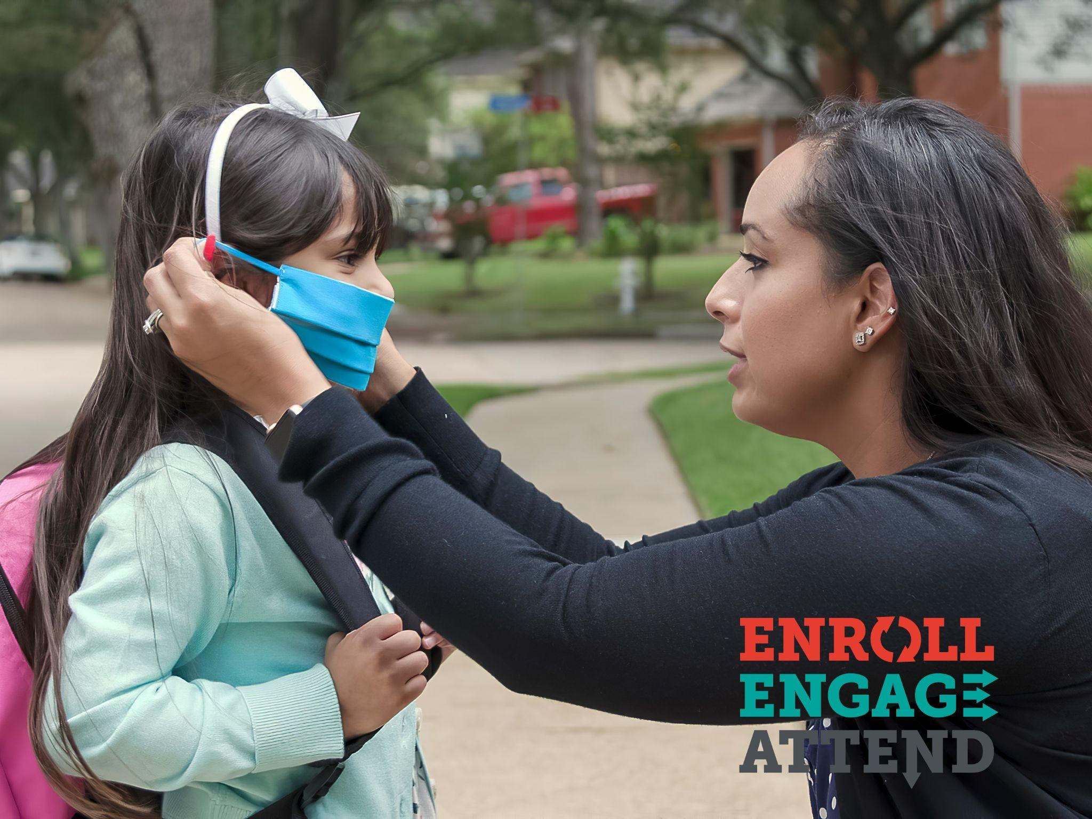
Facebook

Enroll

- Despite the challenges of COVID, our students need to get back in school and back on track. The academic, social and emotional benefits are too important to miss. Contact your school district to see how to enroll your student today! #AttendanceWorks #EnrollEngageAttend #ForOurKids

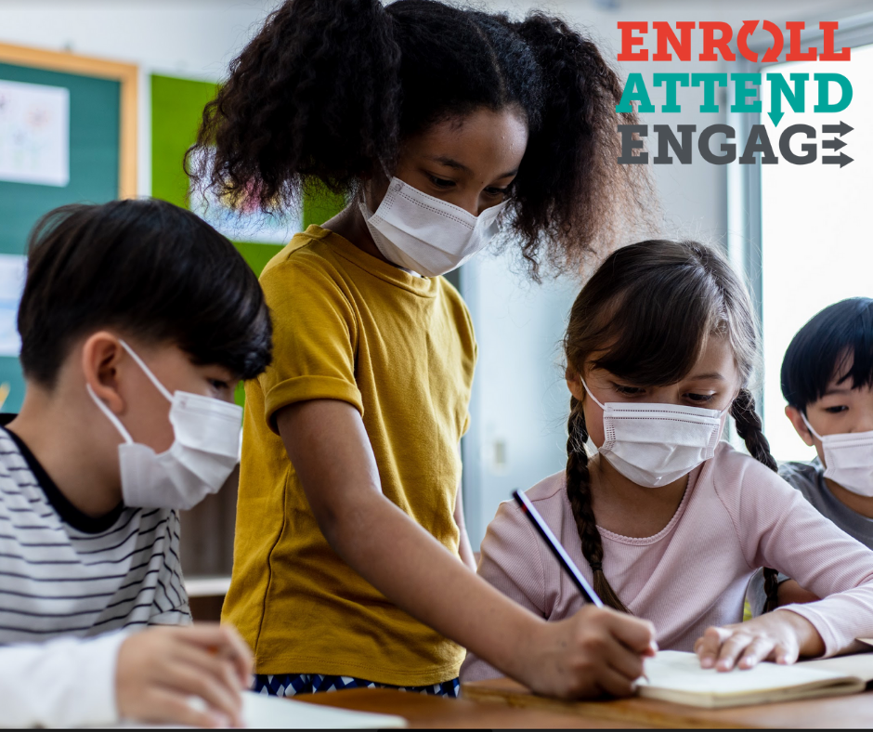

- This fall, enrollment in several local school districts is down by 13%, as compared to pre-pandemic enrollment numbers. We need to get our students back where they belong this fall - in school. Encourage a student in your life to enroll today and have a strong start to the school year! #AttendanceWorks #EnrollEngageAttend #ForOurKids

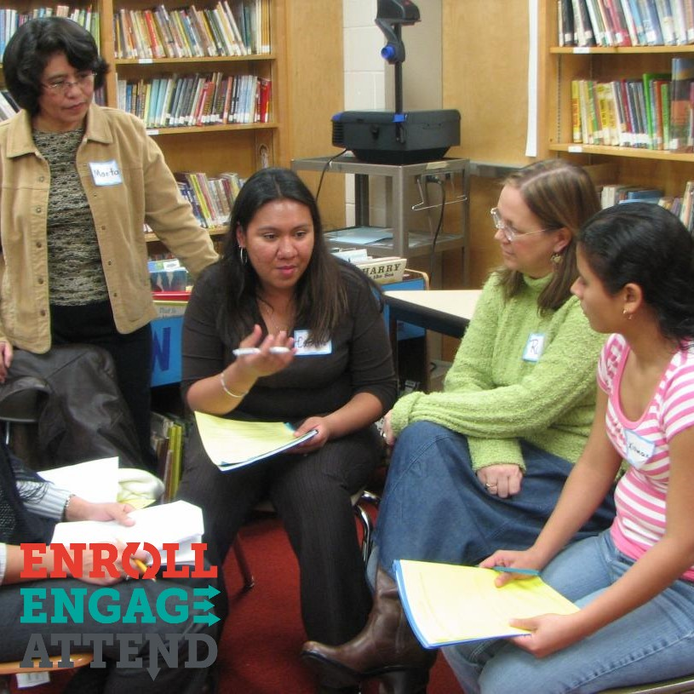

Engage

- Teachers have the greatest influence on our student’s success! As we head back to school, remember that teachers are our partners – keep the communication open and reach out regularly with questions. #AttendanceWorks #EnrollEngageAttend #ForOurKids

- One of the best ways to stay engaged in our children’s learning is through your school’s parent portal or Student Information System (SIS). This fall, become familiar with it to see your student’s grades, keep up with their attendance, and to even contact your child’s teachers. #AttendanceWorks #EnrollEngageAttend #ForOurKids

- The pandemic has brought many changes and uncertainties. But this fall will be successful if we work together as a community to support families and schools. http://bit.ly/34NUbyD #AttendanceWorks #EnrollEngageAttend #ForOurKids

Attend

- Supporting strong student attendance and engagement is one of the most effective ways we can reduce educational inequities. September is National Student Attendance month – find out more here! http://bit.ly/34NUbyD #AttendanceWorks #EnrollEngageAttend #ForOurKids

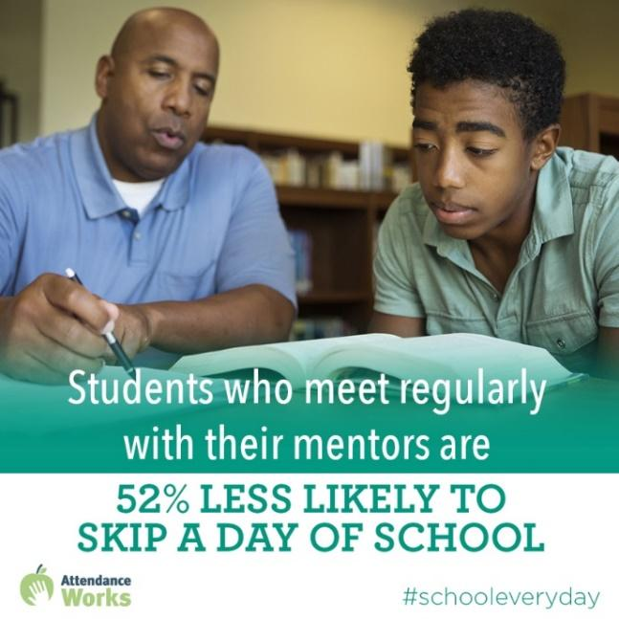
- Students who have a mentor growing up are more likely to graduate & enroll in college. Contact your local school district today about mentorship opportunities! http://bit.ly/34NUbyD #AttendanceWorks #EnrollEngageAttend #ForOurKids

- By 9th grade, regular and high attendance is a better predictor of graduation rates than 8th grade test scores. Let’s work together to make sure our students are present and engaged every day. #AttendanceWorks #EnrollEngageAttend #ForOurKids

- One in 10 kindergarten & 1st grade students misses nearly a month of school each year. But students who attend regularly in the early grades perform better on measures of academic and social and emotional capacities. This fall, let’s make sure our youngest learners are learning every day. #AttendanceWorks #EnrollEngageAttend #ForOurKids

- Strong student attendance requires collaboration and trust between schools, families and community partners. Together, we can help our students learn every day. http://bit.ly/34NUbyD #AttendanceWorks #EnrollEngageAttend #ForOurKids

Twitter

- One in 10 kindergarten & 1st grade students misses nearly a month of school each year. But students who attend regularly in the early grades perform better on measures of academic and social and emotional capacities. This fall, Let’s make sure our youngest learners are learning every day.#AttendanceWorks #EnrollEngageAttend #ForOurKids

- Making sure your child attends school regularly (in-person or online) helps students succeed and the whole school community thrive. http://bit.ly/34NUbyD #AttendanceWorks #LearningTogetherEveryDay #ForOurKids

- Reducing chronic absence takes commitment, collaboration & tailored approaches, particularly during these uncertain times. Will you help? http://bit.ly/34NUbyD #AttendanceWorks #EnrollEngageAttend #ForOurKids

- Students who have a mentor growing up are more likely to graduate & enroll in college. Contact your local school district today about mentorship opportunities! http://bit.ly/34NUbyD #AttendanceWorks #EnrollEngageAttend #ForOurKids

- Missing 10% of school days, just 2 days each month, can put children at risk of academic failure. http://bit.ly/34NUbyD #AttendanceWorks #EnrollEngageAttend #ForOurKidsLearningEveryDayTogether

- Students lose 14 million school days to asthma each year. Controlling asthma = better attendance. http://bit.ly/34NUbyD #AttendanceWorks #LearningTogetherEveryDay #ForOurKids

