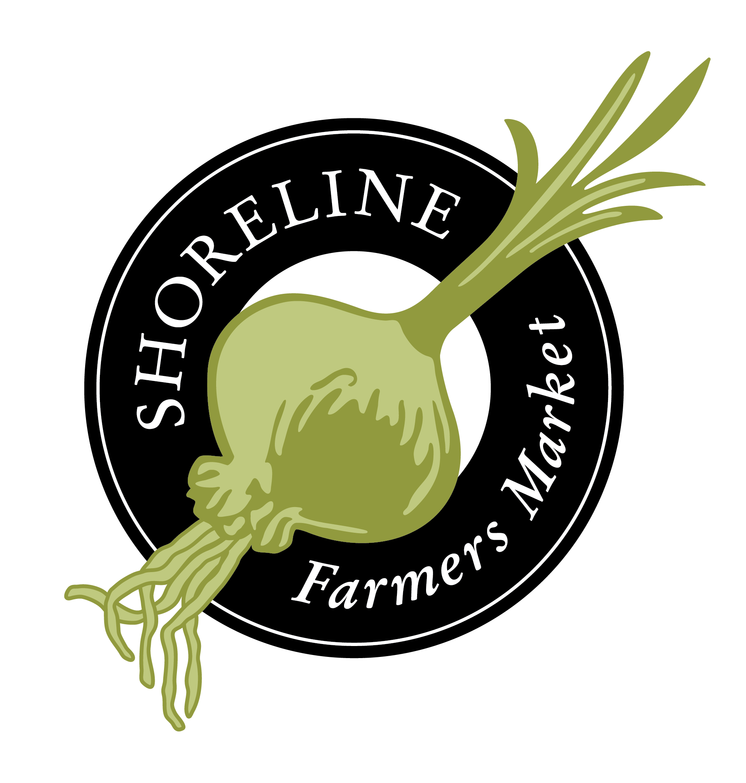
Shoreline Farmers Market
Board Member Application
The Shoreline Farmers Market supports local and sustainable agriculture and small business, community building, food equity programs, and economic development efforts in the City of Shoreline.
Please return to info@shorelinefarmersmarket.org.
Date: ______/______/________
Name: ______________________________________________________________________
Address: ____________________________________________________________________
Phone: ______________________________ Cell Phone: _____________________________
Email: _______________________________________________________________________
If you were to be appointed to the Board, may the above information be shared with other Board Members for purposes of Shoreline Farmers Market business?
- Yes
- No
Employer Name: ______________________________________________________________
Employee Title: _______________________________________________________________
Type of Business: _____________________________________________________________
Please list Boards & Committees that you serve on or have served on (business, civic, community, fraternal, political, professional, recreational, religious, social). List Organization, Role/Title & Years of Service.
Organization Role/Title Years of Service
____________________________________________________________________________
____________________________________________________________________________
____________________________________________________________________________
____________________________________________________________________________
Skills, Experience & Interests (check all that apply)
- Early stage organizations/start-up experience
- Financial oversight
- Strategic planning
- Understanding of community needs
- Money to give or ability to get money
- Available to write grants/sponsorship applications
- Corporate connections
- Political connections
- Small business connections
- Event management
- Real estate management experience
- Urban planning experience
- Farmer or agricultural producer
- Farmers market board member experience
- Farmers market manager or director experience
- Digital marketing knowledge
- Website development experience

Have you attended the Shoreline Farmers Market?
- No
- Yes, once or twice a season
- Yes, 5-10 visits a season
- Yes, most markets a season
How many seasons have you attended the Shoreline Farmers Market?
- 2011
- 2012
- 2013
- 2014
- 2015
- 2016
- 2017
- 2018
- 2019

Why are you interested in serving on the Shoreline Farmers Market Board? What do you hope to gain from the experience?
____________________________________________________________________________
____________________________________________________________________________
____________________________________________________________________________
____________________________________________________________________________

How do your skills, experience, and interests translate to supporting the success of the Shoreline Farmers Market?
____________________________________________________________________________
____________________________________________________________________________
____________________________________________________________________________
____________________________________________________________________________
____________________________________________________________________________
____________________________________________________________________________
____________________________________________________________________________
____________________________________________________________________________
Appointment to the Board requires consistent attendance at regularly scheduled meetings. Are you available for monthly evening meetings?
____________________________________________________________________________
____________________________________________________________________________
____________________________________________________________________________
____________________________________________________________________________
____________________________________________________________________________
____________________________________________________________________________
____________________________________________________________________________
____________________________________________________________________________
Appointment to the Board requires contributing to the Shoreline Farmers Market. Are you available to make a financial contribution by Thanksgiving each year in an amount significant to you?
- Yes
- No
Comments: __________________________________________________________________

