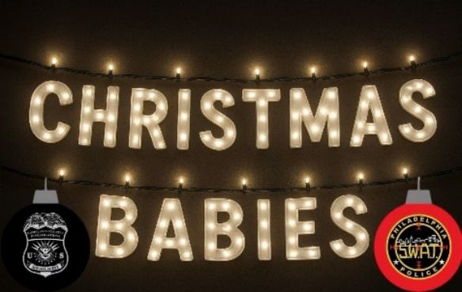

Christmas Babies was founded in 2021 by Ashley Capaldi, a devoted mom, & former Philadelphia Police Investigator in the human trafficking unit of the Special Victim’s Unit. Inspired by her work with survivors of severe abuse and trauma, Ashley launched the nonprofit to fulfill Christmas wish lists for affected children.
Christmas Babies provides Christmas wishes and essential support for children who have been victims of crime, the foster care system, human trafficking, gun violence, and other community hardships. Our mission is to ensure that every child we serve feels seen, valued, and cared for during the holiday season. Through generous sponsors and donors, we fulfill both needs and wishes—bringing comfort, joy, and hope to children and families in crisis.
This holiday season, you can make a real difference in the life of a child. By becoming a Sponsor, your donation will bring joy, hope, and the magic of Christmas to children who have faced unimaginable circumstances and hardships and trauma.
The children we are helping have endured the impacts of crime, violence, foster care, human trafficking, child sexual abuse, near-fatalities and community circumstances, yet their innocence and hope shine brighter than anything else.
Every contribution, big or small, helps provide gifts, expand our programs, and ensure that no child is left without. With your support, we can make this holiday season unforgettable for every child in need.
We believe every child deserves to feel seen, loved, and celebrated- especially during the holidays.
In 2024, the organization expanded its mission with Christmas Babies Bedding, providing essentials like pillows, sheets, and blankets—without replacing the special gifts children wish for.
Christmas Babies is a registered 501(c)(3) non-profit organization. All donations are tax-deductible, and we are happy to provide a letter of tax acknowledgment for your records.
Every gift makes a difference. Help us make sure every child’s wish list is fulfilled this Christmas!

Sponsorship Tiers
🎁 Santa’s Helper Sponsor- $2500
Your generous support goes directly towards expanding our program, ensuring no child is left without, as well as covering larger ticket items and ensuring that more children in need experience the joy and magic of the holiday season. As a Santa’s Helper Sponsor you are a vital part of our mission to make wishes and needs come true for children who have faced the most hardships, those who are the most innocent among us.
In appreciation, your company name, logo and click through link will be included on our website and social media under our platinum sponsor tab. Special recognition will be given throughout our holiday season as we fulfill all needs and wants of the most innocent.
🎁 Family Sponsor- $1000
This sponsorship fulfills the needs and wishes of siblings or small families affected by crime, foster care, or community hardships. By providing for the whole family unit, you bring healing, stability, and a sense of togetherness during the holidays.
In appreciation, your company name or logo will be included on our website and social media under the “Family Sponsor” tab.
🎁 Safe Sleep Sponsor- $400
This level covers the cost of a complete bed—mattress, frame, and bedding—for a child in need. You give them more than just a place to sleep; you give them safety, comfort, and peace of mind.
In appreciation, your company name or logo will be included on our website and social media under the “Safe Sleep Sponsor” tab.
🎁Wish List Sponsor- $250
At this level, your sponsorship grants a child their full personalized Christmas wish list. From essentials to special wishes, you ensure they receive everything they’ve asked for bringing joy, stability, and hope.
In appreciation, your company name or logo will be included on our website and social media under the “Wish List Sponsor” tab.
🎁 Gift Card Sponsor- $100
Your sponsorship provides small denomination gift cards to restaurants, stores, and other essentials for teenage children impacted by crime, foster care, or other hardships. This gift offers dignity, independence, and small comforts during a difficult time.
In appreciation your company name or logo will be included on our website and social media under the “Gift Card Sponsor” tab.
🎁 Helping Hand – Open Donation
Every gift, no matter the amount, helps us bring comfort, hope, and support to children and families through Christmas Babies. Open donations allow us to direct funds where they are needed most, whether that’s providing emergency essentials, extra bedding, clothing, or covering urgent unmet needs. Open donations can be made via check or directly to Venmo.

To become a sponsor, contact us at ChristmasBabies1@gmail.com
Checks can be made payable to: Christmas Babies
Christmas Babies - 1393 Butternut Drive - Southampton, PA 18966

Donations can also be made directly through Venmo: @Christmas-Babies
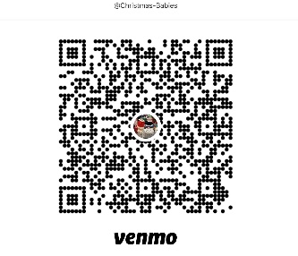

Website: https://christmasbabies1.wixsite.com/christmas-babies

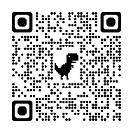
Please follow Christmas Babies on Facebook for updates and a closer look into the organization:

