 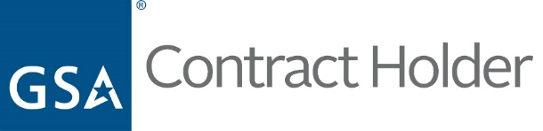



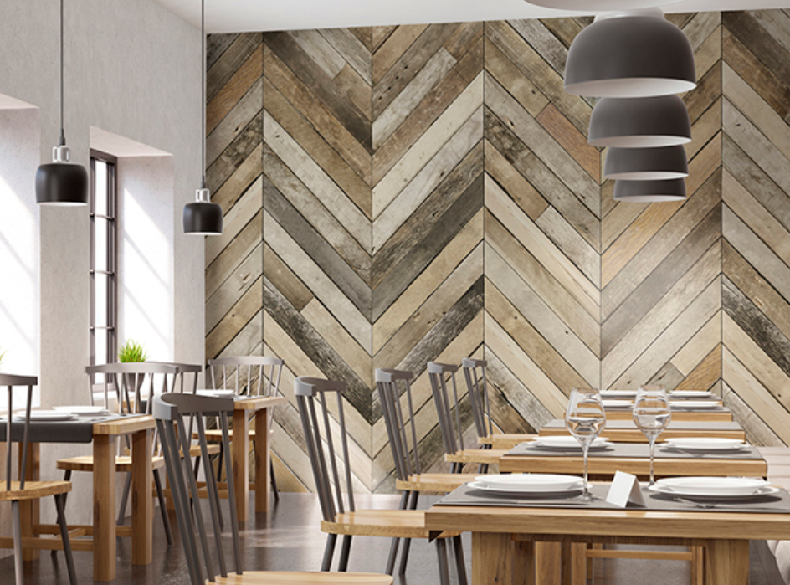

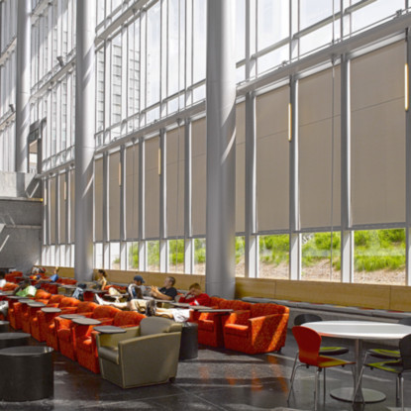

**Light Consultants LLC** dba [www.**Wallpaperwholesaler.com**](http://www.Wallpaperwholesaler.com) believes in offering beautiful and functional wallcoverings at an affordable price. We carry only the highest rated and most preferred brands available. We are distributors of all major brands of residential and commercial wallcoverings, such as Astek, Koroseal, MDC, York, Wolf Gordon and many more. From sophisticated department stores to state-of-the-art medical facilities, prominent restaurants, and office buildings, our commercial wallcovering graces the walls of some of today’s most noteworthy spaces.

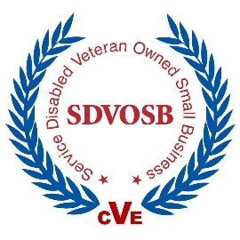

Wallcoverings

**Light Consultants LLC** dba: [www.**Blindsmax.com**](http://www.Blindsmax.com)believes in offering custom window treatments at an affordable price. Whether you’re shopping for blinds, window shades, or shutters, you can find what you are looking for at Blindsmax. We carry only the highest rated and most preferred brands available on any budget with the help of our knowledgeable customer service professionals or shop online at your convenience. We are distributors of all major brands, such as Hunter Douglas, Graber, Draper and many others. We are also proud to carry Caco Window Fashions products that are manufactured in our home state of Tennessee. The products we sell are of superior quality and are Made in the USA using only superior, quality components.

Window Treatments

**# 47QSMAA20D08NB**

2115 Chapman Rd. Suite 101 Chattanooga, TN 37421

Phone 1-888-305-8020 – Email: [gsa@blindsmax.com](mailto:gsa@blindsmax.com) – Webpage: [www.lightconsultantsllc.com](http://www.lightconsultantsllc.com)

Wallcoverings

•

•

•

•

•

•

•

•

•

•

•

**Duns - 174274076**

**Cage - 4EM34**

**GSA Contract # 47QSMAA20D08NB**

**238320** Painting and Wallcovering Contractors

**337920** Blind and Shade Manufacturing

**442110** Office Furniture

**444120** Paint and Wallpaper Stores

**238330** Flooring Contractors

**423210** Furniture Merchant Wholesalers

**442291** Window Treatment ent Stores

Schedule 72

Window Treatments

➢

➢

➢

➢

➢

➢

Over 35 years in business

Our knowledgeable, professional staff has over 75 years combined experience

We participated in an Extreme Makeover show

We aim to take care of your purchasing needs as fast and as cost effective as possible

We have always been and always will be an equal opportunity employer

Light Consultants LLC is owned and managed by Bill Light, a former US Army Special Ops Scout Dog Handler who served in Vietnam and we are a SDVOSB

What sets **Light Consultants LLC** apart from the competition?

As a Service Disabled, Veteran Owned Small Business, **Light Consultants LLC** is committed to excellence and creating innovative and flexible solutions for our State and Federal clients.

Schedule 72 – NAICS Codes

Consulting • Wall Coverings • Window Treatments