ENGAGE
Debbie Roy, Carla Bonnell, Ray Dunham, Rick Bartlett ( Missing in photo: Larry Steele)
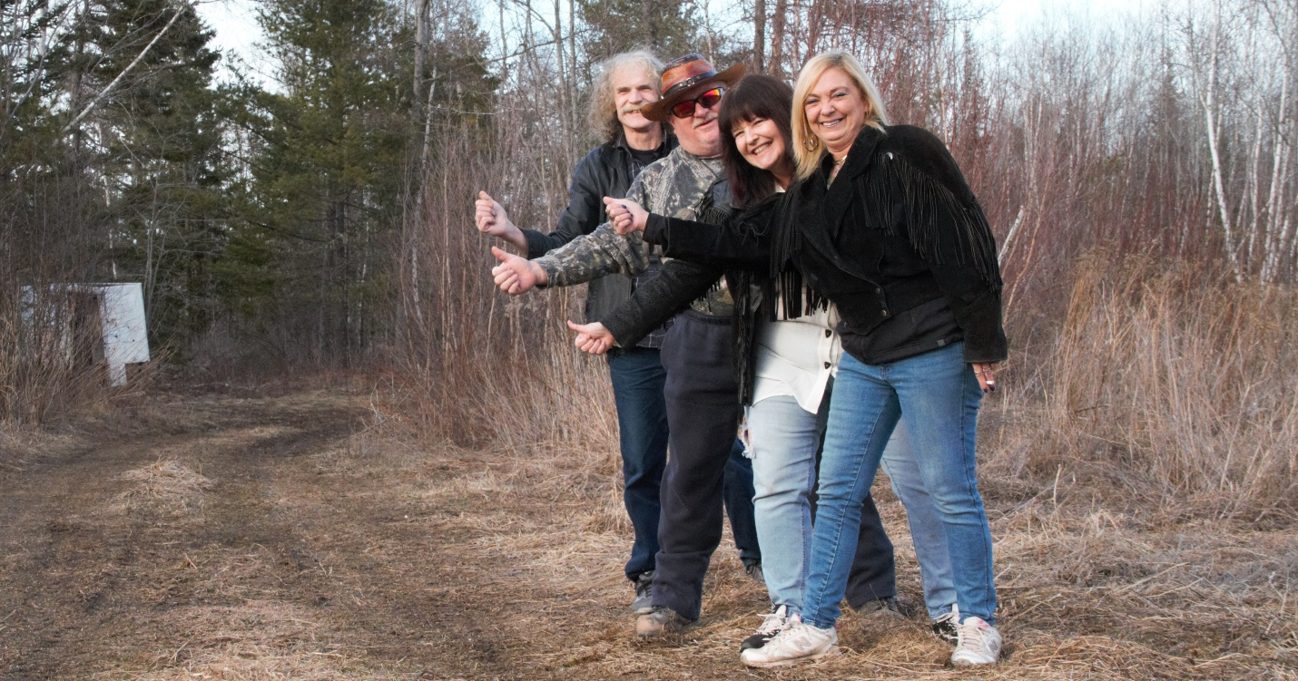

BIO

THE BAND
One of the few bands that does not have a front man/woman! All boast as lead singers, background singers and the most important ingredient- Friendship! The combined influences of prog rock, southern rock, country, blues and folk, has birthed a sound that is highly recognizable as ENGAGE. Fans can be sure that they will be “engaged” in every moment of their performances and will have many good memories for the years to come.
MEMBERS
Debbie Roy: Inductee into the Minto Country Music Hall of Fame. Debbie has toured the Maritime Circuit with the Debbie Roy Band and has been performing solo and as a guest performer since the time she was a young girl. She is a Nashville recording artist with roots in Gospel, Country and Pop Rock. Debbie is releasing her first single with Engage called Voices of the Children

Carla Bonnell: 2014 Inductee into the Minto Country Music Wall of Fame, ISSA nominee 2022 for Vocalist of the Year and Single of the Year, Top 10 finalist in the World Songwriters Contest Winter 2021, and received the Outstanding Legacy Award with the Akademia Awards in LA in June 2022. Carla is a multi-instrumentalist and singer songwriter with influences in southern rock, folk and country.
Rick Bartlett: In 2015 recorded an album with Billy Sherwood, who is the current bass player for legendary prog rock band, "Yes".
Ray Dunham : He played with local bands throughout his music career. Most notably, Southern Justice, who shared the stage with classic bands such as April Wine, Trooper, Matt Minglewood and Randy Bachman to name a few.
Larry Steele Larry Steele who has joined Engage as their drummer on their recording and their shows, toured the Maritime Circuit during the 70s to Early 90s, having played from Labrador to Victoria BC. During this time and into the early 2000's, he has been on National TV as the Drummer gone Plummer on Undercover Boss and recorded at Phase One Studio in Markham Ontario

Single Release
Voices of the Children -ENGAGE
Written and Performed by Debbie Roy
Lead Guitar and Background Vocals : Rick Bartlett
Keyboards and Background Vocals: Carla Bonnell
Bass and Background Vocals: Ray Dunham
Producer/Sound Engineer: Ray Dunham

Wave and MP3 Download Voices of the Children

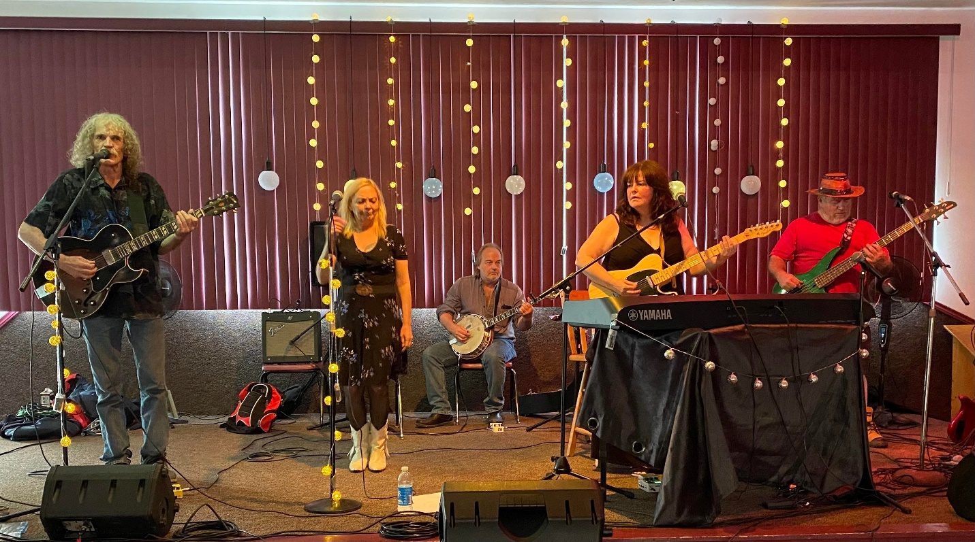
Engage Photos for Download here

