Carla Bonnell
  - The LIBERATOR 2014
  - FREDERICTON, NEW BRUNSWICK
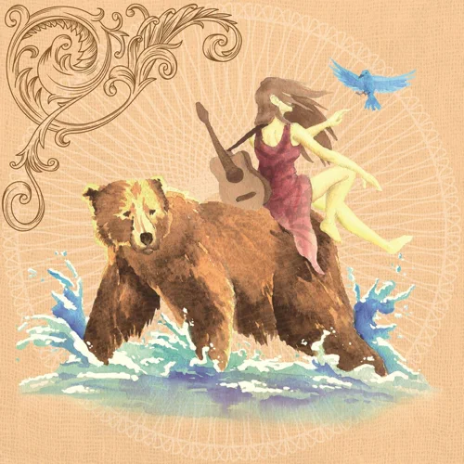

BIO

Award Winning Singer Songwriter, Carla Bonnell brings to the audience a combination of country and rock in her live performances. As a multi-Instrumentalist she moves easily from one to the other with a strong stage performance that draws in her audience.

TRACKS
All songs produced by J.P. Cormier All songs written and composed by Carla Bonnell
- For A Fool 2:42
- The Letter 2:40
- Cariboo Express 2:39
- Two Little Towns 2:45
- Rain 2:49
- The Calling 2:52
- Wishing Well 2:45
- Gypsy Heart 2:33
- The Drive 2:24
- Bless or Curse the Tide 3:04
- The Last Train 2:49
- The Kitchen Party 2:26

SINGLE
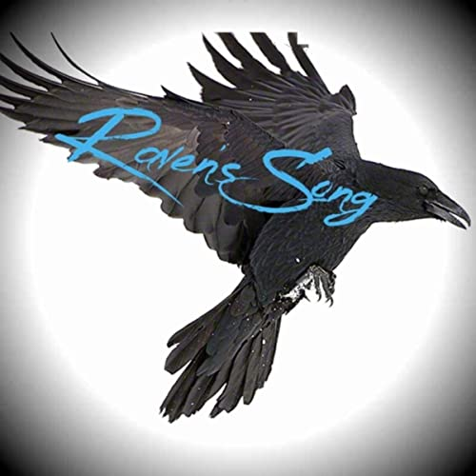

Raven’s Song -2019- lyricist/composer Carla Bonnell – Producer Dustin Jones IRSC usdy41983557

REVIEWS

as refreshing as a Maritime breeze.
I’d say it’s country folk, sort of a cross between Jim Croce and maybe Union Station. The musicianship on The Liberator is exquisite- deftly played acoustic guitars, mandolins for color and flavor, with each song easily relatable to your own life- either what has happened to you, or things you’re going through now. Making music that listeners can see themselves in is no mean feat, and Bonnell accomplishes that with room to spare.Carla Bonnell’s voice is quite ordinary- unadorned but tuneful with no frilly vibrato or fancy vocal tricks. Far from being a complaint that’s a compliment, and exactly what songs like The Drive need to come across. When you put on a CD like this your first shouldn’t be “dazzle me” but “Tell me some stories and make me believe them” and that she does. – John Keireff-The Rock Doctor- Kelown, BC
High Resolution Photos
Raven's Song on Soundcloud
The Liberator Full Album MP3

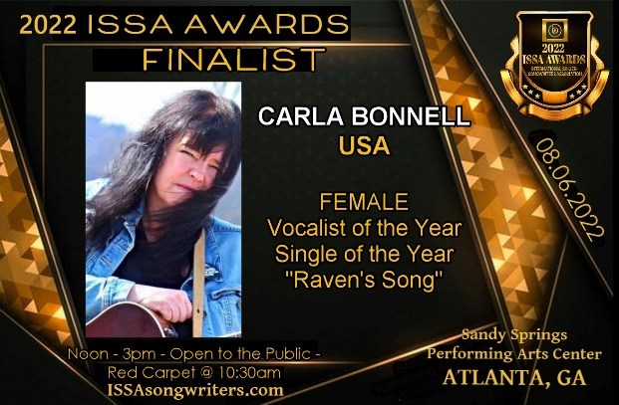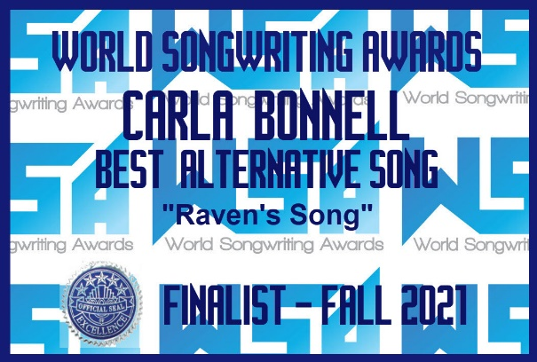
2014 Inductee of the Minto Country Music Wall of Fame

