**MOTILAL NEHRU GOVERNMENT POLYTECHNIC COLLEGE**

**IIC CELL**

**IPR ACTIVITY**: ONLINE WEBINAR

**DATE**: 03/08/23 **TIME:** 11:30 am to 01:00 pm

**TOPIC**: ART OF PATENTING – DO’S AND DONT’S

**HOST:** DEPARTMENT OF EEE & ECE

**SPEAKER**: DR. R.VALLI, PROFESSOR, MIT, PUDUCHERRY.

**REPORT**

A webinar was arranged by the IPR cell to give a fair idea to students and staffs on Patenting Rights. It was well organized by the Department of EEE and ECE. The welcome address was delivered by Dr. Selvam Sahayaradje, (Co-ordinator, IPR) presided by our respected Principal Dr. K.Nagakarthigan (President, IIC) and Vote of Thanks was given by Mrs.R.Bakialakshmy, (Member, IPR). The event was also supported by Dr.S.Janarthanan (Vice President, IIC), Dr.T.Premkumar, (Convenor IIC). The distinguished speaker provided students an opportunity to exchange ideas with many illustrations. Certificates were issued to the participants.

**OBJECTIVE**:

* To create awareness on Patenting to students.
* To understand the pros and cons of Patenting.
* To understand the difference between process patenting and product patenting.
* To know the significance and advantages of Patenting.

**OUTCOME:**

* Students gained knowledge on the scope of Patenting for simple innovations.
* Students were motivated towards innovations and Patenting.
* Students were made aware of various types of IPR
* Students learnt the difference between inventions and innovations.

**POSTER ON WEBINAR**

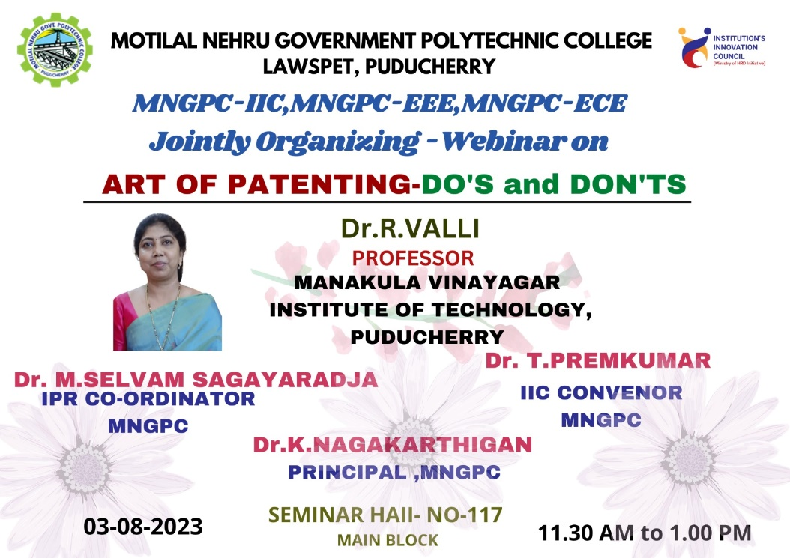

**IMAGES ON WEBINAR**

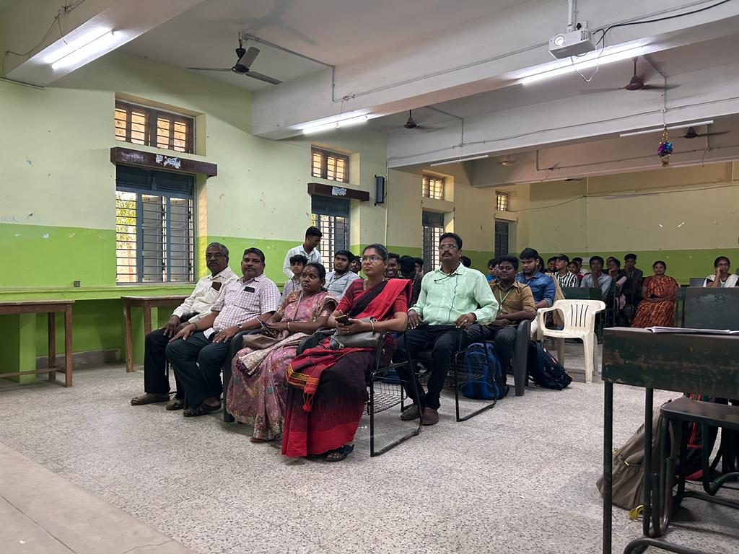

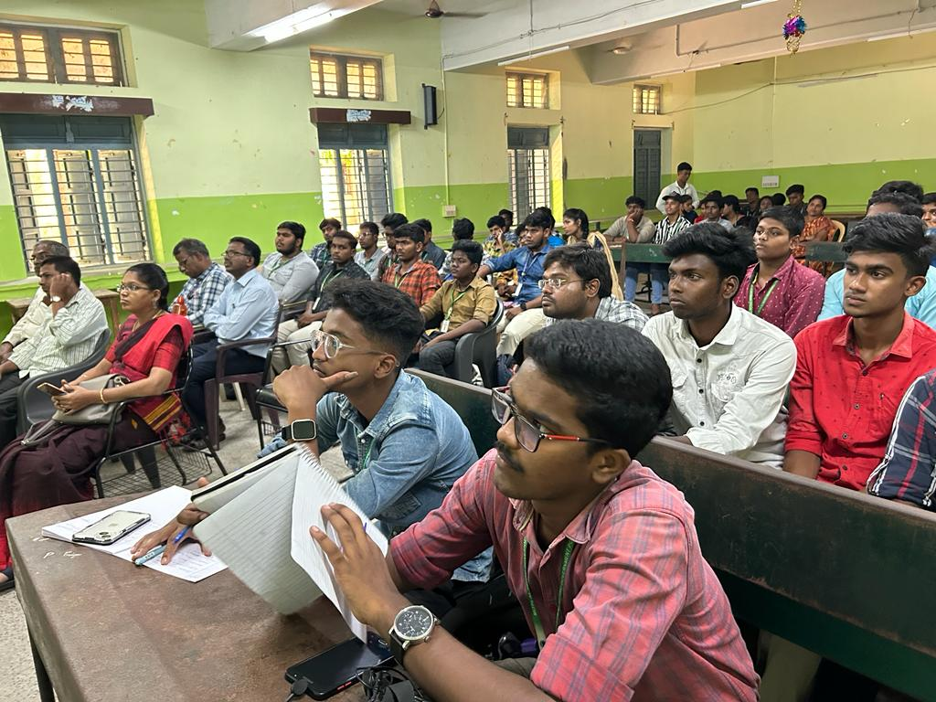

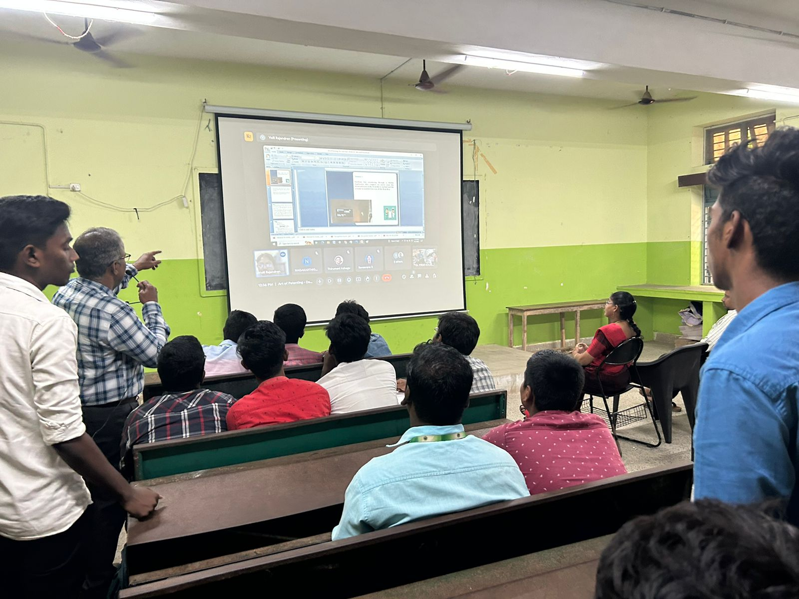

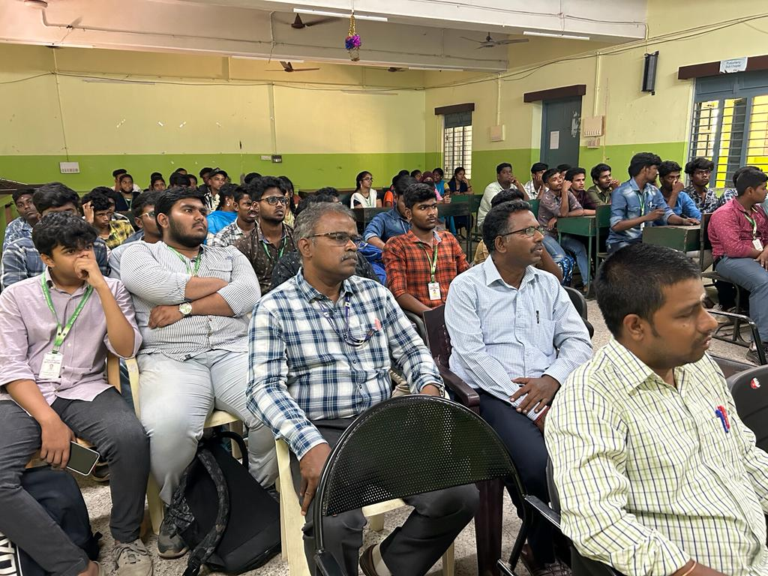

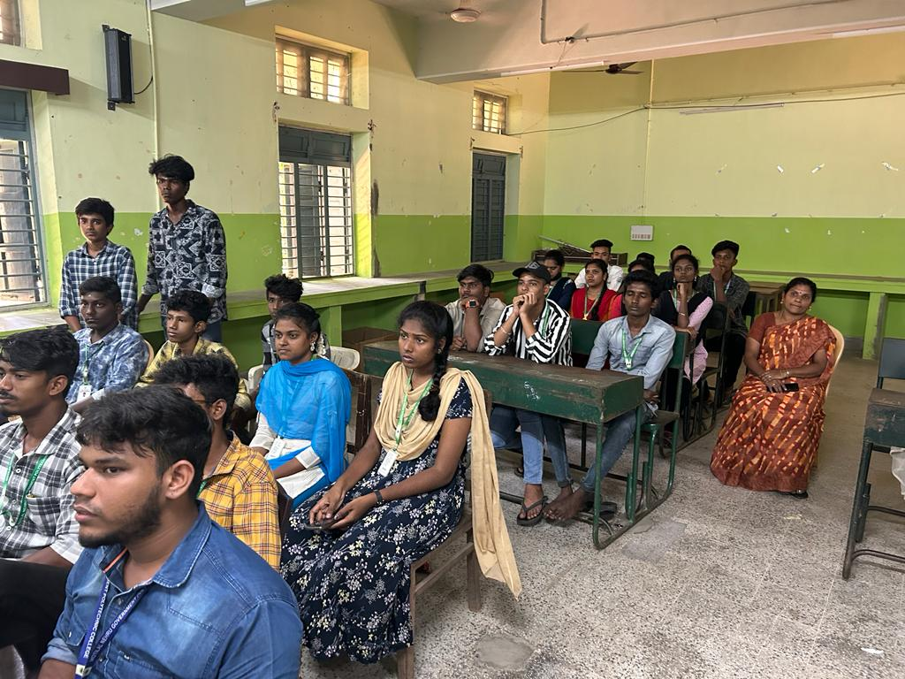

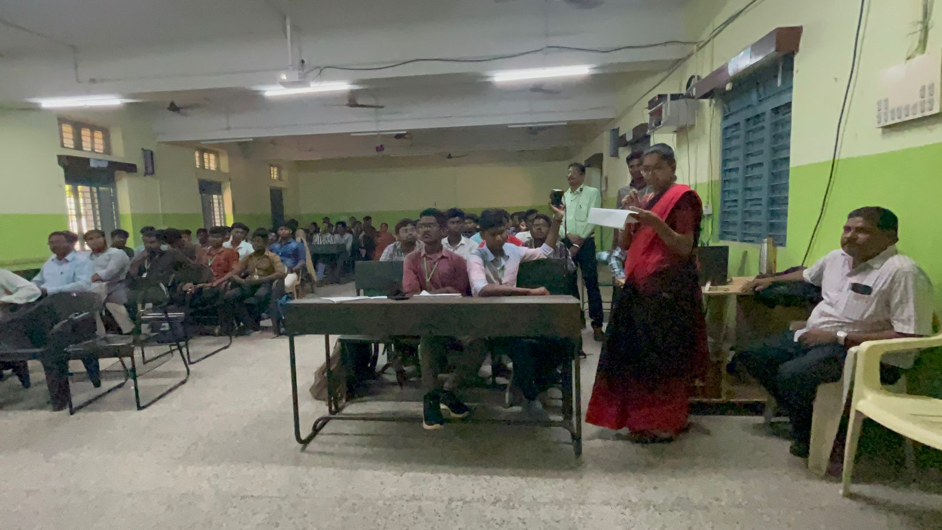

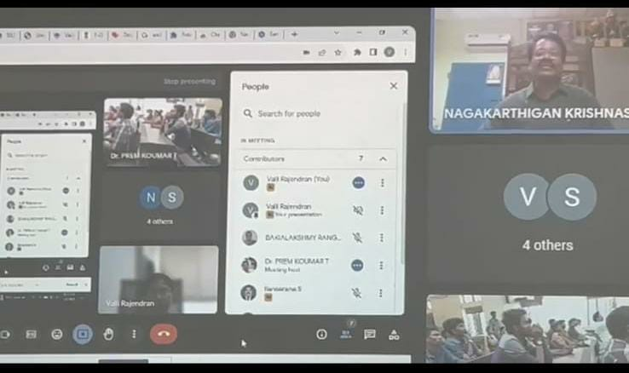

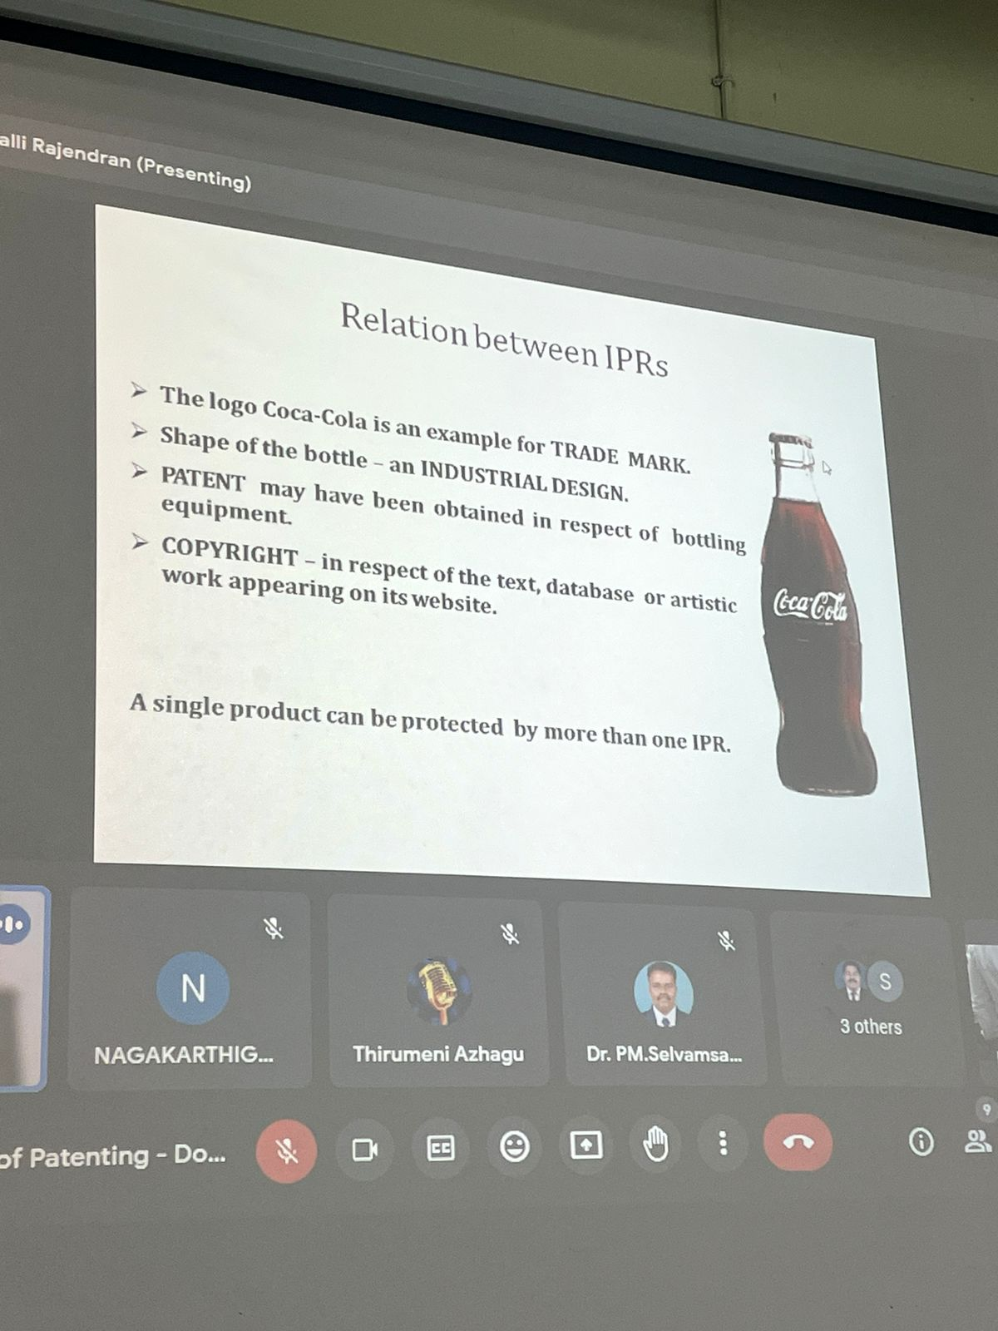

**VIDEO ON WEBINAR**



**CERTIFICATE OF WEBINAR**

