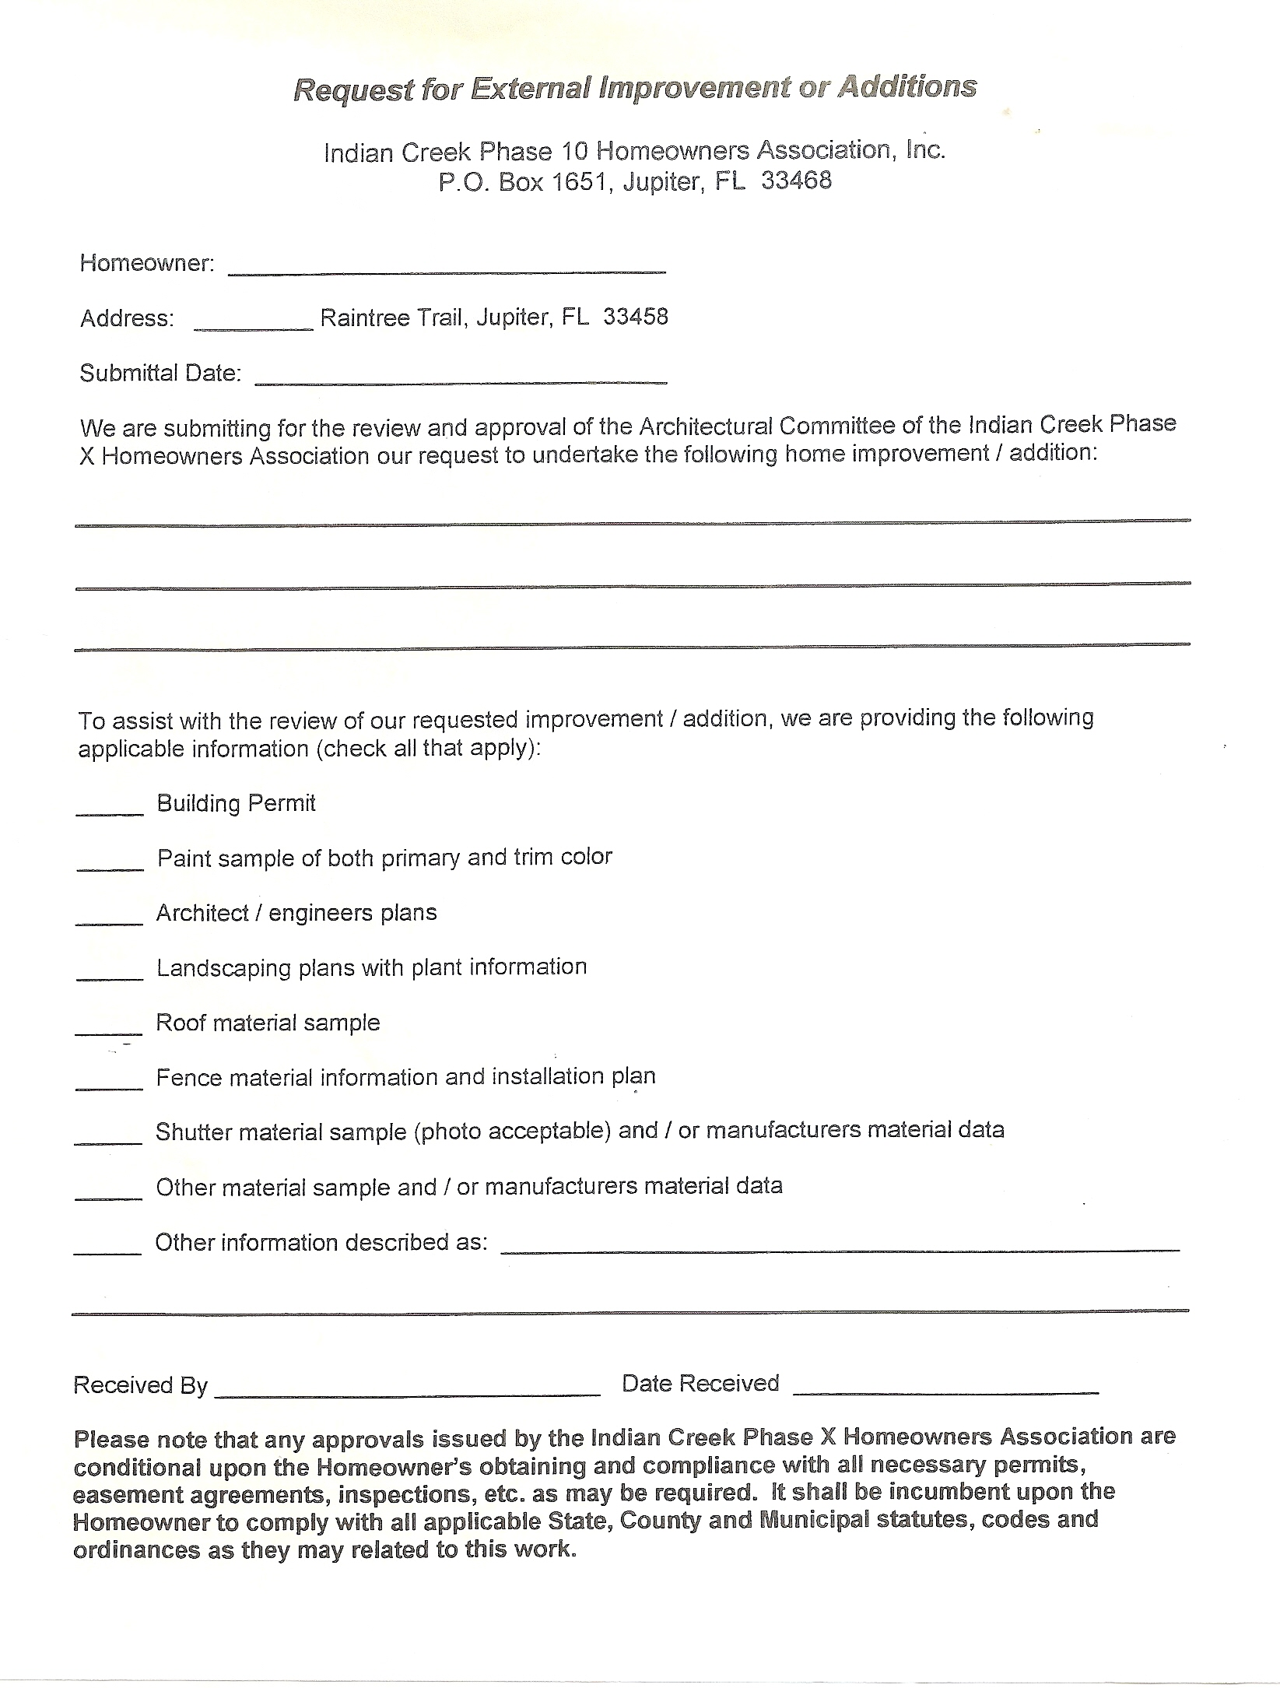

**152 Raintree Trail, Jupiter, FL 33458**