**Ho’on Dojo**

A close up of a sign

Description generated with very high confidence

An Official American Ju-Jitsu Association Dojo



**Student Handbook**

**2018-2019**

Why Ju-Jitsu?

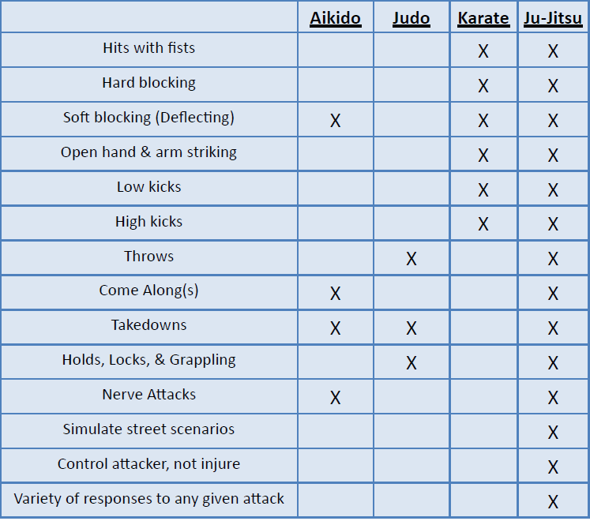

**BIO**

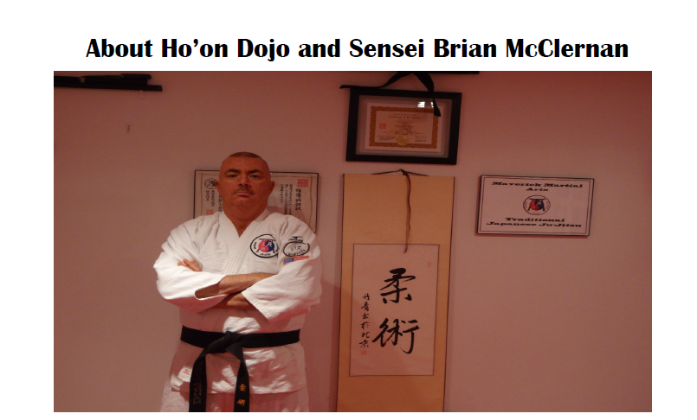

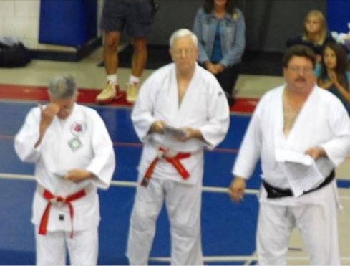



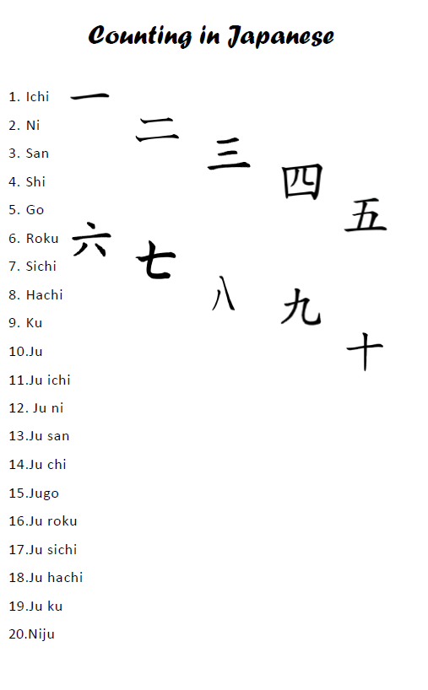

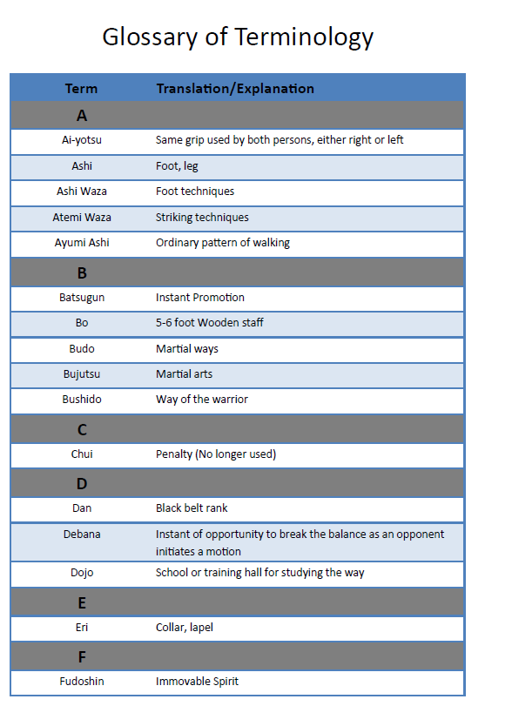

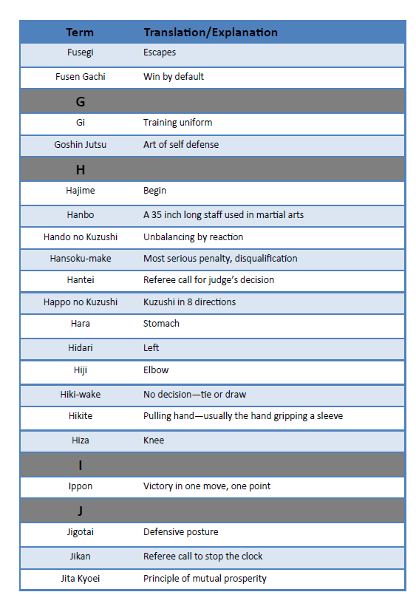

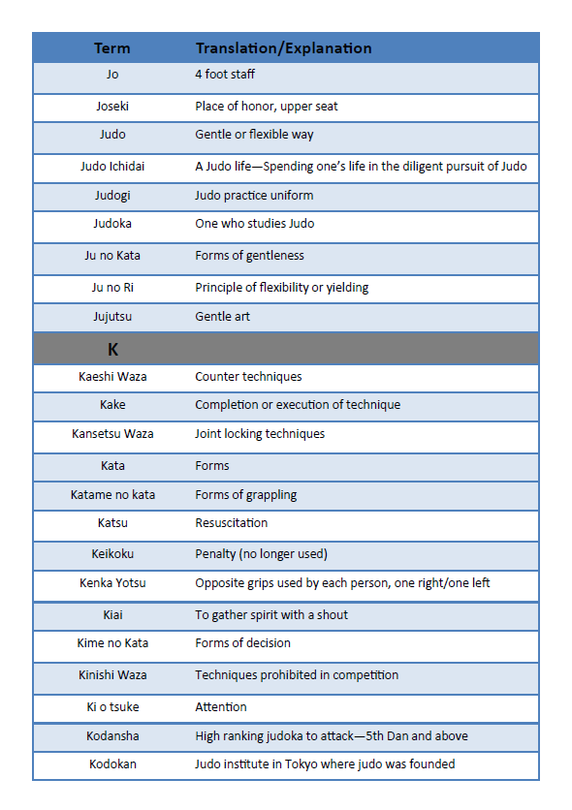

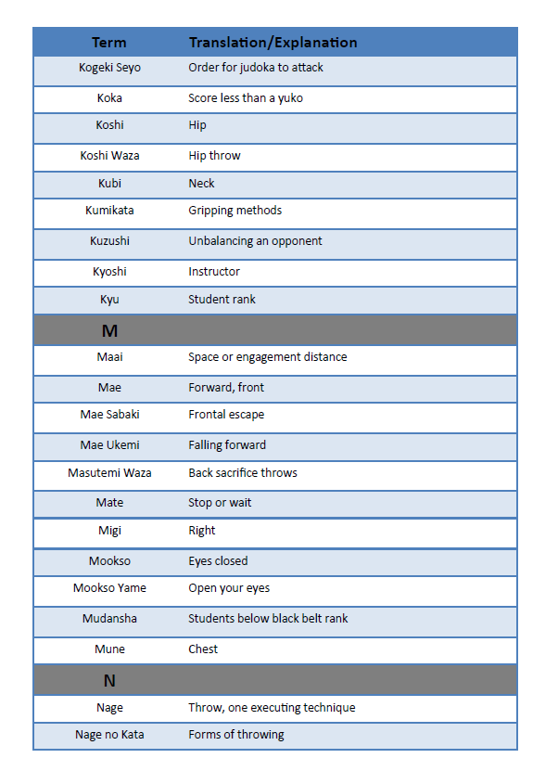

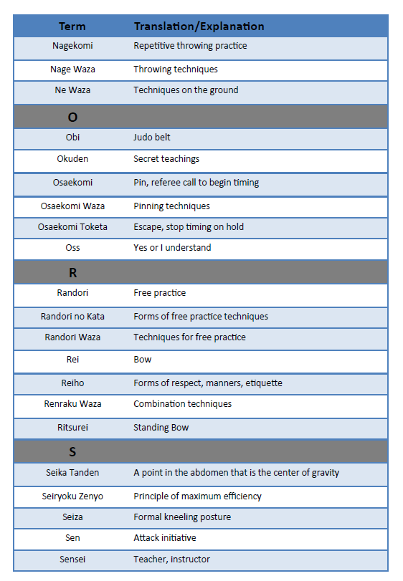

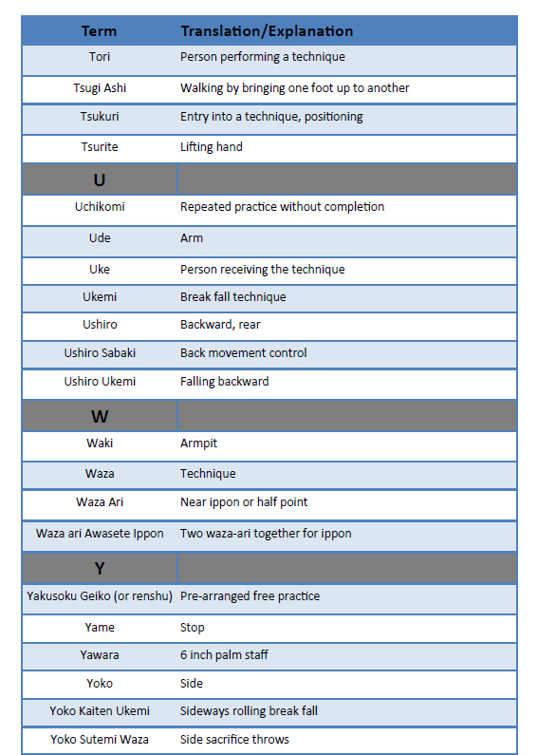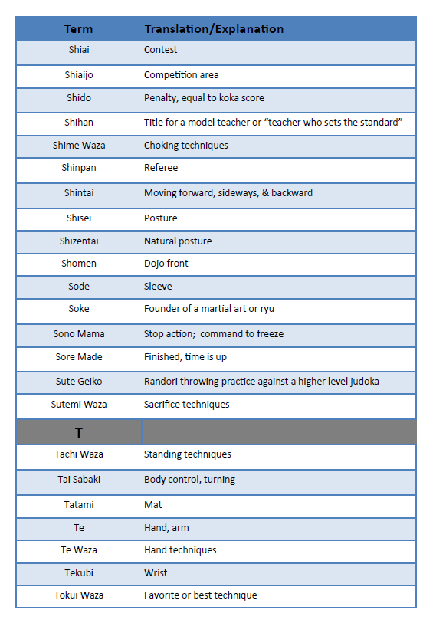

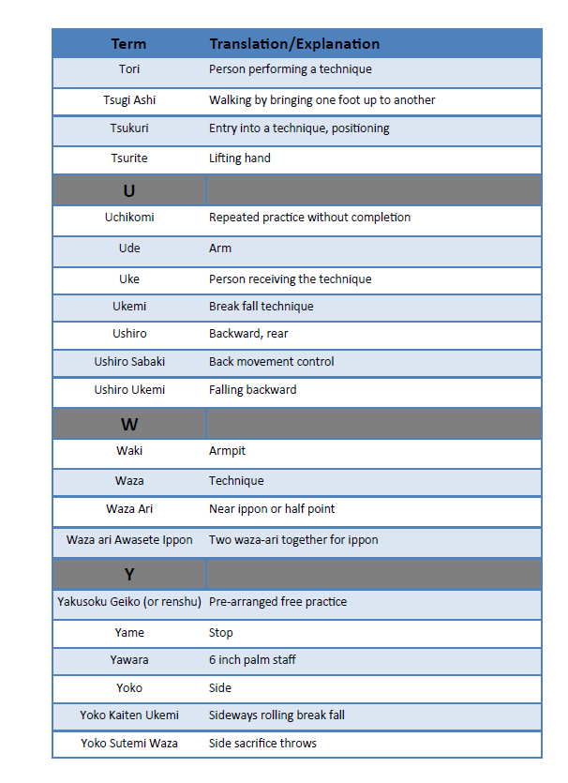

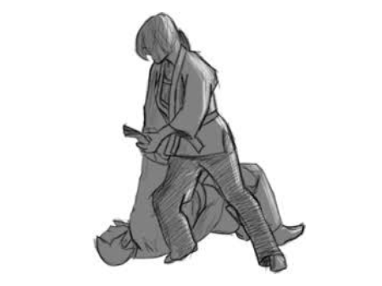

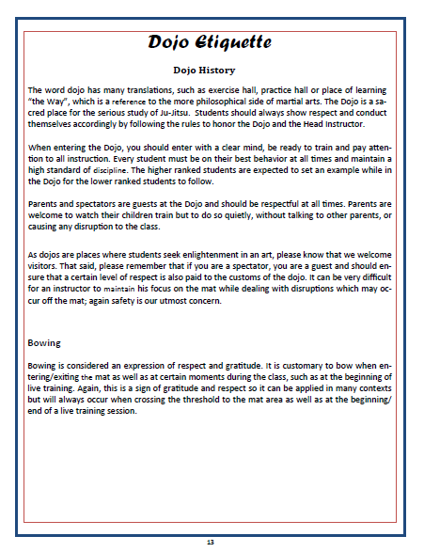

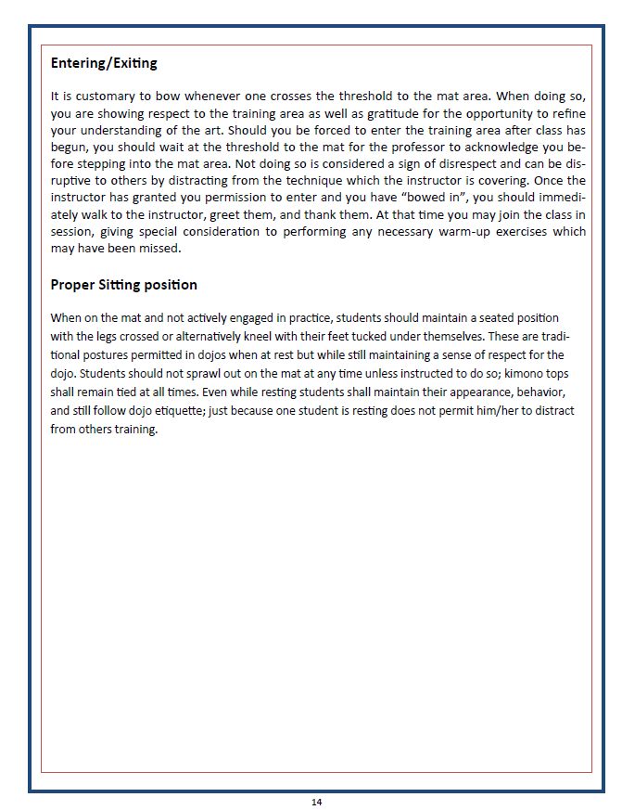

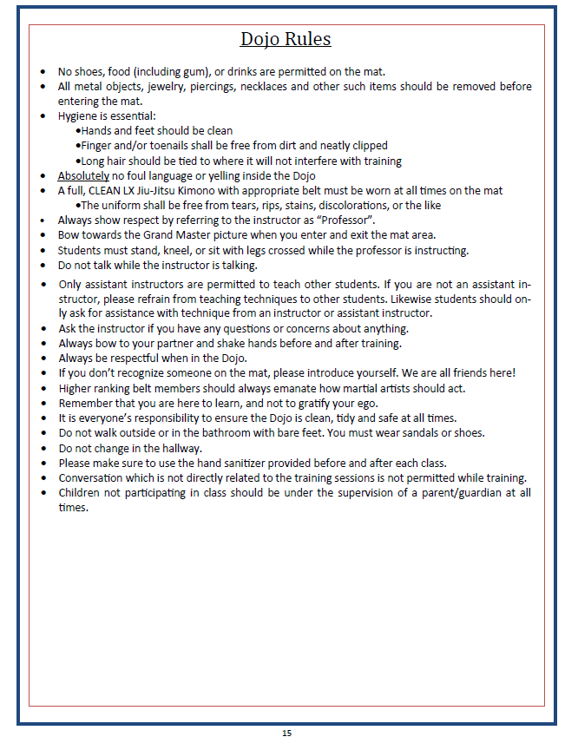

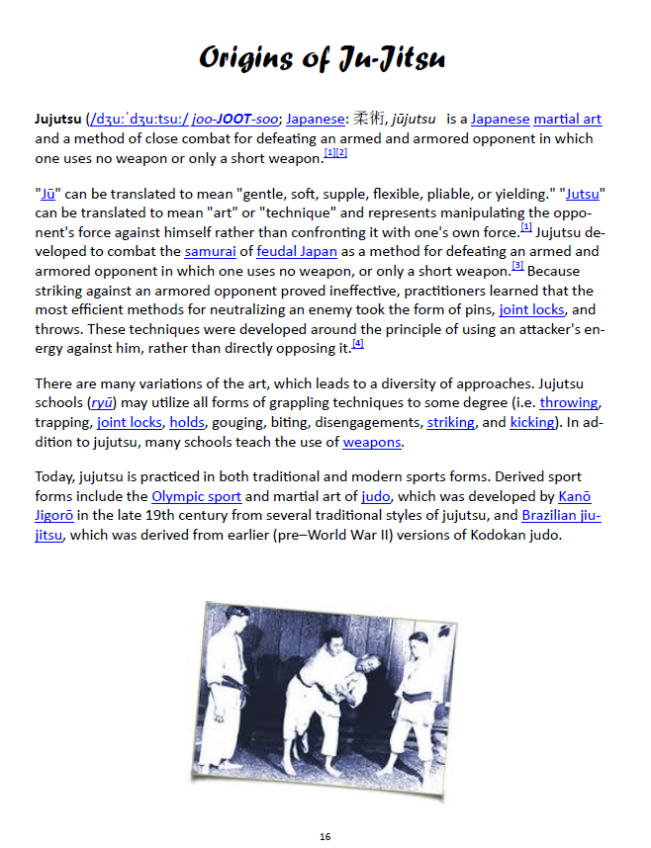

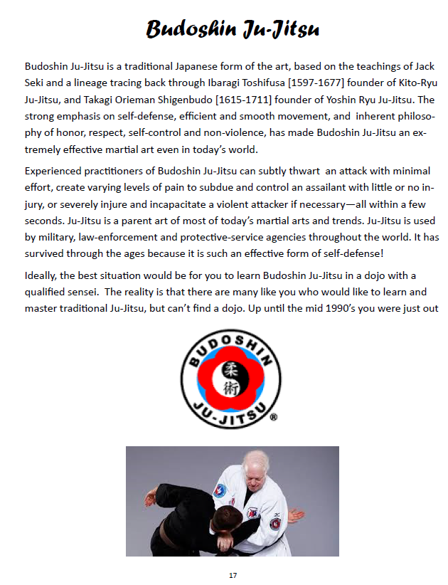

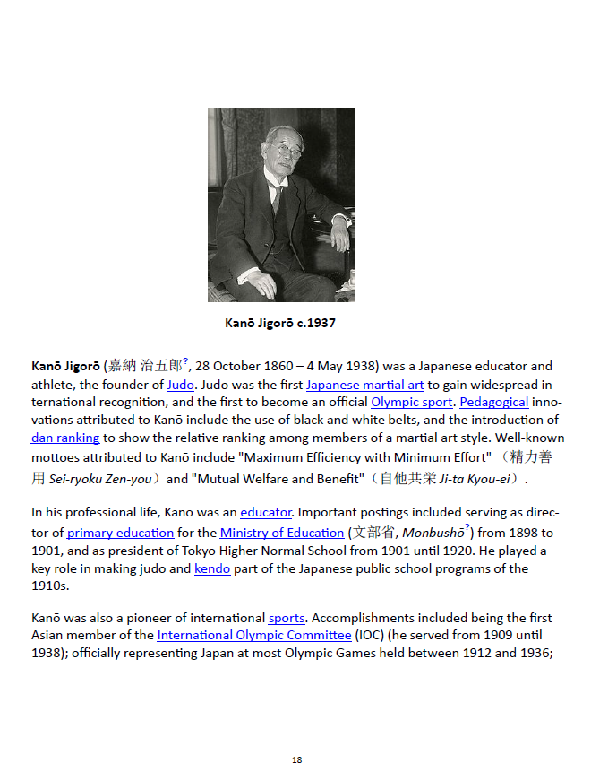

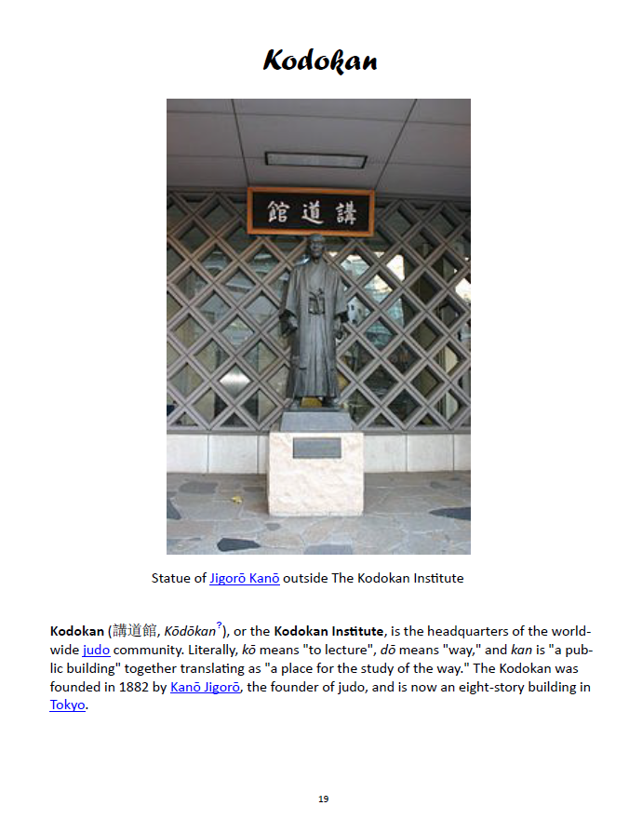

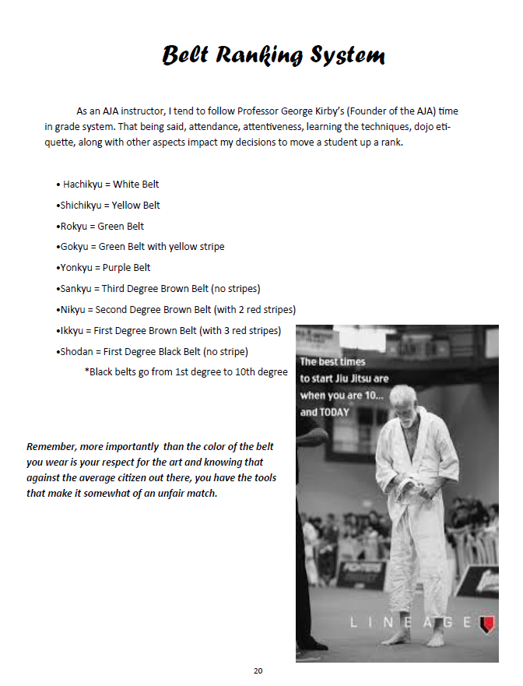

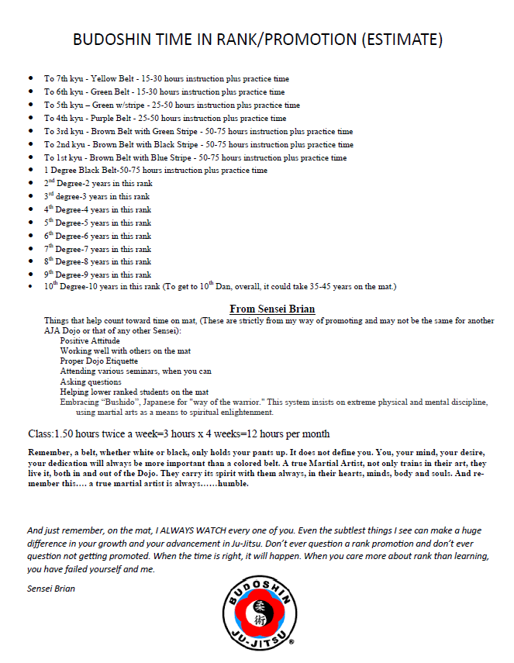

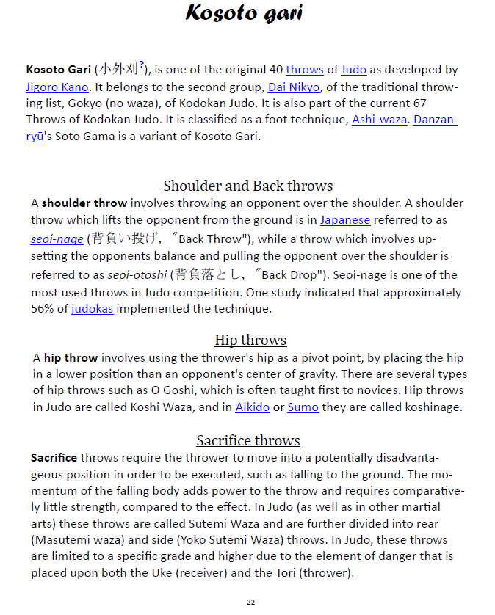

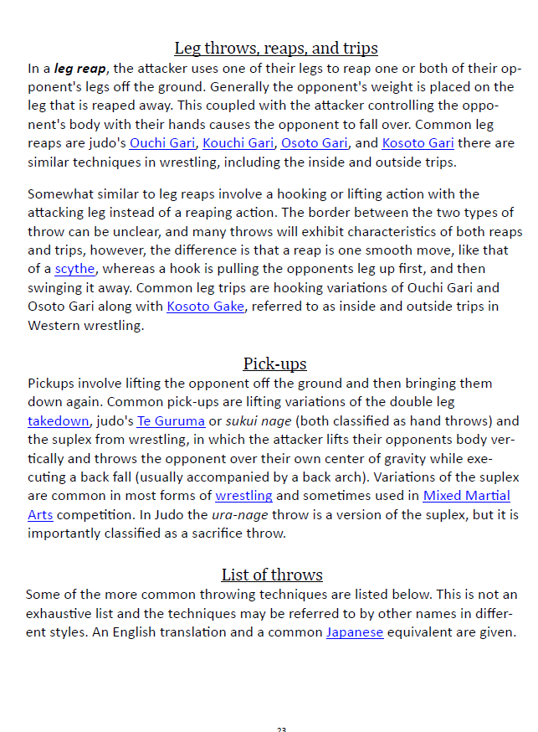

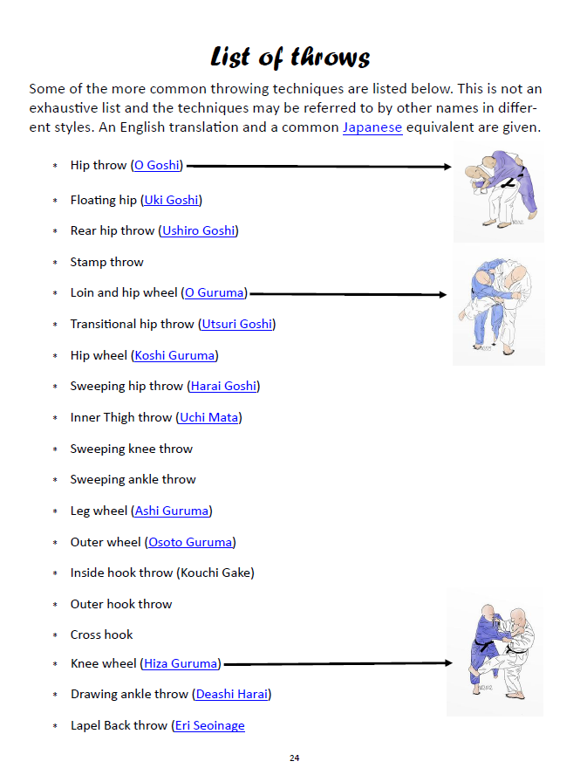

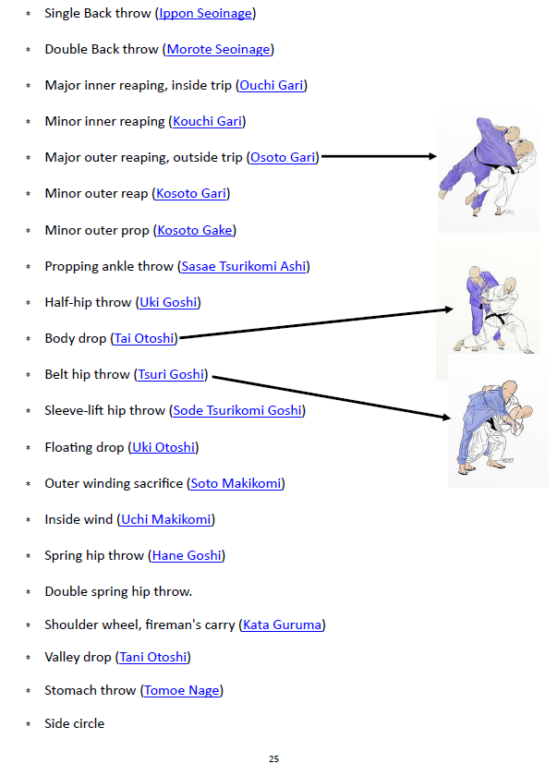

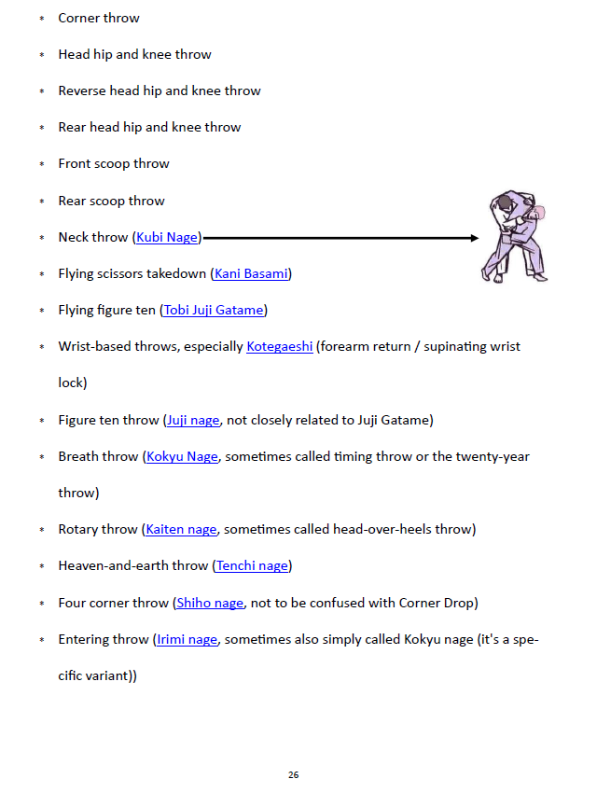

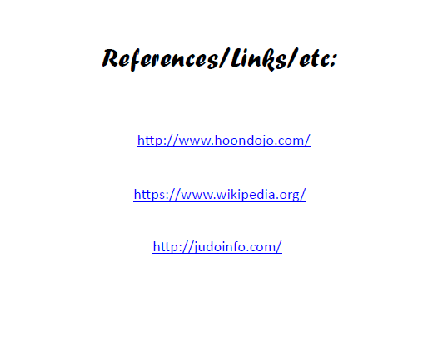

**NOTES**

**____________________________________________________________________________________________________________________________________________________________________________________________________________________________________________________________________________________________________________________________________________________________________________________________________________________________________________________________________________________________________________________________________________________________________________________________________________________________________________________________________________________________________________________________________________________________________________________________________________________________________________________________________________________________________________________________________________________________________________________________________________________________________________________________________________________________________________________________________________________________________________________________________________________________________________________________________________________________________________**

**________________________________________________________________________________________________________________________________________________________________________________________________________________________________________________________________________________________________________________________________________________________________________________________________________________________________________________________________________________________________________________________________________________________________________________________________________________________________________________________________________**