2019 TOURNAMENTS

THUNDERBOWL LANES JANUARY 12, 2019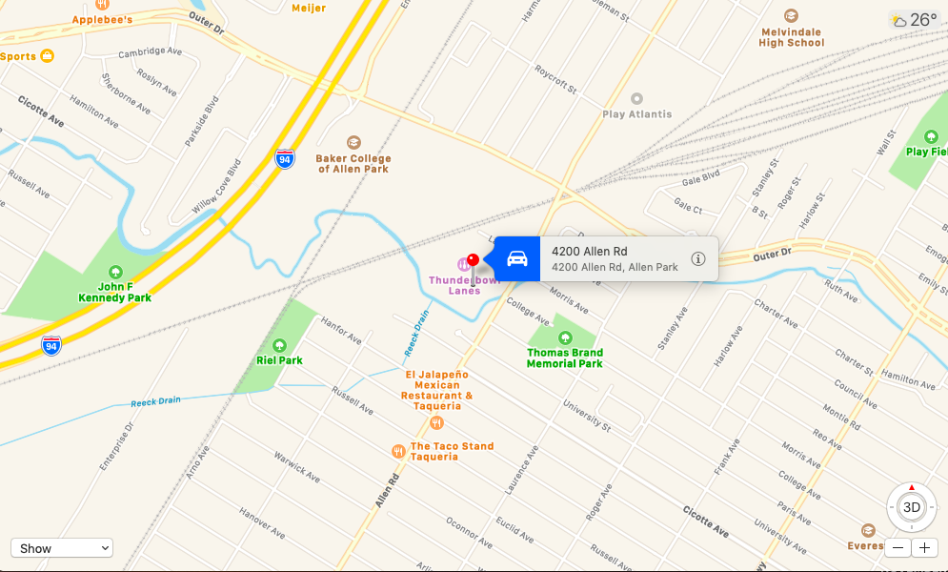

COUNTRY LANES (SUNDAY) FEBRUARY 10, 2019 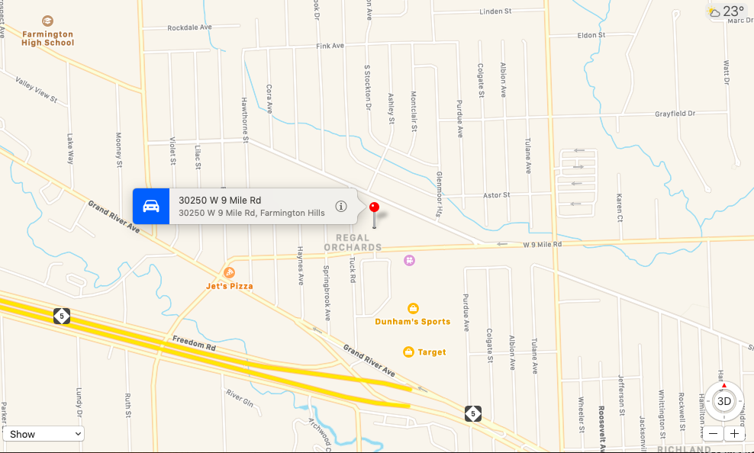

INDIAN LANES MARCH 9, 2019

REGAL LANES APRIL 13, 2019

IMPERIAL LANES MAY 11, 2019

UNIVERSAL LANES JUNE 8, 2019

WOODLAND LANES JULY 13, 2019

5 STAR LANES AUGUST 10, 2019

OAK LANES SEPTEMBER 14, 2019

STERLING LANES (SUNDAY) OCTOBER 13, 2019

ASTRO LANES NOVEMBER 9, 2019

AMF ROSE BOWL LANES DECEMBER 14, 2019

