UPCOMIG TOURNAMENTS 2019

MARCH 9,2019 INDIAN LANES
APRIL 13, 2019 REGAL LANES
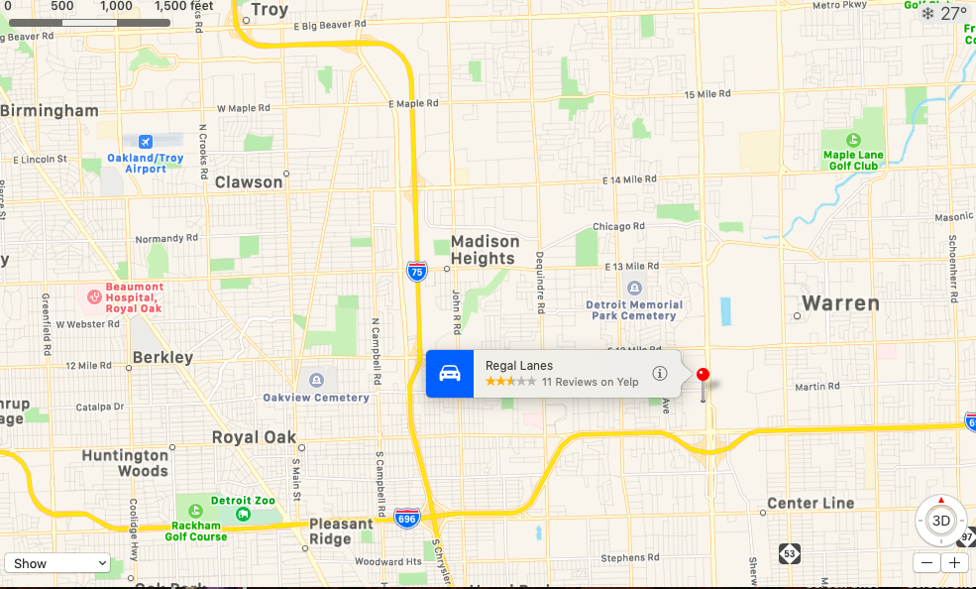
MAY 11. 2019 IMPERIAL LANES
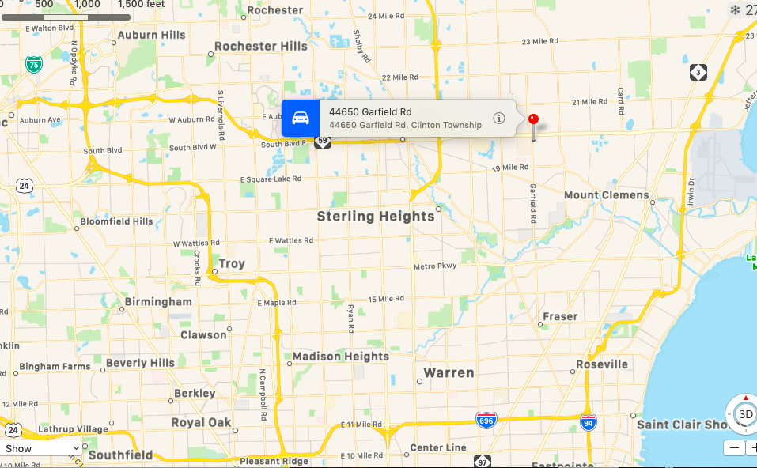

JUNE 8, 2019 UNIVERSAL LANES

JULY 13, 2019 WOODLAND LANES

AUGUST 10, 2019 5 STAR LANES

SEPTEMBER 14, 2019 OAK LANES
OCTOBER 13, 2019 STERLING LANES

NOVEMBER 9, 2019 ASTRO LANES
DECEMBER 14, 2019 AMF ROSE BOWL LANES

