NORTH AMERICAN SUPER SENIOR BOWLERS

WE HAVE TWO OPTIONS BELOW FOR YOU TO PURCHASE NASSBT BOWLING SHIRTS
NASSBT LOGOED SHIRT
JUST DOWNLOAD THE ORDER FORM
PRICING UP TO SIZE 2X CREW NO ZIPPER $ 35.00
$ 3.00 MORE PER X CREW W/ZIPPER $ 40.00
V-NECK NO ZIPPER $ 35.00
POLO W/COLLAR $ 40.00
& ZIPPER

CHOICE OF COLOR: PRIMARY/SECNDARY
NAME ON THE BACK
AMERICAN/CANADIAN FLAG PUT ON LEFT SLEEVE
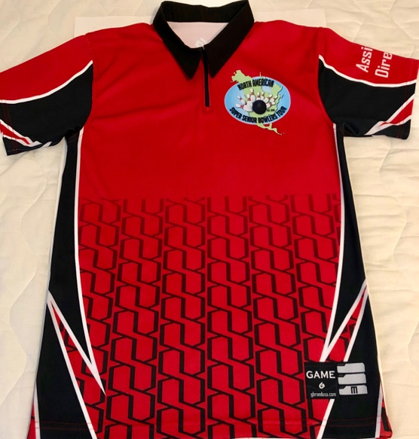

PATRIOTIC NASSBT SHIRT
JUST CLICK LINK BELOW
nassbt.itemorder.com
Cost will be $60 which includes your name on the back.
You can pick up your order, Carl Harden has offered to pick up orders
& bring to the next Tournament, or you can have your order shipped to your home for additional cost.

