√р0-^
Grow up I’ve progressive stages of 3, in 0 platform, Principle to negative energy. Of its exponential.
Principle- marsupials minus the oceans. Ectotomic.

How it affects others. [sii], blur, and its identity to longitude.

In hydronic squares there is a degree of lithium and a gravitational pull of helium based on subatomitry. These elements suggest long term distinction over short term extinction. Both introverted are the same. In Roots, are [para] magnetics, that attract, to sound what is [evil], its negative changes due at protonic form in helium, lithium, and adjacencies to solid/liquid formations via carbon. Thé intertransversal Affect. These properties suggest integrations at their lateral continues and equilateral influential pulls of subatomic light squares. In that inert, to change, requires charges per point blank in system hydrogen, its degree at 1, at ⅓. Life or death. [p].

Angles of the eye. AA
- In short term topography v h2hv infrafracture circumference. [sun to light]. 2v x e^2 proportionate levels xY by radiations. Sound energy to distance time measurement [FYI 3° parallel]. AdV.
  - in short term, there is light released that define pulls per particle by chemical reactive time processes to the inner subjunction (negative) to the pWv positive in time to energy. 3D paralel distance ]cm. Thé partial subplex [y^1] enters are in subjacent light square [&] [q] in diameters to proportionate speeds.
  - Subjenation takes about 3.t (5) instinct reversal per square) in heart to light measurements. And infrafractures by macroseconds of 3x [3° at sound (0 Distinction)] its 3rd speed cycle.
- Pair perplex. Particles. Instance Light. As seen in blood flow to cheeks.

Lithium litigation.
Abstract. In topography. By smell and taste of individual [affliction] at pure weight chemical charges (discharges backwards) by velocity measures of pure instinctual relevance to the (1) human (2) planet and their (3) sound scaled measurements of equilateral squares, in degree, its suction basis by eye movement [per particle spectral degree] to heart sound energy pull by weight. [light].

Pure weight form helium, to 3x intensities per pull weight. Forum q.

At sound has no dividend. But is divided subconsciously by measurement [velocity due at birth, harm, and instinctual existence] in integral respects to helium upon solitude, infinite defined by integrals of 8 (pull weight) 2,2,2,2 or 2^4. 7 its vanishing points equal lithium energy based in solidity of its compound measurements.

- Calcium, behind basis forum to q, answers the (3) particle to refuge culture of a given 0 platform. Its times weight times a 0 negative exponential. For 0 charge based in neutron forms [nucleic] of concentrated systems. Electrical speeds in negative [value] accent [compound] squares (also distinguished through language). Blue.
- Sodium, 0 levels of fluidity. Being adjacent weight to abnormal patience potentials I. The [p]; odd configurations timed its point integral Respect; 7 adjacent. Spectral Light.

Sodium by helium. Adjacency carbon. 0 spectral light at negative. Sensitivities to borrowed weight (perplex). Ground to water ratio at (squares) electrical impulse speeds” (sight) by angled grow up. At 0 ground level (radioactivity); in inert, Oxygen floats up, through the kidneys at 0 electronic dividend. The ground level, through layers, absorbency by organ- the skin. Water to air.

Converts Matter by air. Hypothetical relationships to hypocritical. Adjacency squares. Electronegative. In intervals. Mass to impulses, soundwaves, and renewals.

Absence of oxygen.
Solidity to air formation. Filtrations’ alcohol and time dependency. Life absorbance and degradation. Substitutes and equal Matter. The interval adjunct, measurements by time deconstruct in sound waves to electrical impulses (ll). Brain cells to solidity at [cii] reversal effect of carbon hydration [hydronic squares]. Time to energy deepens at electrical impulses, shockwaves v reality based illusions by behavior, abnormal certainties and influential (time substantial) electrical concurrents. S7 (N6).

Thé areas absorbance is flattened by vertical concentration systems in sugars (alcohol) to blood levels of integral pulse rates. By heightened energy Surplex, déformation occurs equilateral by electrical speed pulls by carbon deficiency to reFlux (electrical negative charge! [sorrow]) hydrogen to distance.

To subvert its energy reFlux then by regurgitated chemical imbalances, time, and past state per absorbance to motion. Areas divided (Surplex) in hypnotical states of energy. Vulnerability its relapse to integral degree.

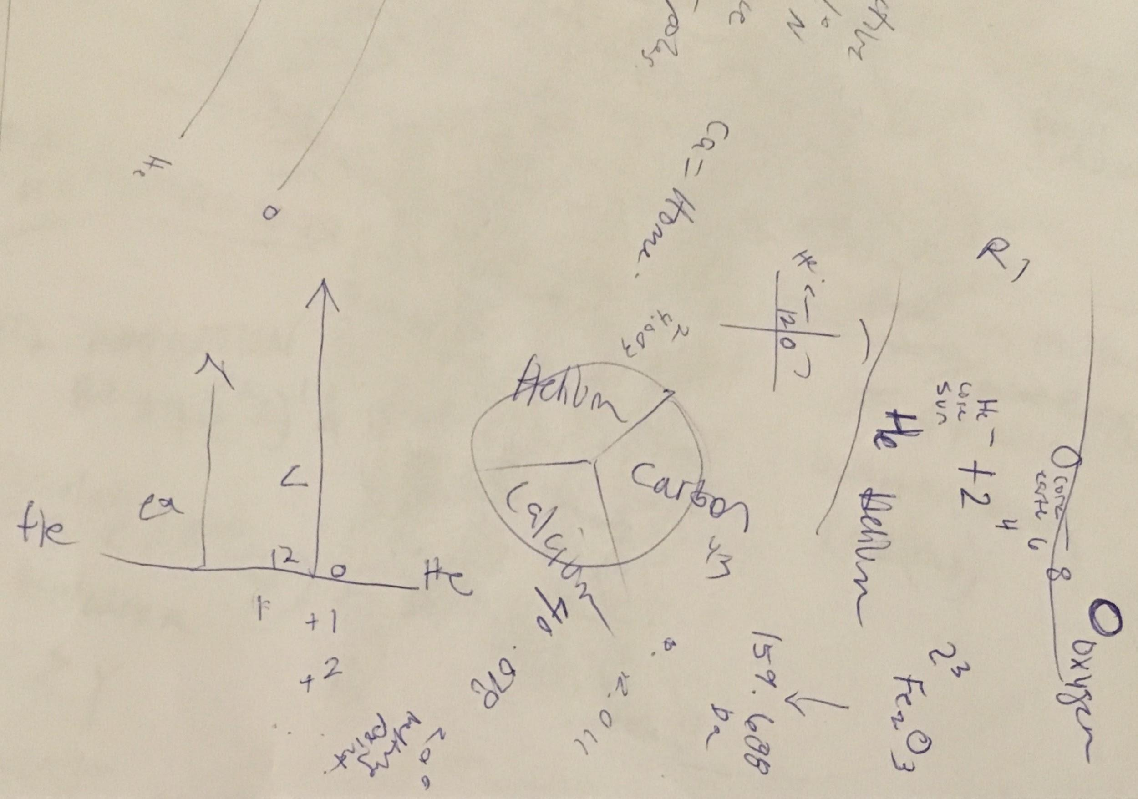

S7
Red
Orange
Yellow (mammals)
Green~ électronégative
Blue (timeline)
Purple
Indigo (integral speeds)

Flatlines- sound minus speed, of infinite proportions to subatomic weight to pressures. Equalizing Systems shared (sun in Subatomic control) equalizing Principle Weight (factorial weight FYI). System sounds adjust according to movement based in heart mass proportions (u) of electrokinetic (kinectic) to Instance energy movement of light adjacency squared per subplux Root proportionate weight i in T. The vanishing point [ei].

