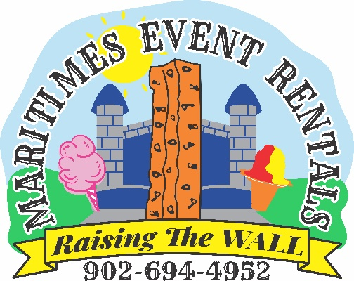
ACCIDENT WAIVER AND RELEASE OF LIABILITY FORM

I HEREBY ASSUME ALL OF THE RISKS OF PARTICIPATING IN ANY/ALL ACTIVITIES ASSOCIATED WITH Maritimes Event Rentals Inc. I certify that there are no health-related reasons or problems which preclude my participation in this activity.

I acknowledge that this will be used by Maritimes Event Rentals Inc. for the activities in which I may participate.

I acknowledge that use of all equipment owned and operated by Maritimes Event Rentals are action sports and recreational activities, and that such activity is subject to mishap and even injury to participants.

I understand while participating in this activity, I may be photographed. I agree to allow my photo, video, or film likeness to be used for any legitimate purpose by Maritimes Event Rentals Inc.

The Accident Waiver and Release of Liability Form shall be construed broadly to provide a release and waiver to the maximum extent permissible under applicable law.

I CERTIFY THAT I HAVE READ THIS DOCUMENT AND I FULLY UNDERSTAND ITS CONTENT. I AM AWARE THAT THIS IS A RELEASE OF LIABILITY AND A CONTRACT AND I SIGN IT OF MY OWN FREE WILL.

_________________________________________________ _________________________________
Parent/Guardian Signature Date

______________________________________________________________________
Participants name/ names:

